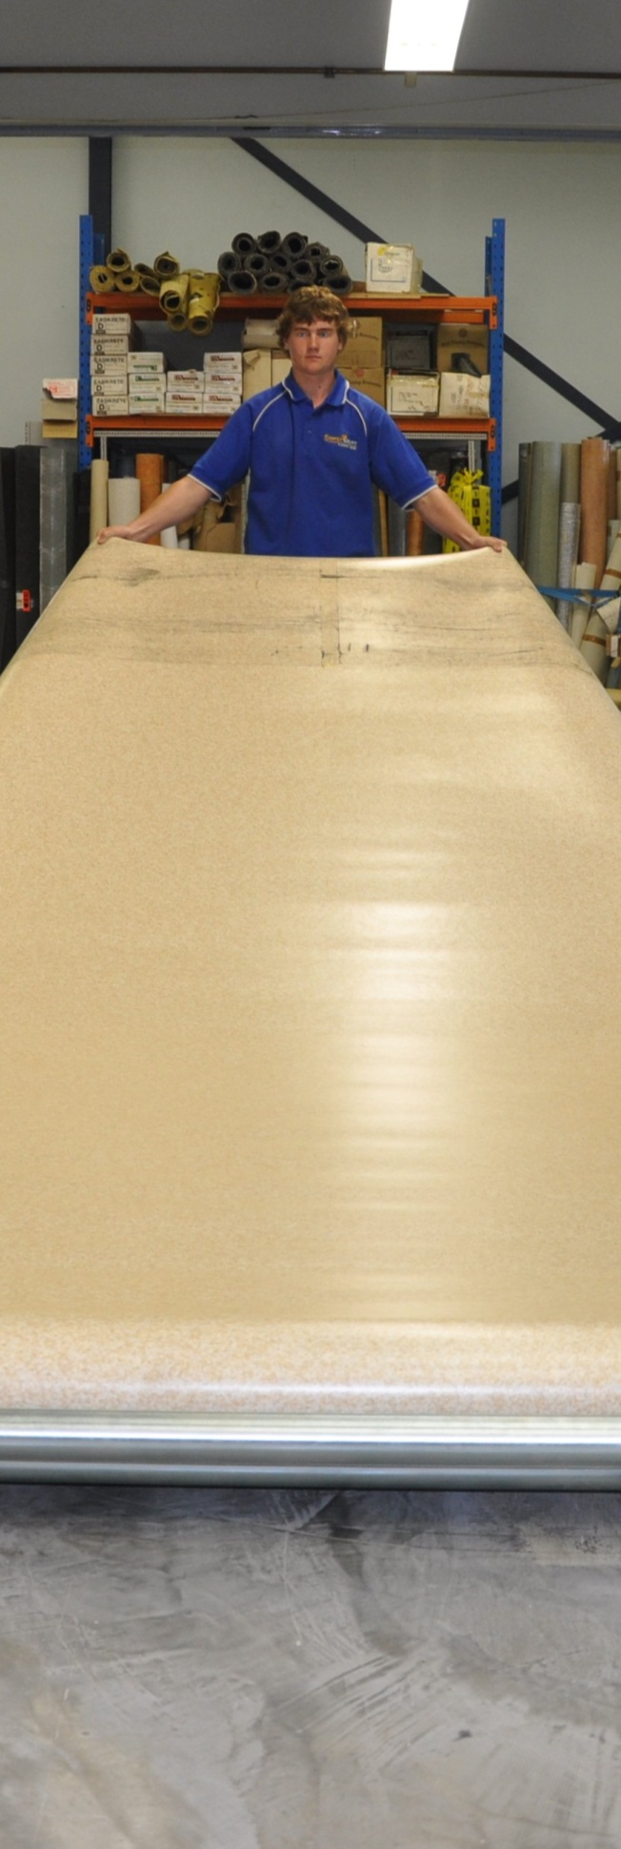
Linoleum

Supporting:
MSFFL 3012: Install
linoleum floor coverings

Learner guide
INTAR Flooring Technology Project 2015

Linoleum
Learner guide

This Learner guide is part of a suite of resources developed for learners undertaking the Certificate III in Flooring Technology (MSF30813). Its purpose is to help apprentice floor layers, sales staff and other workers to acquire the background knowledge needed to satisfy the theoretical components of the competencies covered. It is not designed to replace the practical training necessary to develop the hands-on skills required.

E-learning version
All of the content material contained in this Learner guide is also available in an e-learning format, which has additional photos, interactive exercises and a voice-over narration of the text. The e-learning version can be viewed on the web at: www.intar.com.au

ISBN: 978-1-925087-42-0
This training resource forms part of the Flooring Technology project, developed and coordinated by INTAR (Industry Network Training and Assessment Resources). To see the on-line versions of the resources available under this project, please go to the INTAR website and follow the links.

Copyright
The original version of this resource was developed by Workspace Training for INTAR members – with the copyright owned by McElvenny Ware Pty Ltd, trading as Workspace Training. Parts of the resource are based on material developed by Workspace Training with funding provided by the Workplace English Language and Literacy (WELL) Program – with copyright owned by the Commonwealth Government under a Creative Commons Attribution-Noncommercial-Share Alike 3.0 Australia Licence. All enquiries regarding copyright should be addressed to:
David McElvenny, Workspace Training, PO Box 1954 Strawberry Hills, NSW, 2012
Email: david@workspacetraining.com.au

Disclaimer
The content of this resource is provided for educational purposes only. No claim is made as to its accuracy or authenticity. The authors, copyright owners and INTAR do not give any warranty nor accept any liability in relation to the information presented in this work.
In all cases, users should consult the original source documents before relying on any information presented in the resource. These source documents include manufacturers’ installation guides, Australian Standards, codes of practice and other materials produced by specialist industry bodies and government agencies.

Acknowledgements
The INTAR project team comprises the following people: David McElvenny (Workspace Training) – lead writer and project manager; Kath Ware (Workspace Training) – instructional designer and graphic artist, Jim Vaughan (VCSS) – technical developer and programmer; Alex Vaughan (VCSS) – assistant programmer and voice-over narrator.
All line drawn graphics were produced by Kath Ware. Many of these graphics are based on line drawings or photographs from installation manuals published by floor covering manufacturers.
Most of the on-site work photos were taken by David McElvenny. Some photos showing product samples were supplied by manufacturers, as acknowledged in the text or photo.
Many TAFE teachers, RTO trainers and industry experts have been involved in the development of this resource. Particular thanks go to the following people for providing learning materials, technical advice and feedback:
Craig Bennett – Hunter Institute of TAFE (NSW)
Steven Dalton – Marleston TAFE
Bruce Ottens – Holmesglen TAFE (Victoria)
Chris Shaw – TasTAFE (Tasmania)
William Tree – ACFIT (NSW)
Mark Willis – Armstrong Flooring

Table of contents
Introduction 1
Properties of linoleum 3
Cutting and welding 5
Bight marks and end curls 8
Border coving 10
Assignment 12
Practical demonstrations 13

Introduction
The word linoleum comes from ‘linum’ (Latin for flax) and ‘oleum’ (meaning oil).
It was first invented in the 1850s, using oxidised linseed oil, cork dust and gum to form a resinous mixture, which was poured onto a cotton cloth backing.
Although there have been many refinements to the manufacturing process over the last 160 years, the basic principles haven’t changed.
The main reason linoleum is still so popular is due to its long-term durability and wide range of colours. It is also highly resistant to scratching and performs very well in high traffic areas.

Completing this unit
This unit is designed to be read in conjunction with the following two units:
- Commercial vinyl
- Lay flat vinyl.
All of the general techniques relating to installing resilient sheet products are covered in those two units. The preparations you should make before starting an installation are also covered, along with discussions on safety, adhesives and tools.
So in this unit, we’ll look at the specific installation techniques that apply to linoleum due to its different properties and structure.
There are four lessons in this unit:
- Properties of linoleum
- Cutting and welding
- Bight marks and end curls
- Border coving.
These lessons will provide you with background information relevant to the assignment and practical demonstration requirements.

References
The methods described in this unit are based primarily on the information provided by Forbo in their installation guide. You can download the original PDF documents from their website via the following link:
http://www.forbo-flooring.com.au/Commercial-flooring/Support-installation-and-maintenance/Installation/Installation-technique/
We have also used a variety of photos provided by Tarkett Australia. You can see these photos in the original document at: http://viewer.zmags.com/publication/6612b1a9#/6612b1a9/22.

Assignment
Your trainer may ask you to submit the assignment as part of your assessment evidence for the unit. You will find a hard-copy template in the separate workbook.
An electronic ‘Word’ template of the assignment is available on the website for this resource, at: www.intar.com.au

Learning activities
Each of the lessons has a learning activity at the end. The Workbook for this unit contains all of the learning activities together with spaces for written answers.
Again, you will find the learning activities on the website version, together with some interactive ‘Just for fun’ exercises.

Practical demonstrations
Your final assessment of competency will include various practical demonstrations. To help you get ready for these hands-on assessment activities, see the sample checklist shown in the Practical demonstrations section at the back of this Learner guide.

Properties of linoleum
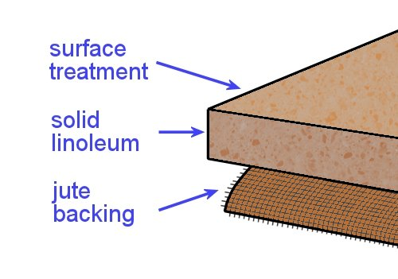
Linoleum is made from natural materials. The primary ingredients are linseed oil and rosin (tree resin). These are mixed with other substances, such as wood flour, limestone powder and colour pigments, to form ‘linoleum granulates’.
The granulates are pressed onto a hessian backing in a rolling mill to make the linoleum sheet. Hessian is a fabric that’s woven from jute plant fibres.
Given the fact that all of these materials are naturally occurring and biodegradable, linoleum is often considered to be more environmentally friendly than vinyl flooring.
Having said that, it is true that vinyl manufacture requires less power – so there are less greenhouse gasses emitted while it is being made. It’s also the case that recycled PVC flooring is increasingly being used as a base material in the manufacture of new vinyl products.
Nonetheless, linoleum still has the reputation for being eco-friendly and available in a wide range of warm ‘earthy’ colours.

Drying room yellowing
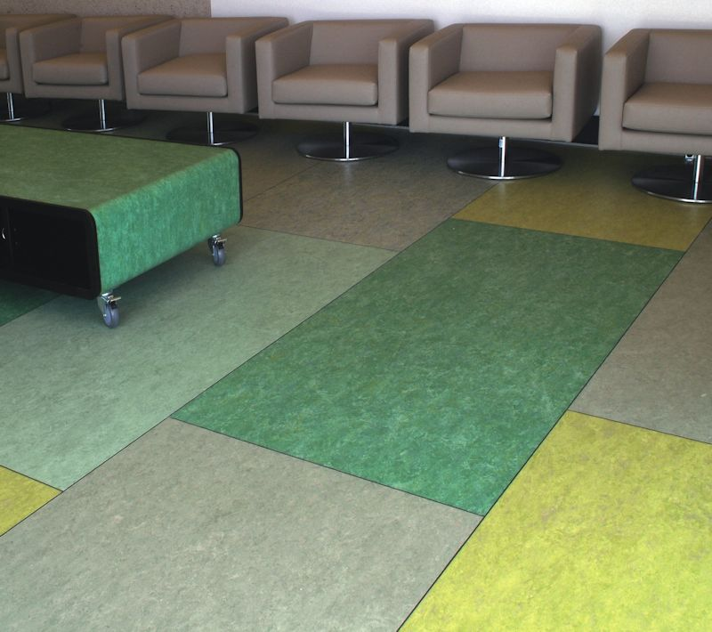
Because linoleum uses linseed oil as one of its ingredients, it sometimes develops an appearance on the surface called ‘drying room yellowing’.
The yellowing occurs when the linseed oil oxidises while it’s drying.
Its final effect depends on the colours in the linoleum – for example, blues and greens tend to look greener, and beige takes on a yellowish hue.

Once the flooring is exposed to light, the yellowing disappears. In bright sunlight, this process will take only a few hours; but in artificial light it can take up to several weeks. Nonetheless, it will still disappear in time, even if you put a floor finish or polish over the yellowing.
If furniture or other objects are placed on the linoleum and the light is blocked out, the yellowing cast may start to reappear. However, you can reassure the client that this isn’t a stain. Once it’s exposed to light, it will fade away again.

Manufacturing process
The diagram below shows the process used to manufacture linoleum sheet flooring. It has been adapted from a drawing developed by Tarkett.
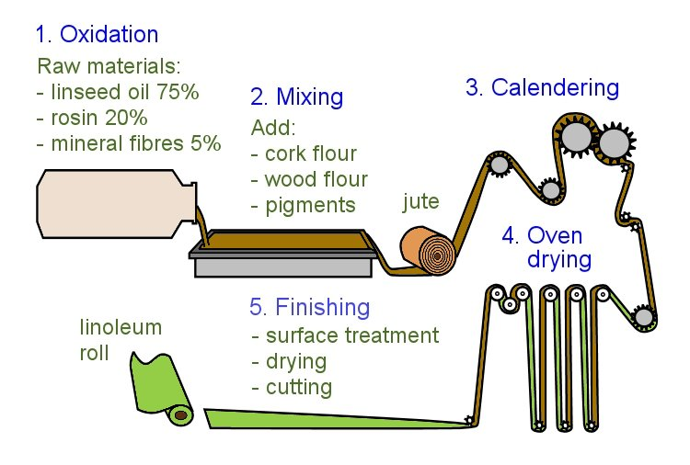

Learning activity
Follow the link below to see a promotional video produced by Forbo on how they manufacture linoleum sheets.
http://www.youtube.com/watch?v=STu33sT7hVo
Watch the video and answer the following questions:
- What brand name is used by Forbo for their linoleum products?
- How long does the linoleum sheet spend in the drying room while it cures?

Cutting and welding
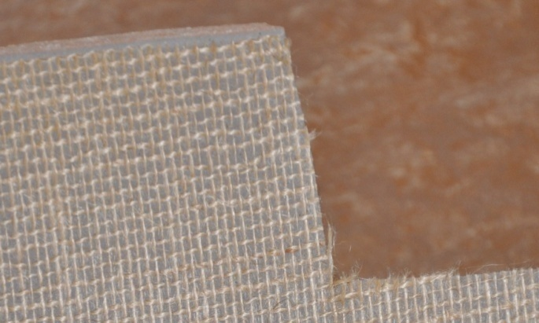
The basic techniques for cutting, fitting and welding linoleum are much the same as for commercial vinyl.
However, linoleum has slightly different properties from vinyl, so there are a few important differences.

Cutting seams
When linoleum is rolled out and placed into the adhesive, the hessian-backed material picks up moisture from the atmosphere and adhesive.
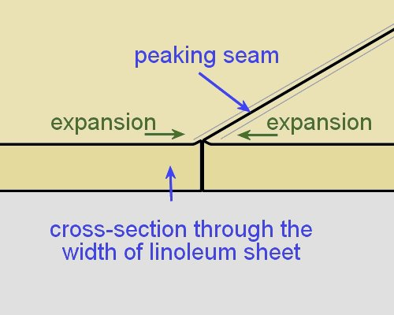
This causes a small amount of expansion across the width of the sheet, which stops when the adhesive starts to cure.
Even though the expansion is only tiny, it can cause the seam to peak if you don’t make allowance for it.
The allowance only needs to be about the thickness of the pin in a pin vice.
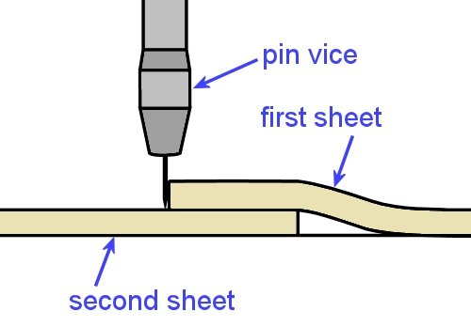
You can accommodate any expansion by using the following procedure:
- Cut the true edge in the first sheet of linoleum as you would for commercial vinyl.
- Lap the second sheet under the first sheet, either matching up the pattern or leaving a 20 mm overlap.
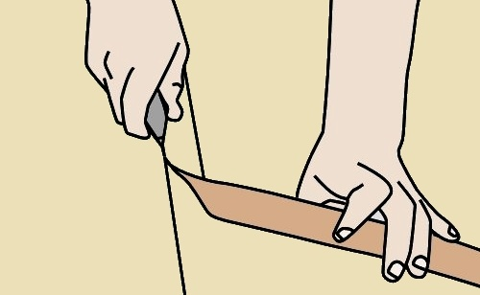
- Score the second sheet with a pin vice, keeping the pin vertical and pressed against the true edge of the first sheet.
- Cut the second sheet with a straight blade and hooked blade.

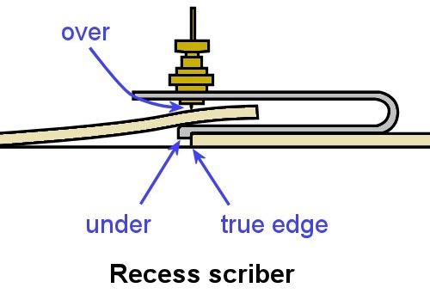
Alternatively, you can use a recess scriber to scribe the second sheet. Run the ‘under’ guide along the true edge of the first sheet and scribe the second sheet with the ‘over’ scribe pin.
But remember to offset the scribe pin by the thickness of the pin to achieve the same result as described before.

Fitting long lengths
If the sheet is long, it will tend to shrink slightly along the length, so you need to make allowance for the shrinkage when you cut the sheet.
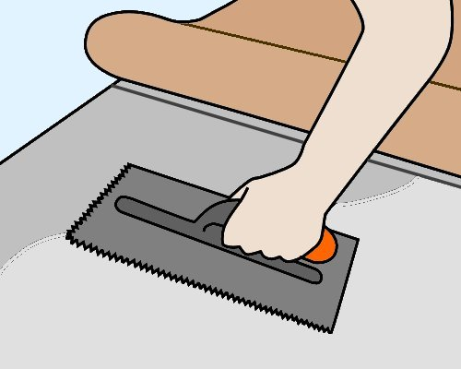
One method of dealing with the shrinkage is to only scribe one end and stick down the sheet up to about the last 2 metres. Then scribe the second end, spread the remaining adhesive and stick that end down.
Note that the whole sheet must be stuck down while the adhesive is still wet. If the first part starts to set before you lay down the last section, any overspread in adhesive might result in bubbles where the two parts meet.

Heat welding
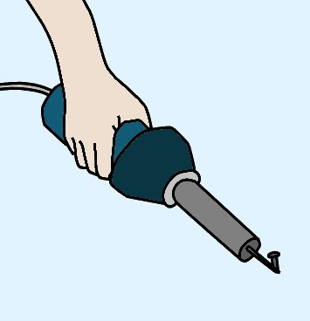
Welded joins are less necessary in linoleum than in vinyl, because well-cut seams are more likely to close up tightly after the material has been stuck down. However, if hygiene or water resistance are important aspects of the job, you should still weld all joins.
The tools used for heat welding are the same for both vinyl and linoleum. However, the welding cable is different, and linoleum is welded at a lower temperature and slower speed.
The chemical reaction that occurs in the welded joint is also different. In vinyl, both the flooring material and welding cable melt and fuse together; but in linoleum, only the cable melts as it bonds to the routed seam.
Linoleum welds should be trimmed almost immediately for the first pass, and soon after for the second. This is different from vinyl, where you should wait a bit longer before doing the first pass, and then let it completely cool before the second pass.

Learning activity
The link below will take you to a Forbo video on the correct use of adhesive when installing Marmoleum.
http://www.youtube.com/watch?v=mvmIm1bFOHs
This video provides a good review on the difference between ‘open time’ and ‘working time’, which we discussed in the unit Commercial vinyl.
It also explains the differences in technique that apply to linoleum, compared to the practices used for commercial vinyl.
Watch the clip and then answer the following questions:
- What conditions will affect the ‘open time’ and ‘working time’ of an adhesive?
- What does ‘fully wet’ mean?
- What does ‘semi-wet’ mean?
- What does ‘flashed off’ mean?
- At what stage of the drying process should you lay the sheet into the adhesive?
- What is one of the most common causes of installation failure in Marmoleum?

Bight marks and end curls
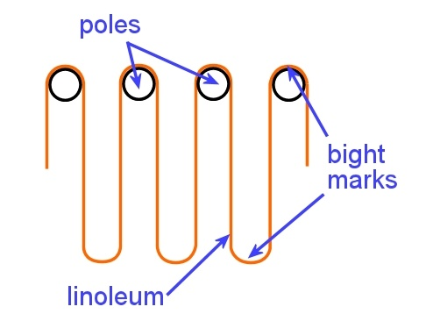
Bight marks occur in linoleum where a continuous sheet loops over poles in the drying oven while it’s curing. The bight marks at the top are cut out at the factory and the discarded material is recycled.
However, the marks at the bottom of each loop are left in the sheet. In the finished roll they often appear as a slight ridge across the sheet, about 150 mm wide.
With products that are 2.0 to 2.5 mm thick, the ridge can be stuck down in the normal way as long as the site is warm and the bight mark is well rolled both across and then along the sheet.
But with 3.2 mm material, or if the temperature is cool, you may need to either cut out the bight mark or use the following technique:
- As you feed the sheet into the wet adhesive and reach the bight mark, lean gently on the mark and rock it in and out of the adhesive, making sure there is a complete transfer of adhesive onto the hessian backing.
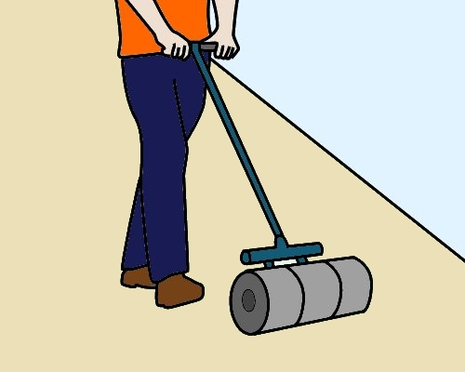
- When the loop of material being fed into the adhesive clears the area of the bight mark, immediately roll it with a 68 kilogram roller and remove any bubbles or trapped air.
- Continue to roll the bight mark every 15 minutes until it has fully bonded to the subfloor.
An alternative method is to use contact adhesive on the subfloor where the bight mark falls. For more information on this process, see the Forbo Installation Guide (referenced in the Introduction section of this Learner guide).

Removing end curl
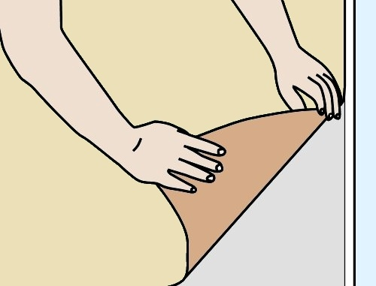
The end of the linoleum sheet also needs to be laid carefully, to make sure that the hessian backing beds well into the adhesive.
If you fold the corner back diagonally and use a ‘bouncing’ action as you place it into the adhesive, it will help to relieve the tension in the end of the length.
Then roll the sheet thoroughly with a floor roller.

Learning activity
Go to the video clip called ‘Forbo marmoleum sheet installation video’ at:
http://www.youtube.com/watch?v=NPgMgoRNM3U
Watch the clip and then answer the following questions:
- When should you roll out the material after it has been laid into the adhesive?
- What would happen to the sheet if you didn’t massage the end curl before you laid it into position?
- What does the presenter suggest you do with the adhesive to help the ‘stove bar’ (bight mark) bond properly to the subfloor?

Border coving
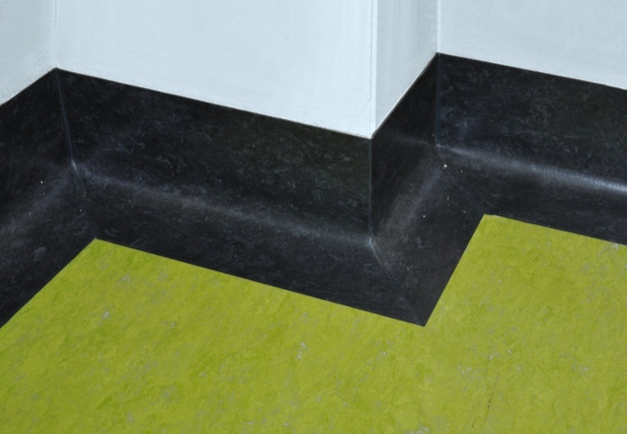
Coving in linoleum is generally installed as a border cove, with a separate piece joined at the floor to the field material.
It can either be the same colour as the field material or in a contrasting feature colour.
Border coving can be formed on-site from field material or installed as preformed pieces.

Using field material to form a border cove
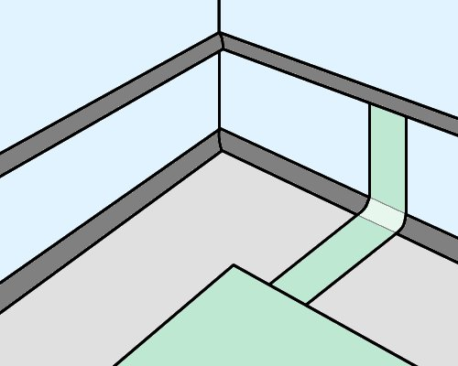
- Lay the field material first.
- Draw a line on the wall to mark the top of the coving. Fit a capping strip and the cove former using contact adhesive.
- Measure the full width of the cove and border using a flexible ruler or a scrap piece of material.
- Cut strips of the correct size from the roll of flooring material.
Note that the strips should be cut lengthwise – if you cut across the end of the roll, the piece is likely to curl inwards in the opposite direction from the way you want to turn it for the cove.
- Butt join each strip against the field material and check that it sits correctly.
- Spread the adhesive and wait the required time. Warm the linoleum with a heat gun to make it easier to curve the material over the cove fillet.
- Carefully place the linoleum into position. Ease the top edge into the capping strip with a screwdriver.

Installing preformed pieces
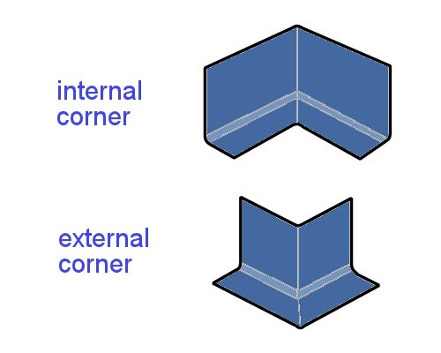
Some manufacturers produce preformed border coving with a reinforced backing. This is supplied in long straight lengths and cut or mitred with a saw on-site.
There are also preformed internal and external corners, which can be used as an alternative to mitre cutting the long lengths. These pieces are placed in position on the floor and heat welded to the adjoining pieces.

Learning activity
The link below will take you to an instruction video produced by an American company called Flashcove, showing how to fit and install their preformed border coves.
‘Installation for Flashcove prefabricated bases’:
http://www.youtube.com/watch?v=GiARlVIM1Sw
Watch the video and answer the following questions:
- How does the installer find the angle for the external mitre cuts with the use of a bevel (rather than a protractor)?
- What tool does he use to push the coving firmly into the adhesive?
- Why is the field material laid after he has installed the flash coving?

Assignment
Go to the Workbook for this unit to write your answers to the questions shown below. If you prefer to answer the questions electronically, go to the website version and download the Word document template for this assignment.
___________________________________________________________________________
- (a) What are the two main raw materials used to make linoleum?
- What is the backing material made from?
- Why is linoleum often considered more environmentally friendly than vinyl?
- (a) What does ‘drying room yellowing’ look like in a linoleum floor?
- What causes this effect?
- What would your advice be to a client who complains about the yellowing in their finished floor?
- (a) Why does linoleum expand slightly across its width when laid into the adhesive?
- How do you avoid the problem of the seams peaking due to expansion?
- How wet should the adhesive be when you lay the linoleum?
- (a) What is the difference in chemical reaction between a heat weld in vinyl and a heat weld in linoleum?
(b) How should you heat weld a linoleum seam in comparison with a vinyl seam (in terms of temperature setting and speed)?
5. (a) What do bight marks look like and how are they caused?
(b) Describe one method for dealing with a bight mark as you lay the linoleum.
6. (a) If you were cutting strips of border coving from linoleum field material, why should you cut them lengthwise along the sheet rather than across the sheet?
(b) How would you make the material more flexible when you are curving it over the cove former?

Practical demonstrations
The checklist below sets out the sorts of things your trainer will be looking for when you undertake the practical demonstrations for this unit. Make sure you talk to your trainer or supervisor about any of the details that you don’t understand, or aren’t ready to demonstrate, before the assessment event is organised. This will give you time to get the hang of the tasks you will need to perform, so that you’ll feel more confident when the time comes to be assessed.
When you are able to tick all of the YES boxes below you will be ready to carry out the practical demonstration component of this unit.
Specific performance evidence | YES
Complete the following installations:
- Cut, lay and heat weld linoleum sheet floor coverings using fillet cove internal and external mitres to custom design and pattern scribe covering (Installation 1)
- Cut, lay and heat weld linoleum sheet floor coverings using pre-formed linoleum coving with internal and external mitres to a corridor and connecting room (Inst. 2)
- Cut, lay and butt join linoleum sheet floor coverings to single/connecting room (Inst. 3)

General performance evidence | YES
- Follow all relevant WHS laws and regulations, and company policies and procedures
- Read and interpret plans and written instructions relevant to the tasks
- Assess the condition of the subfloor to determine its suitability for the installation job
- Select the appropriate adhesives, trims and accessories
- Select the correct tools and equipment, and carry out all necessary pre-start checks
- Plan the sequence of work tasks to maintain efficiency and quality
- Check the specifications of the linoleum floor covering against the work order
- Acclimatise the floor covering according to the manufacturer’s recommendations
- Identify hazards and control risks when handling materials
- Establish starting point and set out working lines
- Correctly cut and fit soft underlay and/or pre-formed fillet, where required
- Lay out the linoleum to achieve correct directional sequence, pattern match and joins
- Mark and cut the linoleum to the required pattern and shape, with minimal waste
- Use adhesives and edge strips/accessories according to instructions
- Weld and fix the materials safely and efficiently
- Set out and install skirting, reducer and edge strips, where required
- Inspect finished installation for problems and rectify faults, if necessary
- Store or recycle unused materials
- Clean and store tools and equipment appropriately
- Clean up work area and dispose of rubbish properly
- Accurately complete all required documentation

