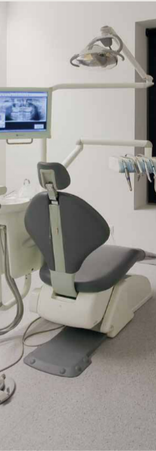
ESD Floors

Supporting:
MSFFL3019: Install anti-static resilient floor coverings
MSFFL3020: Install conductive resilient floor coverings

Learner guide
INTAR Flooring Technology Project 2015

ESD floors
Learner guide

This Learner guide is part of a suite of resources developed for learners undertaking the Certificate III in Flooring Technology (MSF30813). Its purpose is to help apprentice floor layers, sales staff and other workers to acquire the background knowledge needed to satisfy the theoretical components of the competencies covered. It is not designed to replace the practical training necessary to develop the hands-on skills required.

E-learning version
All of the content material contained in this Learner guide is also available in an e-learning format, which has additional photos, interactive exercises and a voice-over narration of the text. The e-learning version can be viewed on the web at: www.intar.com.au

ISBN: 978-1-925087-38-3
This training resource forms part of the Flooring Technology project, developed and coordinated by INTAR (Industry Network Training and Assessment Resources). To see the on-line versions of the resources available under this project, please go to the INTAR website and follow the links.

Copyright
The original version of this resource was developed by Workspace Training for INTAR members – with the copyright owned by McElvenny Ware Pty Ltd, trading as Workspace Training. Parts of the resource are based on material developed by Workspace Training with funding provided by the Workplace English Language and Literacy (WELL) Program – with copyright owned by the Commonwealth Government under a Creative Commons Attribution-Noncommercial-Share Alike 3.0 Australia Licence. All enquiries regarding copyright should be addressed to:
David McElvenny, Workspace Training, PO Box 1954 Strawberry Hills, NSW, 2012
Email: david@workspacetraining.com.au

Disclaimer
The content of this resource is provided for educational purposes only. No claim is made as to its accuracy or authenticity. The authors, copyright owners and INTAR do not give any warranty nor accept any liability in relation to the information presented in this work.
In all cases, users should consult the original source documents before relying on any information presented in the resource. These source documents include manufacturers’ installation guides, Australian Standards, codes of practice and other materials produced by specialist industry bodies and government agencies.

Acknowledgements
The INTAR project team comprises the following people: David McElvenny (Workspace Training) – lead writer and project manager; Kath Ware (Workspace Training) – instructional designer and graphic artist, Jim Vaughan (VCSS) – technical developer and programmer; Alex Vaughan (VCSS) – assistant programmer and voice-over narrator.
All line drawn graphics were produced by Kath Ware. Many of these graphics are based on line drawings or photographs from installation manuals published by floor covering manufacturers.
Most of the on-site work photos were taken by David McElvenny. Some photos showing product samples were supplied by manufacturers, as acknowledged in the text or photo.
Many TAFE teachers, RTO trainers and industry experts have been involved in the development of this resource. Particular thanks go to the following people for providing learning materials, technical advice and feedback:
Craig Bennett – Hunter Institute of TAFE (NSW)
Steven Dalton – Marleston TAFE
Bruce Ottens – Holmesglen TAFE (Victoria)
Chris Shaw – TasTAFE (Tasmania)
William Tree – ACFIT (NSW)
Mark Willis – Armstrong Flooring

Table of contents
Introduction 1
Static electricity in floors 3
Anti-static flooring 6
Conductive flooring 8
Assignment 10
Practical demonstrations 11

Introduction
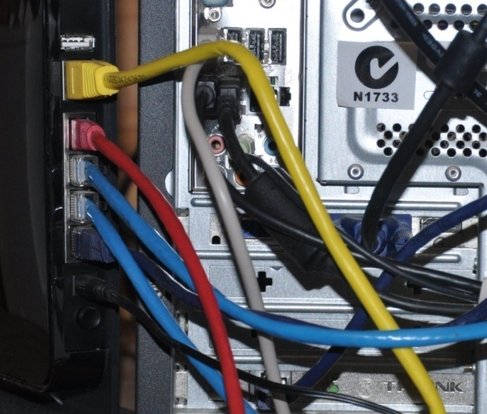
There are some situations where electrostatic discharge (ESD) inside a room can cause problems.
ESD occurs when there is a sudden flow of electricity between two objects.
You can generate static electricity by rubbing certain materials together, or scraping a chair on the floor, or even walking across a floor if your shoes and the floor surface are made of particular materials.

Completing this unit
This unit is designed to be read in conjunction with the following two units:
- Commercial vinyl
- Lay flat vinyl.
All of the general techniques relating to installing resilient sheet products are covered in those units. The preparations you should make before starting an installation are also covered, along with discussions on safety, adhesives and tools.
So in this unit, we’ll look at the specific installation techniques that apply to resilient floor coverings used in ESD environments.
There are three lessons in this unit:
- Static electricity in floors
- Anti-static flooring
- Conductive flooring.
These lessons will provide you with background information relevant to the assignment and practical demonstration requirements.

References
The methods described in this unit are based primarily on the information provided by Forbo and Tarkett in their installation guides. You can download the original PDF documents from their websites via the following links:
Forbo: http://www.forbo-flooring.com.au/Commercial-flooring/Support-installation-and-maintenance/Installation/Installation-technique/
Tarkett: http://professionals.tarkett.com.au/commdocu?field_docu_type_value=
Installation+guide
We have also used a variety of photos provided by Tarkett Australia. You can see these photos in the original document at: http://viewer.zmags.com/publication/6612b1a9#/6612b1a9/22.

Assignment
Your trainer may ask you to submit the assignment as part of your assessment evidence for the unit. You will find a hard-copy template in the separate workbook.
An electronic ‘Word’ template of the assignment is available on the website for this resource, at: www.intar.com.au

Learning activities
Each of the lessons has a learning activity at the end. The Workbook for this unit contains all of the learning activities together with spaces for written answers.
Again, you will find the learning activities on the website version, together with some interactive ‘Just for fun’ exercises.

Practical demonstrations
Your final assessment of competency in this unit will include various practical demonstrations. To help you get ready for these hands-on assessment activities, see the sample checklist shown in the Practical demonstrations section at the back of this Learner guide.

Static electricity in floors
When an electrically charged object is brought near an object that conducts electricity but is separated from the ground, there will be a discharge as the electrons jump across.
If the charge is strong enough, there may be a spark or ‘crack’ sound. But even a tiny discharge, too small for a person to notice, can disturb sensitive electronic components or cause equipment failures.
This is why floors in areas that house sensitive electronic equipment need to be ‘ESD safe’. In critical applications, ESD floors are used in conjunction with other measures, such as humidity controllers and ‘static controlled’ clothing and footwear.

Dealing with static electricity
Resilient floor coverings can be grouped into three basic categories to describe their ability to deal with the problem of static electricity – anti-static, static dissipative and static conductive.

Anti-static
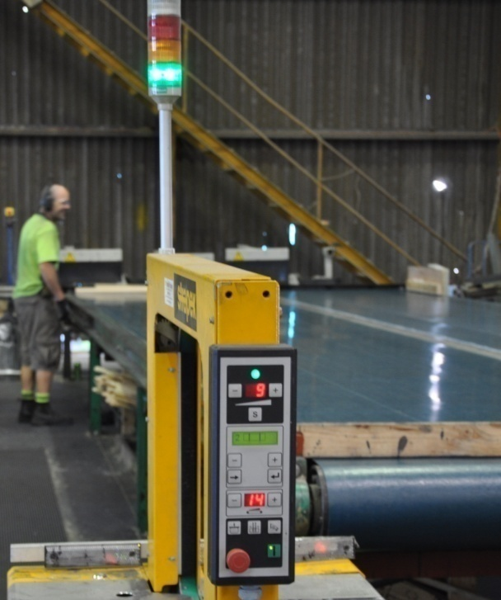
Anti-static floors are made from materials that do not generate a static charge. In that sense, an ordinary linoleum floor is ‘anti-static’ under certain conditions, and so is bare concrete as long as the relative humidity in the floor and air are balanced correctly.
But there is also a wide range of tile and sheet products specifically marketed as anti-static because they do not contribute to the build-up of static electricity, unlike many normal vinyl and carpet products.
They are often used in the picking and packing areas of warehouses and around automated carousels.
Although anti-static floors overcome the problem of people building up a static charge as they walk across the floor, they won’t actively attract or control a charge before it has a chance to discharge somewhere else.
For this reason, they are not classified as ‘ESD flooring’. This term is reserved for static dissipative and static conductive flooring.

Static dissipative
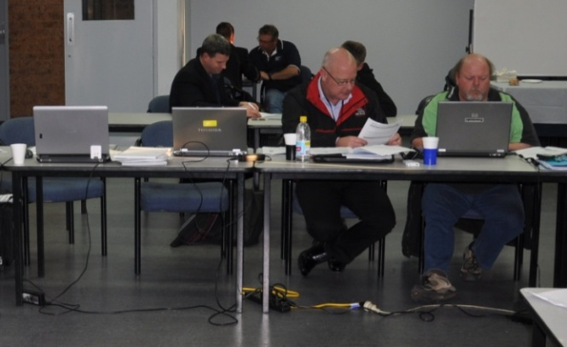
Static dissipative floors allow static electricity to ‘dissipate’, or discharge in a controlled way.
They’re used where a higher level of static control is necessary, such as in computer rooms, x-ray suites, operating theatres and some electronics manufacturing facilities.
In technical terms, a static dissipative floor is defined as having a surface resistance of between 1 x 10⁶ ohms and 1 x 10⁹ ohms. (See below for details on surface resistance in floors.)

Static conductive
These floors are at the top level of ESD flooring, and are more conductive than static dissipative floors. They are used in places where very sensitive components are being handled, such as on electronic assembly lines. Conductivity is improved by installing the floor over a grid of copper tape and earthing it to the ground.
The surface resistance of static conductive floors is defined as being between 4 x 10⁴ ohms and 1 x 10⁶ ohms.

What does surface resistance mean?
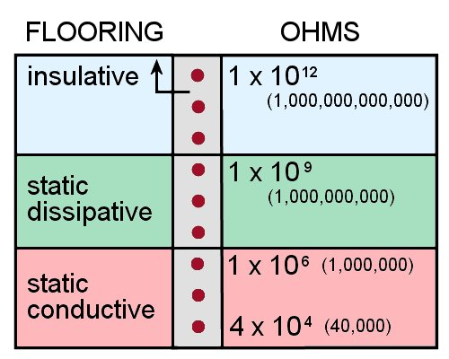
The surface resistance of a floor refers to how easily an electric charge can travel across its surface. The higher the resistance, the more ‘insulative’ it is. The lower the resistance, the more ‘conductive’ it is.
An insulative material is one that has a surface resistance of greater than 1 x 10¹² ohms. 10¹² is another way of saying one trillion (that is: 1,000,000,000,000 – or 1 with 12 zeros after it). An ohm is the unit of measure for the electrical resistance between
two points. Its symbol is Ω.
To remove the problem of electrostatic damage to sensitive equipment, a floor needs to have low electrical resistance so that any static electricity generated is able to be discharged before it has a chance to build up. This is what characterises an ESD floor.
Unlike ESD floors, anti-static floors aren’t officially described in terms of surface resistance, because their purpose is not to control the discharge of static electricity – it’s simply to reduce the build-up in the first place. Nonetheless, the floor coverings that can be classed as anti-static are generally in the range 10¹⁰ ohms to 10¹² ohms.
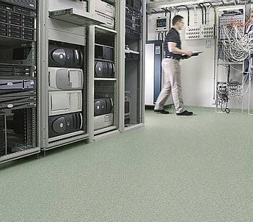
For floors that do need to be ‘ESD safe’, engineers often specify actual surface resistance levels rather than simply calling them ‘static dissipative’ or ‘static conductive’.
For example, hospitals typically have ESD floors specified at somewhere between 5 x 10⁴ ohms and 2 x 10⁶ ohms. Computer companies have varying requirements depending on what they do, but the specifications tend to go up to 1 x 10⁹ ohms.

Learning activity
An American flooring company called StaticWorx has published a set of video clips on ESD flooring at:
http://www.staticworx.com/articles/videos.php
Select the first video called: ‘What is Electrostatic Discharge (ESD)?’
Watch the video and answer the following questions:
- How many volts of electricity are needed for a person to feel a static discharge?
- How many volts are needed for static-sensitive electronic devices to be affected by static discharges?
For a more technical discussion on static dissipative and static conductive floors, see the StaticWorx video called: ‘Static Dissipative vs. Static Conductive Flooring’.

Anti-static flooring
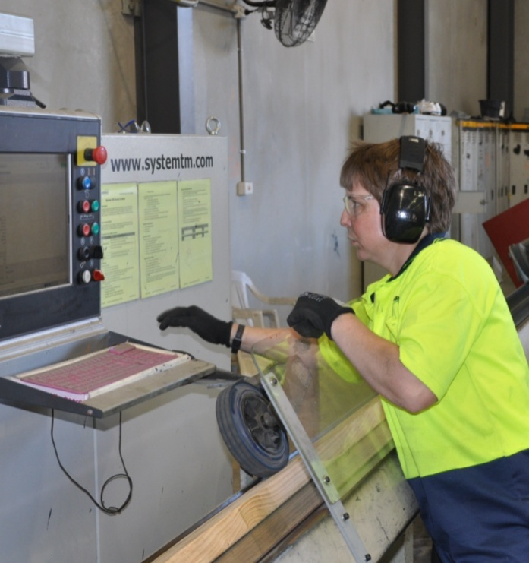
If a client asks you for ‘anti-static flooring’, you need to find out exactly what the purpose of this ‘static control’ is.
If it’s just to stop the problem of people getting a tiny shock when they touch something due to a static build-up, then an anti-static floor covering is the most appropriate choice.
However, if they’re using or handling components that could be damaged by electrostatic discharges, you need to ask more questions and find out what level of protection is required.
The manufacturers of the equipment being used in the room are likely to specify the type of flooring required. In the case of new buildings or facilities, there are sure to be engineering specifications for any ESD-sensitive areas.
The techniques used to install anti-static flooring are the same as for any other tile or sheet installation. However, the composition of the product may be somewhat different, so you should strictly follow the manufacturer’s instructions on the correct adhesive and underlayment to use. The manufacturer may also provide advice on the most appropriate trims and other fittings for this type of floor.

Static dissipative floors
If it turns out that the client needs a static dissipative floor, you can still use the same general installation techniques. However, the following differences will apply:
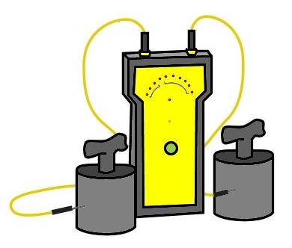
- the flooring material selected must have a surface resistance specification that puts it in the static dissipative category
- the adhesive must also have a low resistance specification and strictly comply with the manufacturer’s requirements

- the levelling compound and subfloor may have to meet certain specifications to ensure that they won’t affect the floor’s ability to dissipate static charges
- under some circumstances, the floor may need to be earthed by a licensed electrician.

Learning activity
Go to the StaticWorx video page at:
http://www.staticworx.com/articles/videos.php.
Select the video clip: ‘Testing your ESD floor’.
Watch the video and answer the following questions:
- Why can’t you use a multimeter with standard probes to test the surface resistance of a floor?
- What type of probes should you use, and how are they different from standard probes?

Conductive flooring
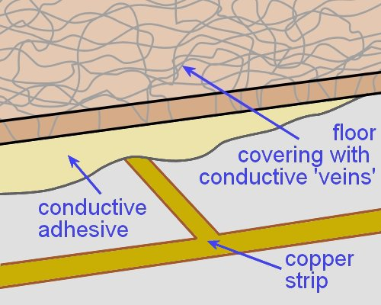
As we discussed earlier (in ‘Static electricity in floors’), conductive floors have a low electrical resistance. This is achieved through adding thousands of tiny conductive fibres or ‘veins’ into the tile or sheet product.
Depending on the brand of flooring, these conductive fibres or chips could be made of carbon, graphite, metal, or a combination of materials.
The structure of the resilient product is homogeneous, to ensure that the fibres are evenly distributed throughout.

Installation method
To install a conductive floor, you should follow the manufacturer’s instructions precisely. There may also be additional building specifications that you need to comply with in the ESD safe area. The general procedure is shown below.
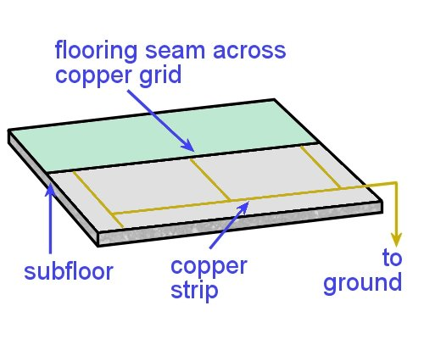
- Apply a primer to the floor with a brush or roller. Depending on the manufacturer and the size of the floor area, you may need to use a conductive primer.
- Stick down the copper strip in the grid pattern specified by the manufacturer, and run it across to the earthing point on the wall.
- Use a conductive adhesive to stick down the flooring, and roll the floor with an appropriate sized roller.
- Check the electrical conductivity, and organise for a licensed electrician to earth the connection.

Learning activity
Go to the video clip produced by Forbo on how to install Colorex SD/EC flooring in ESD sensitive areas, at:
http://www.youtube.com/watch?feature=
endscreen&NR=1&v=FPNLNcE8wbc
Although this particular product is manufactured as a tile, the process of marking out and laying the copper strips is much the same as for sheet flooring.
Watch the video and answer the following questions:
- How does the installer mark out the floor to make sure the copper strip will be laid in a straight line and in the right position?
- How does he draw a guide line on the wall to ensure that the line is an even distance from the floor?

Assignment
Go to the Workbook for this unit to write your answers to the questions shown below. If you prefer to answer the questions electronically, go to the website version and download the Word document template for this assignment.
___________________________________________________________________________
1. Anti-static floors
(a) What are the properties of an anti-static floor?
(b) Where are they typically used?
(c) Why aren’t anti-static floors described in terms of their surface resistance?
(d) Name a product that satisfies the requirements for an anti-static floor.
2. Static dissipative floors
(a) What are the properties of a static dissipative floor?
(b) Where are they typically used?
(c) What are the surface resistance specifications?
(d) Name a static dissipative floor covering (product name and manufacturer)
(e) What adhesive is recommended for this product?
(f) What extra features do you need to build into the installation of this flooring, beyond the normal installation requirements?
3. Static conductive floors
(a) What are the properties of a static conductive floor?
(b) Where are they typically used?
(c) What are the surface resistance specifications?
(d) Name a static conductive floor covering (product name and manufacturer)
(e) What adhesive is recommended for this product?
(f) What extra features do you need to build into the installation of this flooring, beyond the normal installation requirements?

Practical demonstrations
In this unit we have provided background material to cover the following competencies:
MSFFL3019: Install anti-static resilient floor coverings
MSFFL3020: Install conductive resilient floor coverings.
The checklists below set out the sorts of things your trainer will be looking for when you undertake the practical demonstrations for this unit. The performance evidence for the individual competencies are listed separately below.
Make sure you talk to your trainer or supervisor about any of the details that you don’t understand, or aren’t ready to demonstrate, before the assessment event is organised. This will give you time to get the hang of the tasks you will need to perform, so that you’ll feel more confident when the time comes to be assessed.
When you are able to tick all of the YES boxes below you will be ready to carry out the practical demonstration component of this unit.

MSFFL3019: Install anti-static resilient floor coverings
Specific performance evidence | YES
Complete at least one anti-static resilient flooring installation using a conductive acrylic adhesive system
(Anti-static flooring includes resilient flooring with a resistance rating from 108 to
1010 ohms)

General performance evidence | YES
- Follow all relevant WHS laws and regulations, and company policies and procedures
- Read and interpret plans and written instructions relevant to the tasks
- Assess the condition of the subfloor to determine its suitability for the installation job
- Select the appropriate adhesives, trims and accessories
- Select the correct tools and equipment, and carry out all necessary pre-start checks
- Plan the sequence of work tasks to maintain efficiency and quality
- Check the specifications of the linoleum floor covering against the work order
- Acclimatise the floor covering according to the manufacturer’s recommendations
- Identify hazards and control risks when handling materials
- Establish starting point and set out working lines
- Lay out flooring to achieve correct directional sequence, pattern match and joins
- Mark and cut the linoleum to the required pattern and shape, with minimal waste
- Use adhesives and edge strips/accessories according to instructions
- Lay and fix the materials safely and efficiently
- Set out and install skirting, reducer and edge strips, where required
- Inspect finished installation for problems and rectify faults, if necessary
- Store or recycle unused materials
- Clean and store tools and equipment appropriately
- Clean up work area and dispose of rubbish properly
- Accurately complete all required documentation

MSFFL3020: Install conductive resilient floor coverings
Specific performance evidence | YES
Complete at least one static conductive resilient flooring installation with an isolating layer and using a conductive adhesive and earthing strip
(Static conductive flooring includes coverings with a resistance reading of 10⁴ to 10⁸ using a copper grid and isolating layer)

General performance evidence | YES
- Follow all relevant WHS laws and regulations, and company policies and procedures
- Read and interpret plans and written instructions relevant to the tasks
- Assess the condition of the subfloor to determine its suitability for the installation job
- Select the appropriate adhesives, trims and accessories
- Select the correct tools and equipment, and carry out all necessary pre-start checks
- Plan the sequence of work tasks to maintain efficiency and quality
- Check the specifications of the conductive resilient covering against the work order
- Acclimatise the floor covering according to the manufacturer’s recommendations
- Identify hazards and control risks when handling materials
- Establish starting point and set out working lines
- Install copper grid and isolating layer according to specification
- Lay out covering to achieve correct directional sequence, pattern match and joins
- Mark and cut covering to the required pattern and shape, with minimal waste
- Lay, fix and weld the materials safely and efficiently, according to instructions
- Set out and install skirting, reducer and edge strips, where required
- Inspect finished installation for problems and rectify faults, if necessary
- Store or recycle unused materials
- Clean and store tools and equipment appropriately
- Clean up work area and dispose of rubbish properly
- Accurately complete all required documentation

