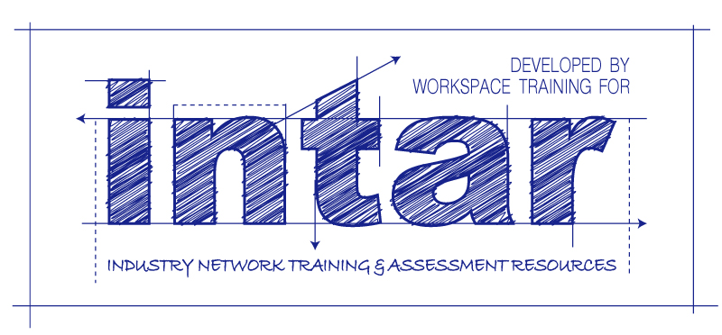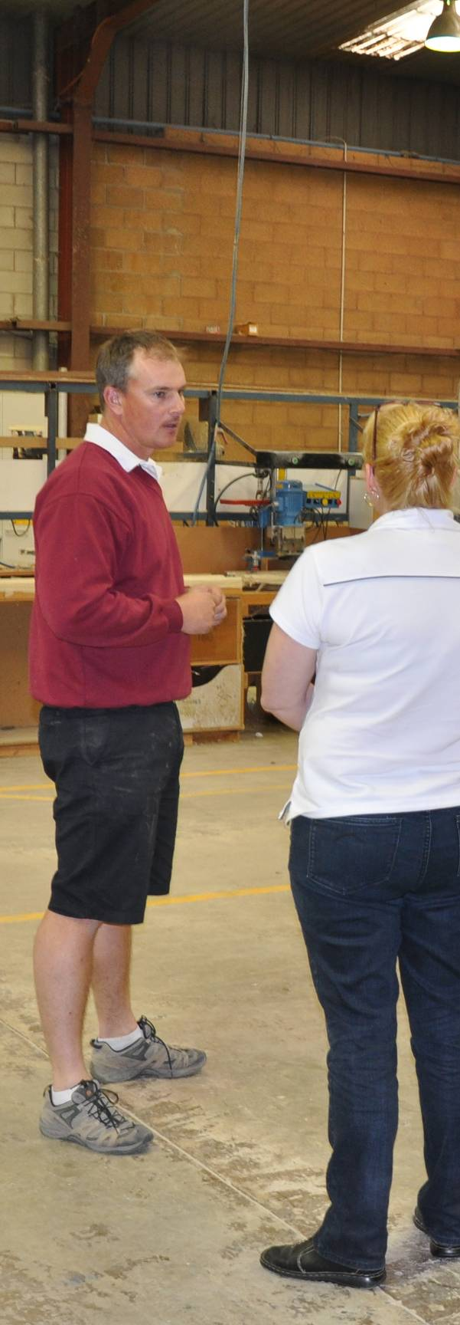

**Supporting:**

***MSMSUP102: Communicate in the workplace***

***MSMSUP106: Work in a team***

**INTAR Flooring Technology Project 2016**

Communication   
and teams

**Learner guide**

Communication   
and teams  
Learner guide



This Learner guide is part of a suite of resources developed for learners undertaking the *Certificate III in Flooring Technology* (MSF30813). Its purpose is to help apprentice floor layers, sales staff and other workers to acquire the background knowledge needed to satisfy the theoretical components of the competencies covered. It is not designed to replace the practical training necessary to develop the hands-on skills required.

#### E-learning version

All of the content material contained in this Learner guide is also available in an e-learning format, which has additional photos, interactive exercises and a voice-over narration of the text. The e-learning version can be viewed on the web at: [www.intar.com.au](http://www.intar.com.au)





ISBN: 978-1-925087-36-9

This training resource forms part of the **Flooring Technology project**, developed and coordinated by INTAR (Industry Network Training and Assessment Resources). To see the on-line versions of the resources available under this project, please go to the INTAR website and follow the links.

**Copyright**

The original version of this resource was developed by Workspace Training for INTAR members – with the copyright owned by McElvenny Ware Pty Ltd, trading as Workspace Training. Parts of the resource are based on material developed by Workspace Training with funding provided by the Workplace English Language and Literacy (WELL) Program – with copyright owned by the Commonwealth Government under a Creative Commons Attribution-Noncommercial-Share Alike 3.0 Australia Licence. All enquiries regarding copyright should be addressed to:

David McElvenny, Workspace Training, PO Box 1954 Strawberry Hills, NSW, 2012

Email: [david@workspacetraining.com.au](file:///D:\Users\Kath\Documents\Current\INTAR\MSF%20Flooring\Commercial%20vinyl\david@workspacetraining.com.au)

**Disclaimer**

The content of this resource is provided for educational purposes only. No claim is made as to its accuracy or authenticity. The authors, copyright owners and INTAR do not give any warranty nor accept any liability in relation to the information presented in this work.

In all cases, users should consult the original source documents before relying on any information presented in the resource. These source documents include manufacturers’ installation guides, Australian Standards, codes of practice and other materials produced by specialist industry bodies and government agencies.

**Acknowledgements**

The INTAR project team comprises the following people: David McElvenny (Workspace Training) – lead writer and project manager; Kath Ware (Workspace Training) – instructional designer and graphic artist, Jim Vaughan (VCSS) – technical developer and programmer; Alex Vaughan (VCSS) – assistant programmer and voice-over narrator.

All line drawn graphics were produced by Kath Ware. Many of these graphics are based on line drawings or photographs from installation manuals published by floor covering manufacturers.

Most of the on-site work photos were taken by David McElvenny. Some photos showing product samples were supplied by manufacturers, as acknowledged in the text or photo.

Many TAFE teachers, RTO trainers and industry experts have been involved in the development of this resource. Particular thanks go to the following people for providing learning materials, technical advice and feedback:

Craig Bennett – Hunter Institute of TAFE (NSW)

Steven Dalton – Marleston TAFE

Bruce Ottens – Holmesglen TAFE (Victoria)

Chris Shaw – TasTAFE (Tasmania)

William Tree – ACFIT (NSW)

Mark Willis – Armstrong Flooring

# Table of contents

[Introduction 1](#_Toc409091217)

[Section 1](#_Toc409091218) [Communicating with others 3](#_Toc409091219)

[Overview 5](#_Toc409091220)

[Verbal communication 6](#_Toc409091221)

[Verbal instructions 9](#_Toc409091222)

[Body language 13](#_Toc409091223)

[Signs and hand signals 15](#_Toc409091224)

[Forms and reports 18](#_Toc409091225)

[Emails 22](#_Toc409091226)

[Mobile phones 25](#_Toc409091227)

[Seeing things from other angles 28](#_Toc409091228)

[Assignment 1 30](#_Toc409091229)

[Section 2](#_Toc409091230) [Working in teams 31](#_Toc409091231)

[Overview 33](#_Toc409091232)

[Features of a good team 34](#_Toc409091233)

[Being a good team player 36](#_Toc409091234)

[Giving and receiving feedback 40](#_Toc409091235)

[Assignment 2 43](#_Toc409091236)

[Practical demonstration 44](#_Toc409091237)

|  |
| --- |
| Introduction |

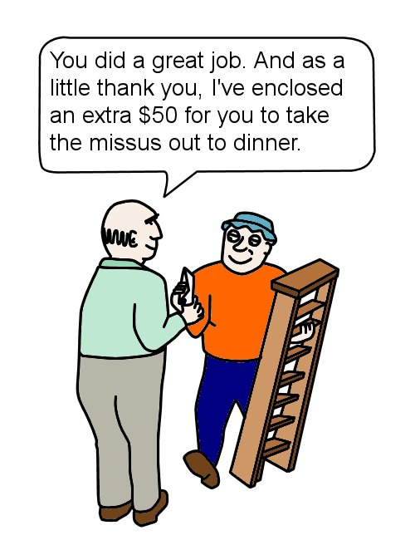As every employee knows, one of the most fundamental characteristics of a happy and productive workplace is good communication.

When everyone is on the same wavelength and working towards the same goals, you’re much less likely to have mistakes, accidents or disagreements.

You’ll also avoid embarrassing misunderstandings, like the one shown in this cartoon.

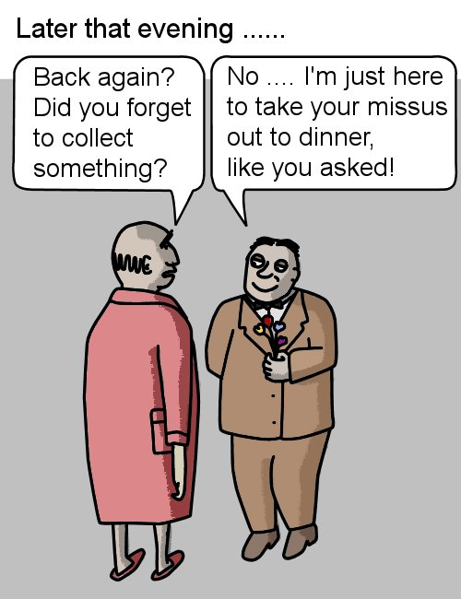In this unit, we’ll look at the different aspects of workplace communication. Once we’ve established what good communication is, we’ll apply those principles to teamwork and examine ways of improving the performance of a work group.

Your trainer may ask you to complete the unit *Work documents* in the same block of learning as this unit. It coverscommunication at its most technical and precise – in the form of plans, specifications and standards.

### Working through this unit

There are two sections in this unit:

* *Communicating with others*
* *Working in teams.*

Each section contains an *Overview*, an *Assignment* and *Lessons* which cover the content material.

##### Assignments

Your trainer may ask you to submit the assignments as part of your assessment evidence for the unit. You will find hard-copy templates for these assignments in the separate workbook.

Electronic ‘Word’ templates of the assignments are available on the website for this resource, at: [www.intar.com.au](http://www.intar.com.au)

##### Learning activities

Each of the lessons has a learning activity at the end. The Workbook for this unit contains all of the learning activities together with spaces for written answers.

Again, you will find the learning activities on the website version, together with some interactive ‘Just for fun’ exercises.

##### Practical demonstrations

Your final assessment of competency in this unit will include various practical demonstrations. To help you get ready for these hands-on assessment activities, see the sample checklist shown in the *Practical demonstrations* section at the back of this Learner guide.



# Section 1

# Communicating with others

|  |
| --- |
| Overview |

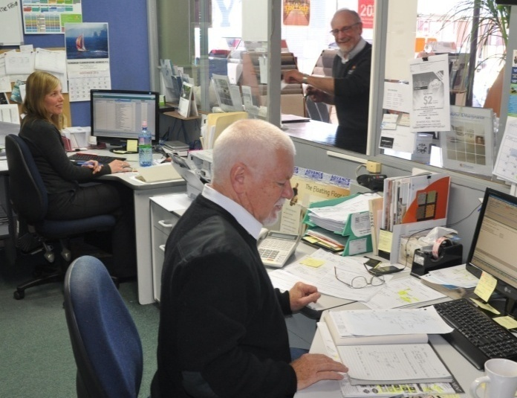There are three basic types of communication:

* **verbal**, which includes talking face-to-face and over the phone
* **non-verbal**, including ‘body language’ and other forms of communication that don’t use words, and
* **written**, such as workplace documents, emails and reports.

In this section, we’ll provide an overview of each of these types of communication. For a detailed discussion on some of the more complex forms of written documents, see the unit: *Work documents*.

### Completing this section

The assignment for this section is designed to test your understanding of the different types of communication and your ability to complete workplace forms.

Have a look at *Assignment 1* on page 30 to see what you’ll need to do to complete it.

There are also eight lessons in this section:

* *Verbal communication*
* *Verbal instructions*
* *Body language*
* *Signs and hand signals*
* *Forms and reports*
* *Emails*
* *Mobile phones*
* *Seeing things from other angles.*

These lessons will provide you with background information relevant to the assignment.

|  |
| --- |
| Verbal communication |

Verbal communication takes place whenever you speak or listen to someone.

Its biggest advantages are that: 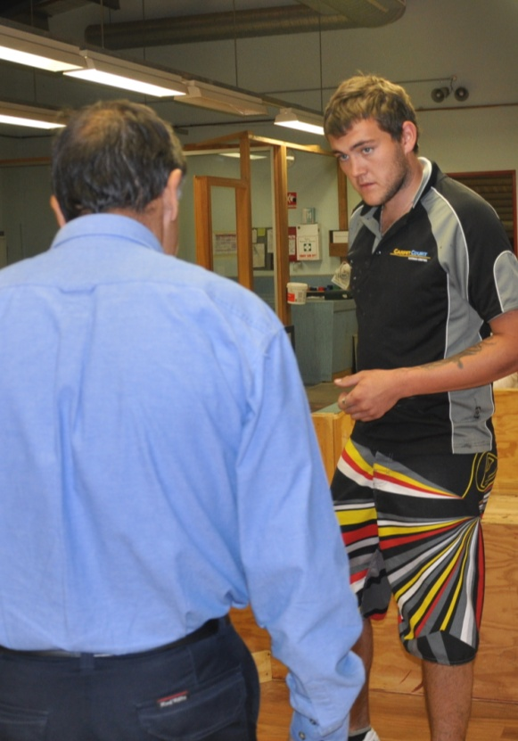

* it’s immediate and direct
* it lets other people query what you’re saying
* it allows you to discuss issues and sort out problems on the spot.

However, its disadvantages are that:

* spoken words can sometimes be misheard, especially if you’re in a noisy area or you don’t share the same language accent
* the whole message might not always get through, particularly if the speaker is in a hurry.

Nonetheless, verbal communication is used everywhere. It is the simplest and quickest way of having a conversation, and of giving instructions or discussing issues on the spot.

### Good verbal communication

Good verbal communication doesn’t just happen – it requires work from both the **speaker** (sender of the message), and the **listener** (receiver of the message).

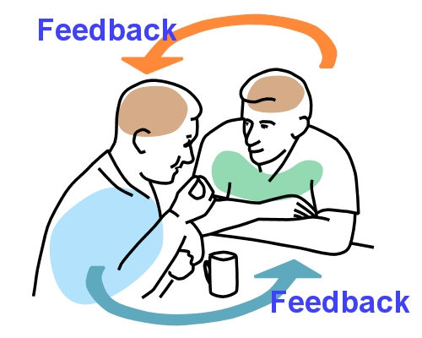The sender needs to make sure the other person understands what they’re saying, and the receiver needs to concentrate on what’s being said, and clarify anything that doesn’t make sense.

This two-way process requires **feedback** from both people. If there’s no feedback, neither of them can be sure that they’re both on the same wavelength.

That’s why your motto should always be:

*I never know what I have said until I listen to the response it gets.*

Feedback can take various forms. For example, if you’re the speaker, you should look for signals that confirm to you that the listener understands, and invite them to ask questions if they need something clarified. You should also ask them for feedback once you’ve finished.

If you’re the listener, you could nod to indicate you understand what you’re being told, ask questions if you don’t, or re-state the main points in your own words to check that you’re both in agreement.

### Phone and 2-way radio

There are some situations where you can’t see the person you’re talking to, such as when you’re on the two-way radio or telephone.

In these instances, you need to pay particular attention to the way you express yourself, because all you have to go on are the words you use and the tone of your voice.

Here are some general hints for using electronic forms of communication to speak to others:

* **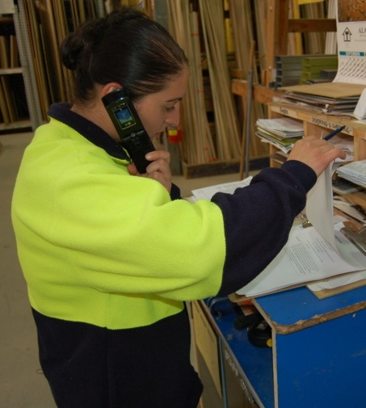Pay attention to how clear your voice sounds.** Make sure you use good diction, don’t mumble your words, and speak into the mouthpiece at a reasonable volume.
* **Try to minimise background noise.** If you’re in a noisy area, move to a quiet location while you’re on the call.
* **Identify yourself**at the beginning of the conversation. Also, if you’re phoning someone from outside the company, state the company name as well.

##### Learning activity

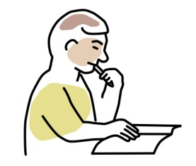Try out the following exercise with a partner.

Think of a topic that interests you, such as something you did on the weekend, a hobby you have, a holiday you’ve been on recently, etc. Talk about the topic to your partner for three minutes.

Use your watch to time yourself so that you know when to stop.

During this time, your partner’s only job is to listen – they’re not allowed to interrupt you or ask questions at any time.

When your time limit is up, give your partner two minutes to summarise your story as accurately as possible in their own words. While they’re talking, they are not allowed to ask you any questions, and you’re not allowed to butt in or correct them.

When you’ve finished the exercise, swap roles with your partner and do it again.

Then answer the following questions in your workbook:

1. How accurate were your summaries of each other’s story?
2. What’s it like to be the listener and be unable to ask questions?
3. Are there any hints from this exercise that you can apply to your own listening skills?

|  |
| --- |
| Verbal instructions |

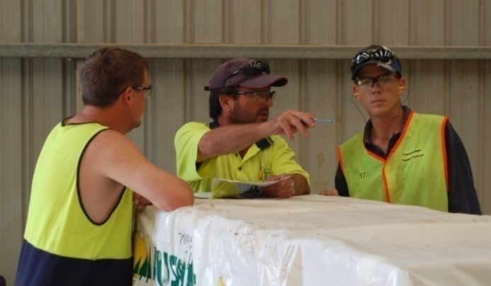Most people take the process of giving and receiving instructions for granted. It happens all day long, and it’s part and parcel of simply being at work and doing your job.

But it still requires concentration from everyone involved to avoid misunderstandings and mistakes.

Here are some hints for giving and receiving verbal instructions.

### When you’re giving instructions

* **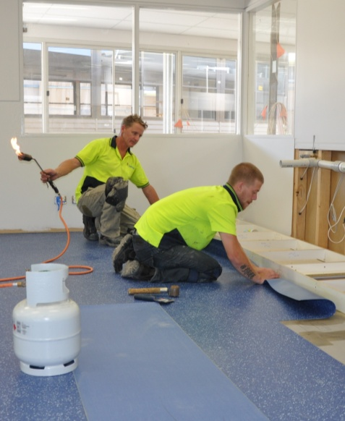Think before you speak** – work out what you want to say before you say it, and make sure you cover all of the points that are relevant.
* **Avoid jargon** – don’t use words that the listener won’t understand.
* **Watch for body language signals** – see if the listener looks like they understand what you’re saying.
* **Ask for feedback** – check that the listener has understood the message the way you intended it.

### DSC_0247 (2).jpgWhen you’re receiving instructions

* **Listen to the whole message** – don’t assume you know what the speaker is going to say before they say it.
* **Use positive body language** – show that you’re taking in what they’re saying.
* **Ask questions** – clarify any points you don’t understand.
* **Give feedback** – restate in your own words what you think the speaker is saying, and check that they agree with you.

### Effective listening

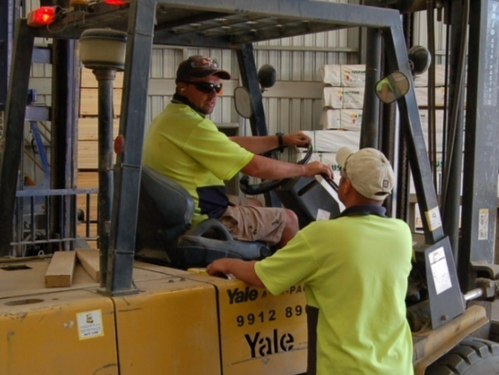Effective listening is an active process. This is because listening isn’t the same thing as hearing.

For example, when you’re working in a busy or noisy area, you may hear lots of different sounds around you – but that doesn’t mean you’re listening to every one of them. In fact, it’s impossible for you to focus on all of them at once.

This is why you need to select the sounds you want to listen to. Remember, when you’re the listener, you have to concentrate on what the speaker is saying.

### Asking questions

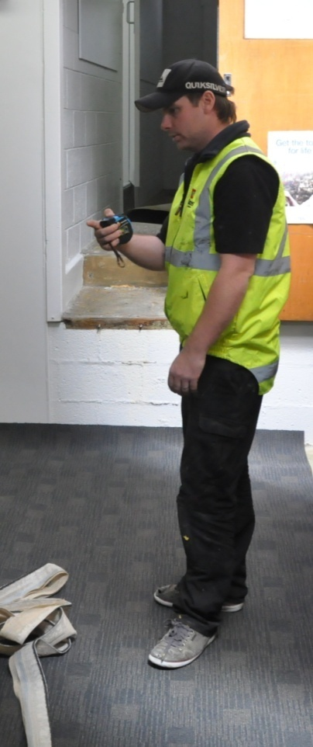One way to check that you’ve correctly understood a message is to ask questions. Asking questions while you’re being given instructions allows you to clarify any queries you may have. It also shows that you have understood what you’ve been told.

Here are some examples of questions you might ask when you’re being given instructions:

* I need you to sweep up the floor and clear this area for the stock to come in.

*Do you want me to do it now, or after I finish packing up the tools?*

* This customer order has to go out today.

*What time does it need to be ready by?*

* I want you to get all these components ready for installation.

*Which ones do you want me to do first?*

These questions might sound simple, but in each case they help you both to clarify the instruction, and allow you to work together to expand on the information being communicated.

### Open and closed questions

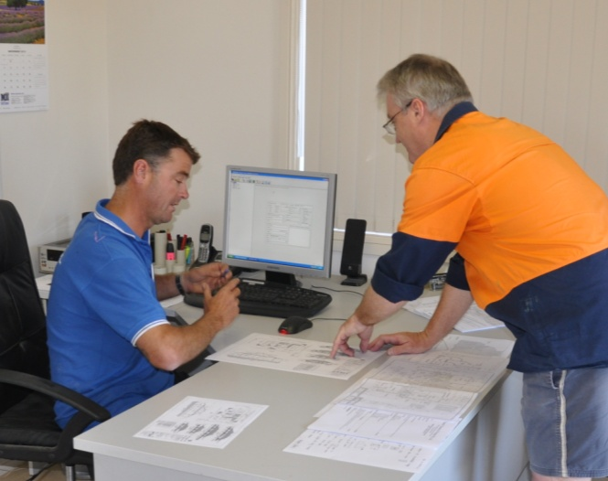Some questions only require a simple one-word answer, such as ‘yes’ or ‘no’.

These are called **closed questions**, because the person doing the asking controls the conversation.

Examples of closed questions are:

* *Is this the wall that needs to be   
  re-measured?*
* *What time is it?*

Other questions are designed to let the other person give advice, or say what they think about a topic. These are called **open questions**, because the answer is open-ended. Examples are:

* *What’s the best way to spread the adhesive?*
* *How are we going to get this cupboard up the stairs?*

Open and closed questions are both very useful in a conversation. If you only want a quick yes or no, closed questions are best. But if you’re looking for help, or need more information on an issue, open questions will encourage the other person to give you a much fuller answer, and allow the conversation to flow on.

### Repeating details

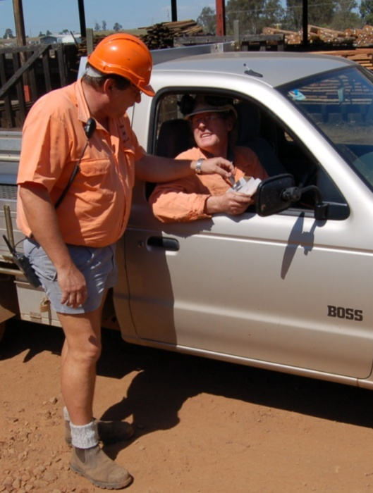Repeating the details in your own words often helps you to understand an instruction better, particularly if the task you’ve been asked to carry out is complicated, or you haven’t done it before on your own.

*OK, I’ll take these fittings over to Bill and tell him the three-hole brackets go on the underside and the four-hole brackets fit flush against the wall.*

This helps you to reinforce the steps in your own mind while you’re still both together, so that you’ve each got one last opportunity to pick up on any misunderstandings before you set off to do the task.

##### Learning activity

Here is another exercise, similar to the last learning activity. It is also designed to illustrate the crucial importance of feedback in allowing both parties to a conversation to check that the message has been received and understood properly.

This time we’ll use an example that involves giving and receiving instructions.

Ask your partner to turn around so they’re facing away from you. Draw a simple diagram of several shapes, like the drawing below. (You can use this actual drawing if your partner hasn’t already seen it.)

Your task is to provide an exact description in words of the drawing to your partner. Their task is to re-draw it, based only on the verbal instructions you give them. They are not allowed to see your drawing or ask you any questions. You are not allowed to see their drawing or ask them for any responses.

Once you have finished describing the drawing, ask them to stop and turn back to face you. Compare the two drawings to see how closely they resemble each other. Then answer the following questions in your workbook.

How did you both fare – are the two drawings a close match? If not, why not?

What sort of mental effort was involved when neither of you were able to give each other any feedback?

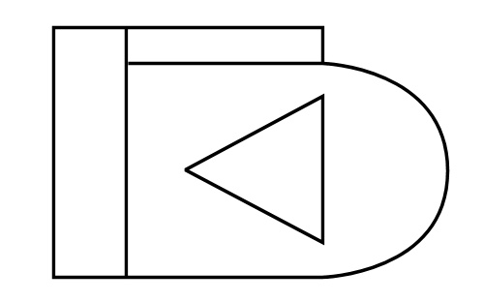What does this tell you about the value of two-way communication when you’re giving or receiving verbal instructions?

|  |
| --- |
| Body language |

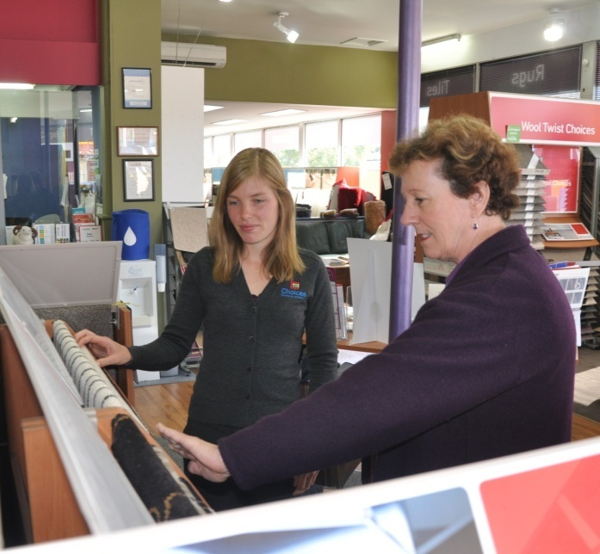Body language is a form of non-verbal communication. It includes all of the ways people express themselves through their gestures, facial expressions and body poses.

Some aspects of body language can be carefully managed, such as the way you nod and maintain eye contact to look interested in what someone is saying.

But other aspects are almost impossible to control, such as your facial expression when you’re upset or angry.

So even though you may not be aware of it at the time, the non-verbal signals you display are very powerful ways of showing how you feel at any given moment. Some researchers believe that when people are speaking to each other face-to-face, up to 80% of the message is conveyed through non-verbal means – that is, via body language, tone of voice, clothing, grooming, distance from each other, and so on.

### Creating a good impression

*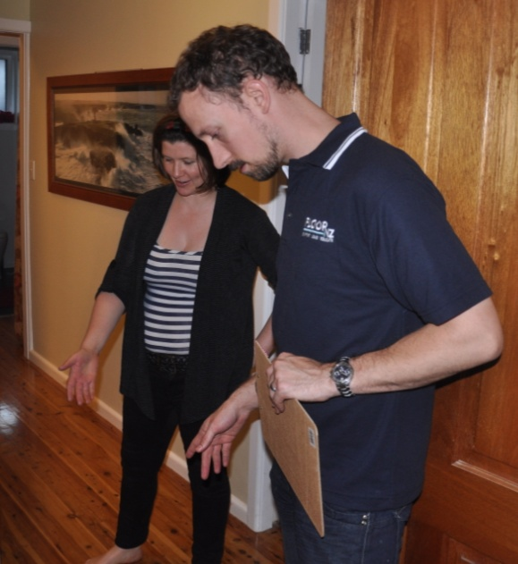First impressions last* – as the advertising slogan goes.

In other words, the first impression you make on others is a long lasting impression.

And once the other person has formed an initial judgement about you – either rightly or wrongly – it will be very hard for you to change their view.

That’s why it’s so important when you meet a client for the first time that your non-verbal signals convey an image of being professional and responsive to their needs.

Here are some examples of non-verbal signals that would help to create a good impression in the mind of the client:

* smiling to indicate friendliness
* maintaining eye contact to show you’re paying attention
* nodding to show you understand.

When a client likes your attitude and is impressed with your professionalism, they will be easier to deal with and more willing to help you solve problems that might crop up during the course of the job. They’ll also be much less likely to nit-pick over slight defects in the workmanship or materials in the finished project.

Above all, happy clients provide a feel-good factor to the work you do, over and above the payment you receive for the job. They’re also the best form of advertising you can get for future business – personal referrals from a satisfied customer.

##### Learning activity

Most people are very good at reading the facial expressions of others to determine how they’re feeling.

Have a look at the cartoons below showing a range of different moods. See if you can describe in one or two words what emotion each one is portraying.

But it’s important to remember that not all cultures express every emotion in exactly the same way. Can you think of any examples where someone from a non-English speaking culture might portray a basic emotion in a different way?

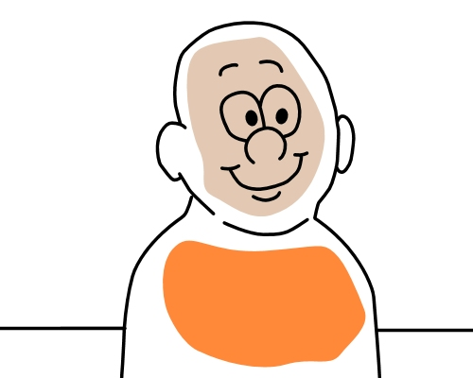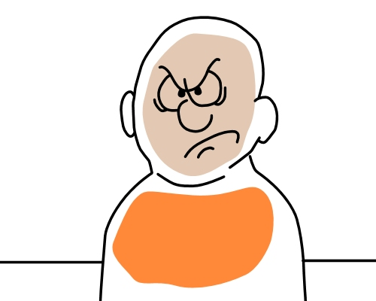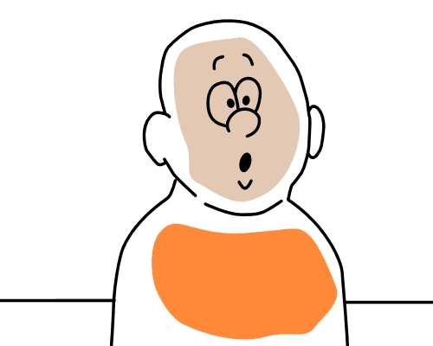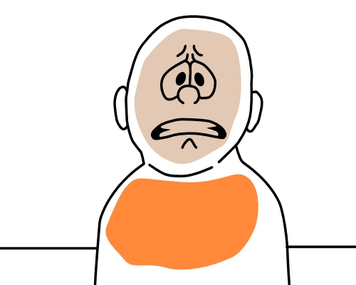

|  |
| --- |
| Signs and hand signals |

There are some instances when the best way to transmit information is to do it visually.

This may be because the workplace is noisy or there is some distance between the people communicating.

Or it could be because there are general risks in an area, requiring everyone entering it to take precautions.

The simplest way to get information across under these conditions is to use workplace signs or hand signals.

### Safety signs

Most safety signs use standard colours and conventional symbols. Here’s some examples.

|  |  |
| --- | --- |
| prohibit.jpg | Signs with a red circle and diagonal bar through the centre are called **prohibition** signs, meaning ‘not permitted’. |
| restrict.jpg | A red circle specifies a **restriction**. This sign says that the speed limit is 5 kilometres per hour. |
| hardhat.jpg | A blue circular background indicates a **mandatory**, or ‘must do’ sign. This sign is telling you to wear a hard hat. |
| warning.jpg | A yellow triangle means **warning**. In this case, the sign is saying ‘keep clear’. |
| danger.jpg | **Danger** signs are used to refer to life threatening hazards. This sign would be put over the entranceway to a confined space. |
| exit.jpg | A green rectangular background is used for **emergency** information.  The most common example is an ‘exit’ sign. |
| fire.jpg | A red rectangular background is used for information about **fire** services.  This sign indicates that a fire extinguisher is nearby. |

### Hand signals

Workers in a team often develop their own hand signals to convey particular instructions or directions. However, there are certain signals used in crane and dogging operations that you can apply to lots of other applications. These include directing forklift drivers, reversing vehicles, and operators of scissor lifts and gantry cranes.

Here are some common examples.

|  |  |
| --- | --- |
| hand_signal_1.jpg | The most universally understood hand signal is **stop**.  Hold your hand head-high, with your palm towards the person you’re signalling. As with all signals, make sure your actions are big and obvious. Don’t use half-hearted movements. |
| hand_signal_4.jpg | To indicate **go left** or **go right**, point in that direction and move your whole hand in a sweeping action in the same direction. Again, use strong decisive actions to signal your directions. |
| hand_signal_2.jpg | To indicate to a driver to **raise a load**, use your index finger to point up, with the rest of your hand closed. Move your whole hand up to make the direction obvious. |
| hand_signal_3.jpg | To **lower a load**, point down, moving your whole hand down at the same time. |

##### la_man_drawing.jpgLearning activity

Below are some common workplace signs. See if you can guess their meanings.

Write your answers in the Workbook for this unit.

|  |  |  |  |
| --- | --- | --- | --- |
| prohibit_2.jpg | first_aid.jpg | emergency.jpg | prohibit_1.jpg |
| boots.jpg | dustmask.jpg | eyeprot.jpg | earmuffs.jpg |

|  |
| --- |
| Forms and reports |

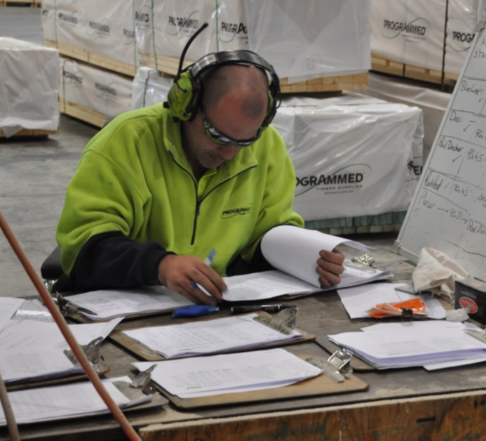In the workplace, forms and reports are used to document information so it can be referred to at a later time.

Forms are based on a ‘template’ format, which provides a fixed structure with standardised subheadings and questions.

Reports, on the other hand, are much more free-flowing. They allow you to express your opinions on matters instead of simply providing specific answers to set questions.

Let’s look at some typical types of forms and reports.

### Forms

#### Injury form

If you suffer a workplace injury, you’ll probably be asked to record the details in an injury or incident form. Generally the company’s Safety Officer will help you, or even fill in the details for you. The example below shows a typical layout of an injury form.

|  |  |  |  |  |  |
| --- | --- | --- | --- | --- | --- |
| **Injury form** | | | | | |
| **Name of injured person:** Sam Poulos | | **Position in company:** Orderperson | | | |
| **Date of birth:** 24 March 1976 | | **Phone number:** 9444 4444 | | | |
| **Action taken:** 🗹 First aid given ❑ Sent to doctor ❑ Taken to hospital | | | | **Time/date:** 8.45am 4/9/14 | |
| **Nature of injury or illness:** Cut to left hand | | | | | |
| **Treatment given:** Antiseptic and bandage applied by first aid officer | | | | | |
| **Cause of incident:** Breaking steel strapping on a pallet of stock | | | | | |
| **Corrective action recommended to prevent recurrence:** Wear gloves while doing this job | | | | | |
| **Person responsible for implementing corrective action:** Jill May (Safety Officer) | | | | | |
| **Corrective action completed:** Yes | **Name:** Jill May | | **Signature:** *J. May* | | **Date:** 10/9/14 |

#### Telephone message

|  |  |
| --- | --- |
| **d:\Users\Kath\AppData\Local\Microsoft\Windows\Temporary Internet Files\Content.IE5\5WIHNIQC\MC900389396[1].wmfMESSAGE** | **Date:** 25/7/14 |
| **For:** Robert | **Time of call:** 2pm |
| **Who called:** Sue Simpson | **Telephone no:** 9444 444 |
| **From:** Simpson Engineering | |
| 🗹 **Wants you to phone back** ❑ **Will phone later** | |
| **Message:** Wants to know whether the bearings have arrived yet. She needs to know today. Please phone her back before  5 pm | |
| **Message taken by:** Sam | |

Telephone messages are often recorded on a template-type pad bought from the local newsagent.

The advantage of using a template is that it gives you prompts so you can make sure you’ve written down the necessary details while the caller is still on the phone.

#### 

#### Toolbox minutes

One of the meetings you’re likely to be involved in at work is a toolbox meeting. Because they play an important role in the company’s occupational health and safety system, the points raised at toolbox meetings need to be formally documented.

The example below shows a standard layout for recording the minutes.

|  |  |  |  |  |  |  |
| --- | --- | --- | --- | --- | --- | --- |
| **Toolbox meeting minutes** | | | | | | |
| **Name** | | **Present** | **Name** | | | **Present** |
| Derek Peters (Supervisor) | | ✓ | Matt Cantopolous | | | ✓ |
| Susan Witherspoon | | ✓ | Adam Mathews | | | ✓ |
| **Topics discussed** | | | | | | |
| Derek said that Sam cut himself last week while breaking the steel strapping on a pallet of stock. To stop this in future, workers must wear gloves from now on when breaking steel strapping. | | | | | | |
| **Supervisors signature** | *D. Peters* | | | **Date** | 10/9/14 | |
| **Follow-up / action taken** | | | | | | |
| Order placed for 6 pairs of gloves – will arrive on Friday | | | | | | |
| **Safety Officer's signature** | *J. May* | | | **Date** | 12/9/14 | |

### Reports

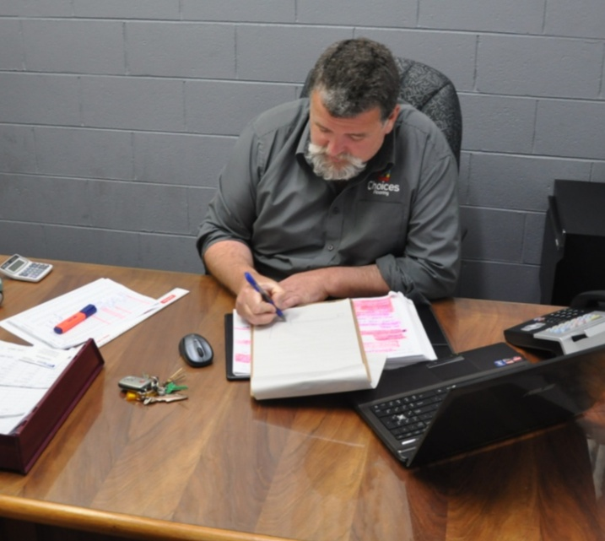Sometimes reports are written into a document with a template layout. These might include a customer complaint, accident report or quality inspection.

Other reports have no pre-formatted structure at all, particularly when they represent the writer’s views on a subject.

The big difference between a report and a form is the amount of control you have over how you express yourself.

But with this increased level of freedom comes an equal increase in the care you have to take with the words you use.

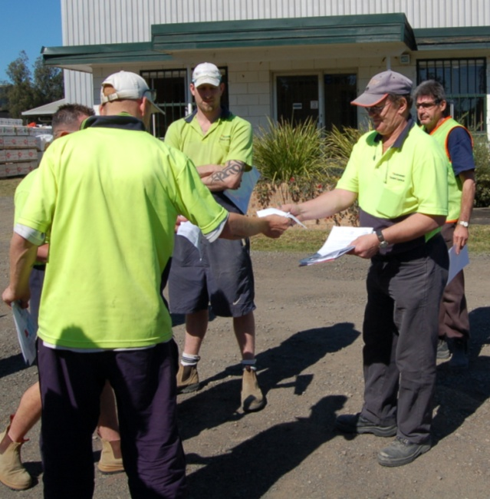Unlike talking, when you communicate your ideas in writing there is no way of checking on the spot that the message is being received the way you’d intended it.

So by the time you do get feedback on your report, the reader will have already formed an opinion on it, and may have also put plans into action on the basis of what they thought you were saying.

The best way to avoid misunderstandings when you’re writing a report is to think about the topic from the reader’s perspective.

Remember that they’re unlikely to have the same amount of background information on the matter as you do, so you have to include any details that are important to their understanding of the issue.

### Checklist on how to write a report

Here’s a brief checklist for report writing.

1. **Make sure you understand the purpose of the report.** This will help you to provide the exact information needed, so that you don’t leave out important points or add other details that aren’t necessary.
2. **Keep your sentences short and clear.**Complex sentences are more difficult to read, and can often hide information. Remember, a single sentence should contain only one idea. If you need to, you can separate the different parts of an idea with dot points or a numbered list.
3. **Avoid acronyms and abbreviations** unless you're sure they will be understood by the reader. An acronym is a word made up of letters from the original term, such as ‘Hasmat’ for ‘hazardous materials’.
4. **Carefully proof read what you’ve written**before you send off the report.Check that it makes sense and there are no spelling or grammar mistakes.
5. **Ask someone else to proof read it**if the message is very important. They will be reading your report more objectively, so they’re better placed to pick up any parts that may need more explanation, or errors in grammar or spelling.

##### Learning activity

In your Workbook is a simple example of an incident report. In some workplaces, an incident report is combined with an injury form to create an ‘Injury/incident report’.

Incident reports are used to record the details of an event that caused an injury, damaged property, or was a ‘near miss’ (that is, nearly resulted in an injury or property damage).

They are also used to document the cause of the incident and to suggest corrective action to stop the same sort of situation happening again.

Think of an incident that you are aware of, or alternatively, make up an incident that might occur at your workplace if something went wrong.

Go to your Workbook and fill in the incident report template as if you were the safety officer investigating the matter.

|  |
| --- |
| Emails |

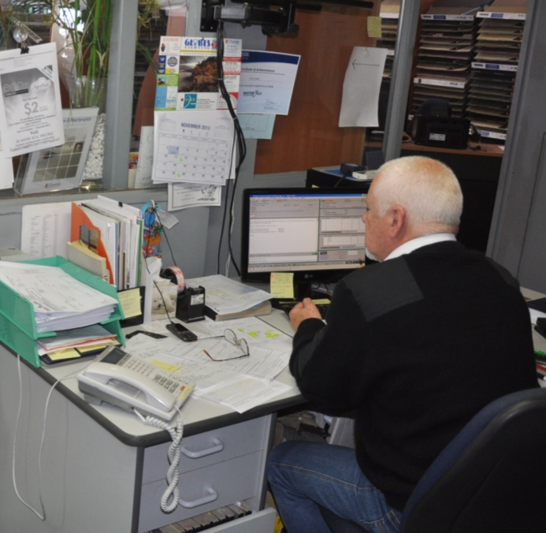If you use a computer as part of your work, you probably send and receive a lot of emails.

You may even have your email account linked to your mobile phone, particularly if you spend most of your time travelling or out on jobsites.

Because most people also use emails to correspond with their friends and relatives, their style of writing is generally much less formal than it would be in a letter, even when they’re sending work-related messages.

In itself, this isn’t necessarily a bad thing. However, when you’re corresponding with clients, suppliers and work colleagues, you need to keep your emails polite and businesslike, and avoid sending anything that might look unprofessional or offensive.

Below are some tips on how to send work emails that reflect well on you and your company.

1. **Check your spelling** and correct any mistakes before you send the message. It’s easy to make typos on a computer keyboard, especially if you’re typing quickly. But errors make your writing look careless, and it doesn’t take much longer to correct them as you go.
2. **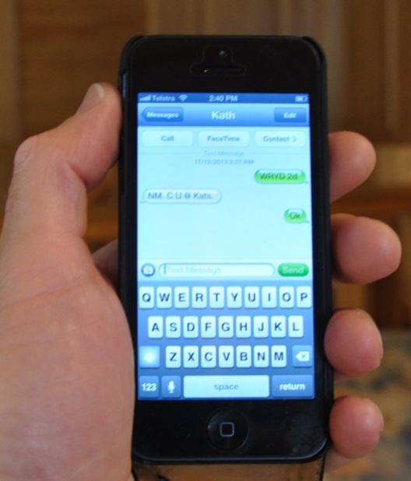Avoid ‘SMS language’** unless it is already   
   an accepted practice between you and your recipient. Short message service (SMS) language is fine for mobile phones, where messages tend to be short and punchy.

But in an email it can be confusing to a reader who doesn’t know what it means – and even if they do, they may not regard it as appropriate language for a business relationship.

We’ll talk more about SMSs in the next lesson.

1. **Avoid other forms of abbreviation** unless you’re sure that the receiver will understand them. The same applies to jargon words – that is, special terms that have technical meanings. If you need to use abbreviations or jargon, explain what they mean the first time you use them.
2. **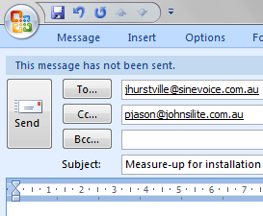Use the ‘Cc’ line for people you are not addressing personally.** ‘Carbon copy’ (or ‘courtesy copy’) is designed for copying in people who should be kept up-to-date with the messages but are not the direct recipient.

**Use the ‘Bcc’ line only when necessary.** ‘Blind carbon copy’ is designed for copying in other people without the knowledge of the direct recipient.

But you should be careful about using it for this purpose, because as a general rule it is always better to be up front with the recipient about who else is sharing your email correspondence.

Bcc can also be used to hide the email addresses of a large distribution group. This is a handy way to avoid overcrowding the ‘To’ or ‘Cc’ line with a big list of addresses that individual recipients don’t need to know.

1. Always assume that your **work emails are not private**. If you have a company email account, your company ‘owns’ the emails you send through it. This means they can legally read them if they want to. For that reason, you should only send material that you’d be happy for your boss to see.
2. **Use the subject line to give your email a title.** Try to summarise the point of the email in a few words. Don’t call your email ‘Hi’ or ‘Hey mate, it’s Peter here’.
3. 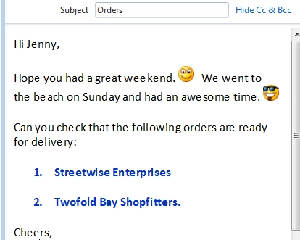Remember that **not all people use the same email programs.** This means that formatting, coloured fonts, emoticons and other elements you see on your screen will not necessarily look the same on other people’s computers.

Your recipient may even be reading the message on their smart phone or some other device. So don’t go to too much trouble formatting the text or inserting graphic elements unless you’re sure that the reader has similar software and hardware.

1. **Use an automated signature block** at the bottom of your emails. Include your name, company, phone number and any other important contact information. Some companies also like to insert their logo as a graphic into the signature block.
2. **Use the ‘read receipt’ option** when you’re sending an important email. In some email programs, you can turn on the ‘Request a read receipt’ function by ticking a box under ‘Options’. This will let you confirm that the recipient has read your email.

##### Learning activity

Which email program do you use?

Do you have an automated signature block? If not, do you know how to set one up?

Also, have you used the ‘Request a read receipt’ option before? If not, do you know how to activate it?

If you haven’t used either of these functions previously, go to your email system and find out how they work. For more information, click on the ‘Help’ icon in the email program or ask someone else at your workplace to give you a hand.

|  |
| --- |
| Mobile phones |

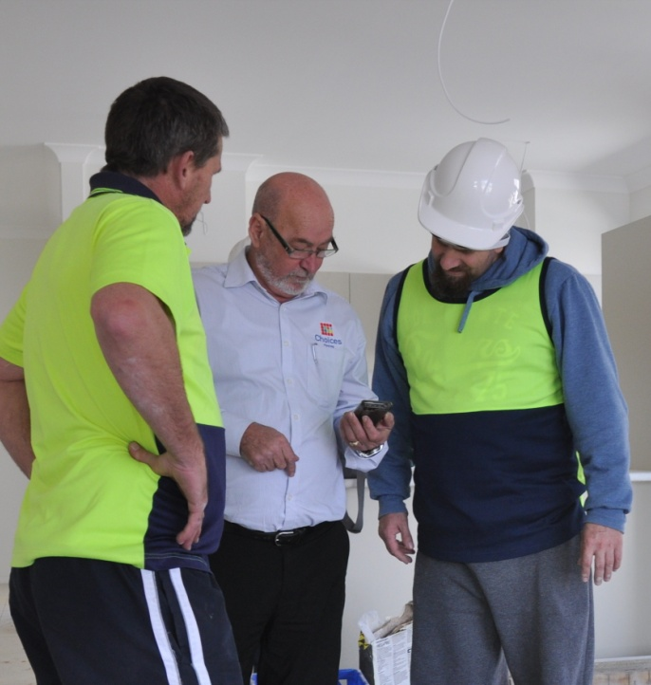Mobile phones have revolutionised the way people stay in touch with each other.

You can be out at a jobsite, in the warehouse, on the beach or down at the pub – as long as you’re within range of the nearest mobile phone tower, people can contact you.

Smart phones have added another dimension to mobile phone use. Now you can take photos, listen to music, surf the web, update your Facebook page and do lots of other things via your phone.

Many tradespeople use their phones these days to manage appointments and even to take credit card payments.

But like every other form of technology, if it’s not used properly there can downsides. Some companies have had to go to the extent of banning mobile phone use at work because employees were wasting too much time or abusing their privileges.

Below are some of the benefits of having a mobile phone at work, as well as some ‘protocols’, or rules, that should be observed.

### Benefits

**1. Taking on-site photos**

‘A picture paints a thousand words’. There are many times when an on-site photo of a fault or problem can save you a great deal of verbal explanation. Photos can be downloaded and inserted into written reports, or simply sent as a message to the person who needs to see it.

You can also take photos of subfloor problems or moisture metre readings to keep on file as a form of evidence. This lets you refer back to them later if the need ever arises.

**2. Communicating verbally**

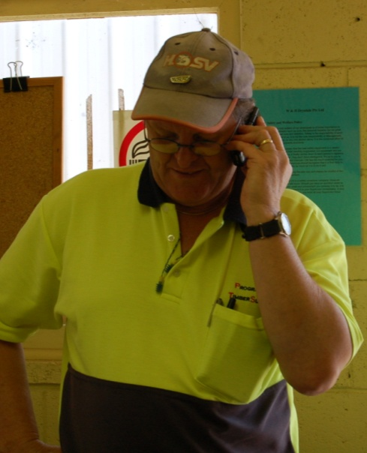Having a mobile phone lets you make and receive calls at any time. This allows you to attend to urgent matters, organise meetings, talk to suppliers and clients, and generally stay connected wherever you are.

**3. Communicating via SMS or email**

Like phone calls, having access to email and SMS services when you’re on-site or in transit can be a huge boost to your productivity. It means you can deal with issues on the spot and always be in touch with your office and other important contacts.

**4. Storing information**

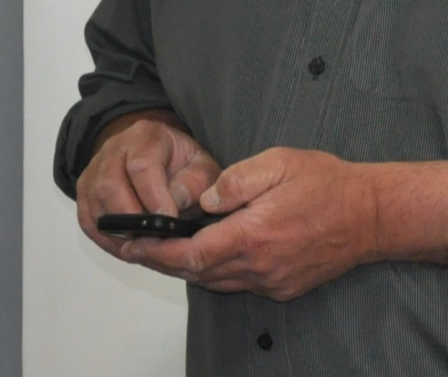Depending on the programs and applications you have loaded onto the phone, you can maintain your diary and keep your work schedule up-to-date.

Most phones will also let you store various types of files, so you can refer to important pieces of information when needed, such as installation details, Australian Standards, technical images, and so on.

### Protocols

**1. Making calls**

Just because you’re capable of making a phone call whenever you want to, it doesn’t mean you should use up valuable work time chatting to friends. Don’t use your phone for personal calls during work hours unless there are exceptional circumstances – it will irritate your workmates and annoy your boss.

Even when you do need to make a call, it’s polite to do it away from others so that you don’t disturb them – especially if you tend to talk loudly on the phone.

**2. Receiving calls**

The same rule applies to receiving calls as making calls – only take work-related calls during work time. Let all other calls go to your message bank, and ring the person back when you have a break.

If you’re meeting with a client or having an important conversation, let every call go to the message bank unless you know it relates to an urgent matter. Best of all, turn off the ringer while you’re in the meeting so there is no disruption.

**3. Sending and receiving SMSs**

Unless an SMS is work-related and needs to be dealt with on the spot, you should reserve your texting time to breaks and after hours.

Even then, most people consider it rude for someone to be sitting in general company and laughing at private jokes, especially if you’re all having lunch together or are part of a group conversation.

The same applies to playing games on your phone. Wait until you’re on your own to do this solitary activity.

##### Learning activity

What annoys you most about other mobile phone users? Write down two or three things that you wish people wouldn’t do.

Compare your notes with other learners in your group or your work colleagues. Have they come up with any irritations that you recognise in yourself?

|  |
| --- |
| Seeing things from other angles |

When you’re communicating with others, you have to bear in mind that different people sometimes see things in different ways.

So you need to constantly remind yourself that the message you *think* you’re conveying may not be the same as the message that’s received.

Just to illustrate the point, have a close look at this picture. Is this woman young and beautiful, or old and ugly?

If you can only see one of the images – keep looking – you’re about to get a surprise. Once you’ve found both, take a moment to switch back and forth between them.

See how different each one is, but also how obvious they both are once you know what to look for.

Communication is like that. When you’re with people who know where you’re coming from, it’s easy, and comes naturally. But when you’re in a situation where you can’t make sense of what the other person’s saying, or why they’re reacting the way they are, you need to be able to take a step back and say:

### *What does this look like from their point of view?*

To be able to see the issues from the perspective of others is a huge asset. It doesn’t mean you always have to agree with them, but it does help you to see where the misunderstandings might be.

It also allows you both to explain your positions more fully. This is what good communication is all about – getting the message across so that both parties can see its meaning in the same way.

##### Learning activity

Show the picture of the young lady and old lady to some other people.

Which image do they see first? Is it the same as the one you first saw?

Can you think of an example from your own experience where you interpreted a situation in a certain way, and then realised that someone else might have taken it quite differently? It may have related to a joke you told or a sarcastic comment you made. Try to think of an example that involved a cultural difference between you and the other party.

|  |
| --- |
| Assignment 1 |

Go to the Workbook for this unit to write your answers to the questions shown below. If you prefer to answer the questions electronically, go to the website version and download the Word document template for this assignment.

\_\_\_\_\_\_\_\_\_\_\_\_\_\_\_\_\_\_\_\_\_\_\_\_\_\_\_\_\_\_\_\_\_\_\_\_\_\_\_\_\_\_\_\_\_\_\_\_\_\_\_\_\_\_\_\_\_\_\_\_\_\_\_\_\_\_\_

1. What are the three basic types of communication? Give two examples from your own workplace for each type of communication.

2. What is ‘active listening’? Give two examples of ways you can demonstrate active listening when your supervisor is talking to you.

3. Imagine you were writing down a message for a work colleague. Describe two possible reasons why they might misunderstand what you had written. For each case, explain what you could do to reduce the chance of that happening.

4. Below is a verbal instruction that a supervisor is giving to his apprentice. Identify the main problems with this instruction and then re-write it in your own words to make the meaning clearer.

Sam, can you bring in the red toolbox from the truck? Actually, I need the pinch bar, not the toolbox. George was using it yesterday so I hope he put it back in the toolbox. He’s in the next room, so if you can’t find it just ask him. Who knows where it is now?

5. Choose two forms from your own workplace that require written responses to open questions or prompts. The forms may be used to record injuries, incidents, customer complaints, OHS hazards, phone messages, maintenance requests or any other issues that require descriptive responses.

Fill in the forms with your own details. You may report on actual situations that have occurred at your workplace, or make up scenarios that could possibly happen some time.



# Section 2

# Working in teams

|  |
| --- |
| Overview |

There are some jobs you can do on your own, without any help from others. But most people work in a team at least some of the time.

Team work allows individual members to specialise in different aspects of the job, and to help each other when the task requires more than one pair of hands.

Teams also help to motivate the individual members and give everyone the sense that they’re working together with the same objectives in mind.

In this section, we’ll analyse the characteristics of a good team and talk about how you can get the most out of your involvement and put the most back into the group effort. To a large extent, productive teams depend on strong communication skills between the members – so we’ll apply a lot of the concepts covered in the last section to this topic.

It's quite likely that your work team will be involved in on-site installations. However, there are many other environments in this industry where people work as part of a team, including in manufacturing plants, retail outlets, showrooms and warehouses. The same principles apply to all of these workplaces.

### Completing this section

The assignment for this section is a self-report on your ability to plan a task, manage your time and work with others.

Have a look at *Assignment 2* on page 43 to see what you’ll need to do to complete it.

There are also three lessons in this section:

* *Features of a good team*
* *Being a good team player*
* *Giving and receiving feedback.*

These lessons will provide you with background information relevant to the assignment.

|  |
| --- |
| Features of a good team |

People who are part of a good work team know what Aristotle was getting at when he said:

*The whole is greater than the sum of its parts.*

It’s another way of saying that the output of a productive team is more than just everyone’s individual efforts added together.

When it’s working at its optimum, a team can produce better results than anyone could achieve on their own, because the individual members are able to support each other, pool their talents, utilise each other’s strengths and make up for other’s weaknesses.

Teams that work well are:

* **efficient** – getting the job done in the allocated time and according to the plan
* **focussed** – with individual members having a shared vision of what the team is aiming to achieve
* **cooperative** – enabling the team to solve problems along the way and cope with hold-ups or unexpected events
* **competent** – with each member being skilled at what they do, and understanding where they fit in to the overall process.

### Team leaders

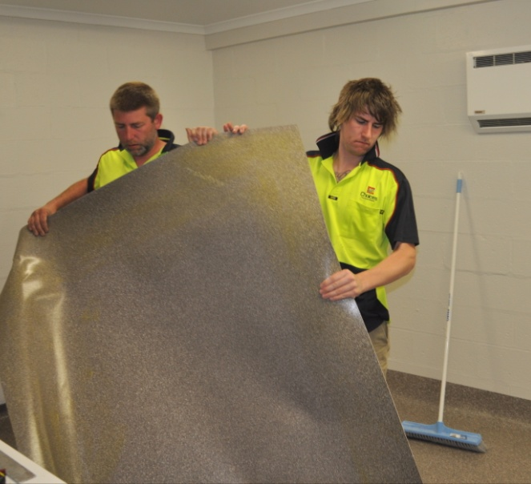If you’re part of a small on-site installation team, you might work side-by-side with your boss and be under their direct supervision throughout the day.

On the other hand, if you work as part of a sales team, you might have a fair degree of independence and simply report back to your boss at particular times.

So the management style of a successful team leader can vary greatly, depending on who the members are and what sort of work they carry out. Good leaders are able to tailor their management style to suit the personalities and skills of each person and bring out their best characteristics.

Again, it’s all about utilising people’s strengths and finding ways to make up for their weaknesses.

##### Learning activity

Think of a good team that you’ve worked in. It might be the one you’re with right now, or it could be a team you were part of in a previous job.

What made it a good team? Write down the characteristics that were most important.

Here are some suggestions to get you started:

* good communication between team members
* everyone knew what their job was in the team
* people got along well and enjoyed each others’ company
* team leader was decisive and knew what he or she was doing.

Share your answers with other learners in your group.

|  |
| --- |
| Being a good team player |

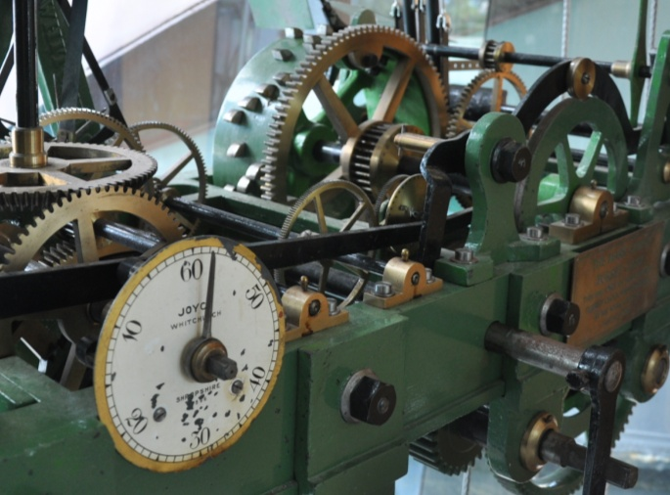Being a team player is like being a cog in a machine – you have to mesh well with the cogs around you so that all the parts can turn smoothly.

If you don’t, then the whole machine will end up feeling the pain, even the parts you’re not directly engaged with.

Below are some of the ways you can be a valuable member of your work team.

### Be cooperative

Teamwork is all about cooperation. If you support the group effort, do the work that’s expected of you, and pitch in to help others when needed, you’ll be held in high regard by the other team members.

Being cooperative also includes keeping your sense of humour when things go wrong or the work becomes difficult. Remember, it’s when the going gets tough that people show their real character.

### Respect the other team members

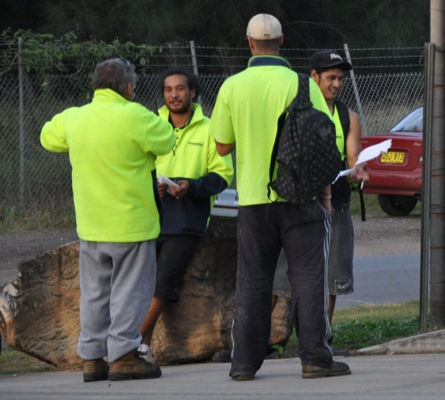You don’t have to be friends with everyone in your team, but they all deserve to be   
respected.

Try to be tolerant of people who are different from yourself. Even better – learn to ‘celebrate their diversity’.

You might be surprised at how well you get along with them once you’ve come to understand how they tick.

The same applies to the way you work alongside other tradespeople at the jobsite. On large projects, you’ll often have to cooperate with plumbers, electricians, painters, plasterers and other specialist installers so you can all do your job efficiently without slowing down or damaging each other’s work.

### Share important information

Sometimes you may have an issue that other people need to know about, such as a medical problem that’s affecting your work or an appointment that will require you to leave early. Or you might be having trouble concentrating at work because you’re very worried about something that’s happening at home.

Always tell your boss or supervisor if there is an issue that could affect the way they plan the day, or that would help to explain your behaviour. Don’t bottle it up, because it will only make you feel more stressed while they don’t know, especially if your boss ends up saying: ‘Why didn’t you tell me before?’

### Ask for help when you need it

Some people find it awkward to ask for help, particularly if they’re a new trainee or the youngest member of the team.

But it’s in everyone’s interest for people to support each other, because they all want to get the job done properly and finished on time.

Here are some hints on how to ask for help:

* Find the right person for the question you want to ask, and use their name.
* Wait until you’ve got their attention before you explain the details – don’t talk on while they’re focused on something else.
* Be clear about your request, and exactly what you’re asking them to do. Where possible, give them some notice if you need their help, so they can plan their time.
* If they can’t come straight away, agree on a more suitable time or work out another solution to the problem.
* Thank them when you’ve finished.

### Plan your time

Most projects need to be completed in stages, with each stage having its own place in the overall sequence. So although there’s likely to be a whole range of tasks that have to be done, they still need to be tackled in order of priority for the job to run smoothly.

The first thing you should do when you start any job is to plan your time and decide on the order of priorities. Below is a simple procedure you can use to plan out a job and manage your time.

1. 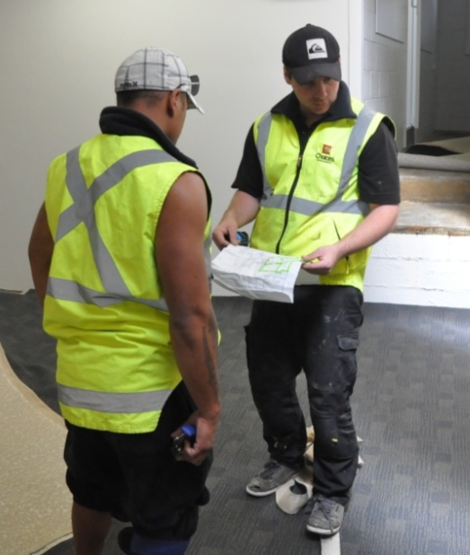Find out whathas to be done and whenit needs to be done by.
2. Work out what equipment you’ll need, the materials required, and whether anyone else will be involved.
3. Think about any problems or hold-ups that might affect your progress.
4. Think through the most practical course of action for doing the job, making allowances for the problems you need to look out for.
5. Work out a set of steps and the orderthey need to be done in.
6. Double-check your steps, writing them down if necessary, to make sure you haven’t missed out anything or got any of the tasks in the wrong order.
7. Start the job and monitor your progress. If anything doesn’t go according to plan, be flexible and make adjustments as you go.

### Take pride in your work

You may have heard the old quotation:

*The quality is remembered long after the price is forgotten.*

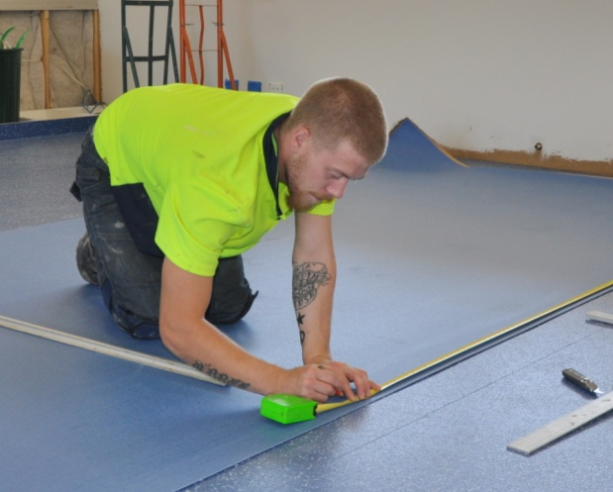Clients remember quality, because it’s what they see every time they look at the job you did for them.

It’s also what they’ll comment on most when they talk about your work to other people.

If you maintain high standards and pay attention to detail, you’ll be able to stand back at the end of a day’s work and be proud of what you’ve achieved.

Your boss will also take notice of your performance, and be more likely to give you new responsibilities or opportunities for promotion.

##### Learning activity

It’s not just the boss who needs to practise good time management. For any team to work productively, everyone on board has to know how to manage their time effectively.

What are the three biggest time wasters in your day? Write them down in your Workbook. Beside each one, write down how you could reduce the time it gobbles up during the day.

The issues you raise might include: getting equipment organised, looking for missing tools, waiting for an offsider to come and help, waiting for the boss to tell you what to do next, answering personal mobile phone calls or SMSs.

|  |
| --- |
| Giving and receiving feedback |

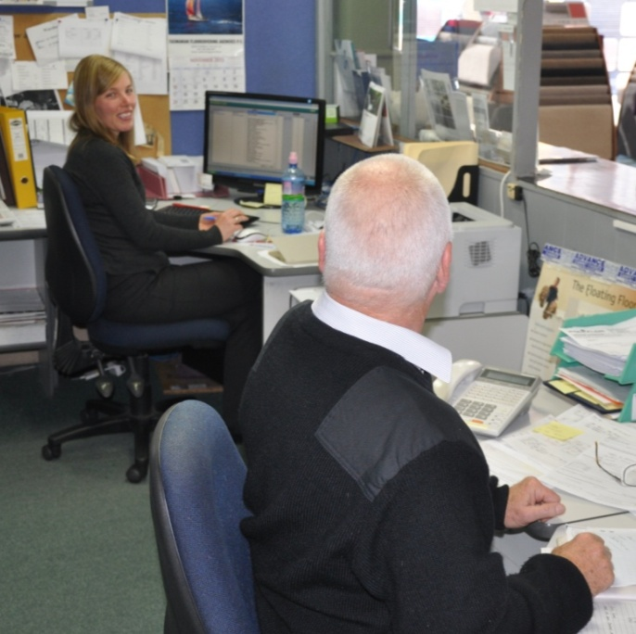How do you know when you’re doing a good job? How do other people know that you’ve understood them correctly?

As we discussed in Section 1, the answer is – through **feedback**.

Giving and receiving feedback is an important part of working with others in a team.

It keeps communication channels open so that everyone understands how they are performing and whether any problems need to be addressed.

### Receiving feedback

Getting positive feedback on the work you’re doing is a real pat on the back. It lets you know you’re on the right track and gives you a boost of confidence.

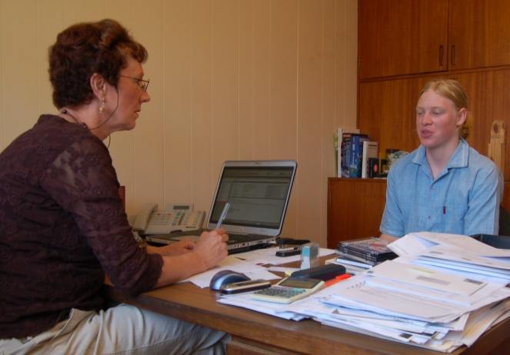On the other side of the coin, getting negative feedback can be a quite a blow to your self-esteem. But if you handle it properly it can help you learn and improve your performance.

By turning critical comments into constructive advice, you will make the most of what you’re being told and grow from the experience.

Here’s some tips for receiving negative feedback in a positive way:

* **nod** to indicate you have understood what the other person is saying
* **ask questions** if you need them to clarify something, and don’t be offended by their answers – try to see the issue from their point of view
* **think** about how you can learn from what they’re saying
* **take steps** to improve your own performance, and ask for further advice if you’re not sure how to apply the feedback you’ve been given.

### Dealing with conflict

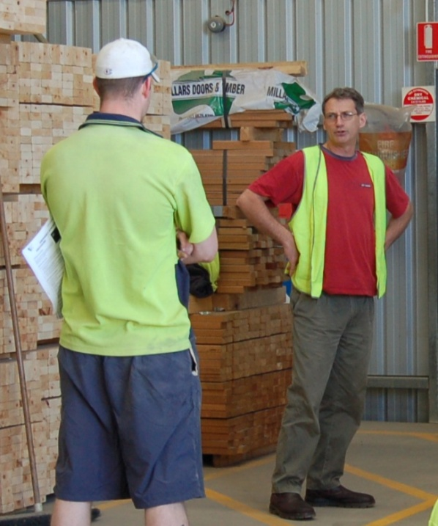Conflict occurs when people can’t resolve their differences. Sometimes it starts with a disagreement over how to go about a job, or who is responsible for a particular issue.

Other times it could be the result of one person rubbing someone else up the wrong way.

In any busy team, people can get touchy when things aren’t going the way they should, or if they’re feeling under pressure to get a job finished on time.

So it’s normal to have a bit of stress or the odd harsh word from time to time.

But if the negative emotions develop into an on-going state of conflict, it can become very unpleasant for the people involved and quite counterproductive for the whole team.

If you do find yourself in conflict with another team member, it’s important to sort out your differences as quickly as possible. Your first response should be to approach them directly and try to resolve it together.

If that fails, you should take the matter to your boss or supervisor. If your boss or supervisor is actually part of the problem, you may need to find another person who can act as a ‘mediator’ for you and discuss the issues on your behalf.

Below are some guidelines on how to handle a conflict situation with another team member.

1. Make sure you have a **clear understanding** of the all the issues involved before you go to them to talk about the problem.
2. Approach them at an appropriate time and say that you’d like to **discuss the matter**. Don’t confront them unexpectedly, or try to have it out while they’re busy doing something else. If need be, arrange a more convenient time to talk it over.
3. Once you start the discussion, **be honest about the issues** and don’t hold back on any gripes that might resurface later. On the other hand, don’t attack them about irrelevant or personal things – make sure you keep to the issues.
4. **Give them a chance** to explain their side of the story, and try not to interrupt them while they’re talking.
5. **Come to an agreement** about what the basic problem is and what would fix it.
6. Once you’re in agreement, talk about what each of you could do to **make amends** and overcome the ill feeling.

##### Learning activity

The more receptive you are to feedback, the more inclined people will be to help you with advice and little hints along the way.

Below are a range of responses you could give to the feedback that you're being offered. Some of these responses are likely to encourage people to continue offering constructive comments in the future. The other responses are more likely to turn them off from wanting to help with further advice.

Rate these responses as 'good' or 'bad', depending on the message they're likely to give the person providing the feedback. Use your Workbook to tick the appropriate box.

1. Maintaining a lot of eye contact and nodding.

Good ❑ Bad ❑

1. Looking at your watch and fidgeting.

Good ❑ Bad ❑

1. Waiting for the other person to finish making their point, even if you want to butt in and disagree.

Good ❑ Bad ❑

1. Folding your arms and looking into the distance.

Good ❑ Bad ❑

|  |
| --- |
| Assignment 2 |

Go to the Workbook for this unit to write your answers to the questions shown below. If you prefer to answer the questions electronically, go to the website version and download the Word document template for this assignment.

\_\_\_\_\_\_\_\_\_\_\_\_\_\_\_\_\_\_\_\_\_\_\_\_\_\_\_\_\_\_\_\_\_\_\_\_\_\_\_\_\_\_\_\_\_\_\_\_\_\_\_\_\_\_\_\_\_\_\_\_\_\_\_\_\_\_\_

Choose a task that you will need to carry out at work. To be suitable for this exercise, the task should:

* involve at least one other member of your work team
* consist of several steps that need to be prioritised
* allow you to make decisions about the way you will manage your own time.

Before you undertake the task, answer the questions below under: 1. Plan.Then carry out the task. Once it’s completed, answer the questions under: 2. Evaluation.

### Plan

(a) What is the task? That is, what do you need to do?

(b) How much time have you been given to do the task?

(c) What materials will you require?

(d) What tools and equipment will you require?

(e) Who else will need to be on hand to help you? What will their role be?

(f) What hold-ups or problems might occur? How will you avoid them?

(g) What steps will you follow to carry out the task? Write down the numbered steps, making allowances for any of the problems you need to look out for.

### 2. Evaluation

(a) Did you complete the job within the timeframe you had allowed?

(b) Did anything not go according to plan? If not, describe what went wrong and how you went about fixing it.

(c) Looking back, is there anything you would have planned differently?

# Practical demonstrations

The checklist below sets out the sorts of things your trainer will be looking for when you undertake the practical demonstrations for these two units. Make sure you talk to your trainer or supervisor about any of the details that you don’t understand, or aren’t ready to demonstrate, before the assessment event is organised. This will give you time to get the hang of the tasks you will need to perform, so that you’ll feel more confident when the time comes to be assessed.

When you are able to tick all of the YES boxes below you will be ready to carry out the practical demonstration component of this unit.

### MSMSUP102: Communicate in the workplace

|  |  |
| --- | --- |
| Performance evidence | YES |
| 1. Listen attentively | ❑ |
| 1. Formulate questions to clarify work requirements or instructions | ❑ |
| 1. Read and interpret workplace information | ❑ |
| 1. Complete workplace forms | ❑ |
| 1. Write legibly and/or use electronic keyboard | ❑ |
| 1. Record and interpret numbers, codes and symbols | ❑ |
| 1. Use clear and concise language in verbal and written communication | ❑ |

### MSMSUP106: Work in a team

|  |  |
| --- | --- |
| Performance evidence | YES |
| 1. Identify own tasks within team requirements | ❑ |
| 1. Identify components of tasks | ❑ |
| 1. Plan, prioritise and organise activities in accordance with instructions | ❑ |
| 1. Use communication and interpersonal skills with team members, team leaders and supervisors | ❑ |
| 1. Complete workplace records | ❑ |