Work documents
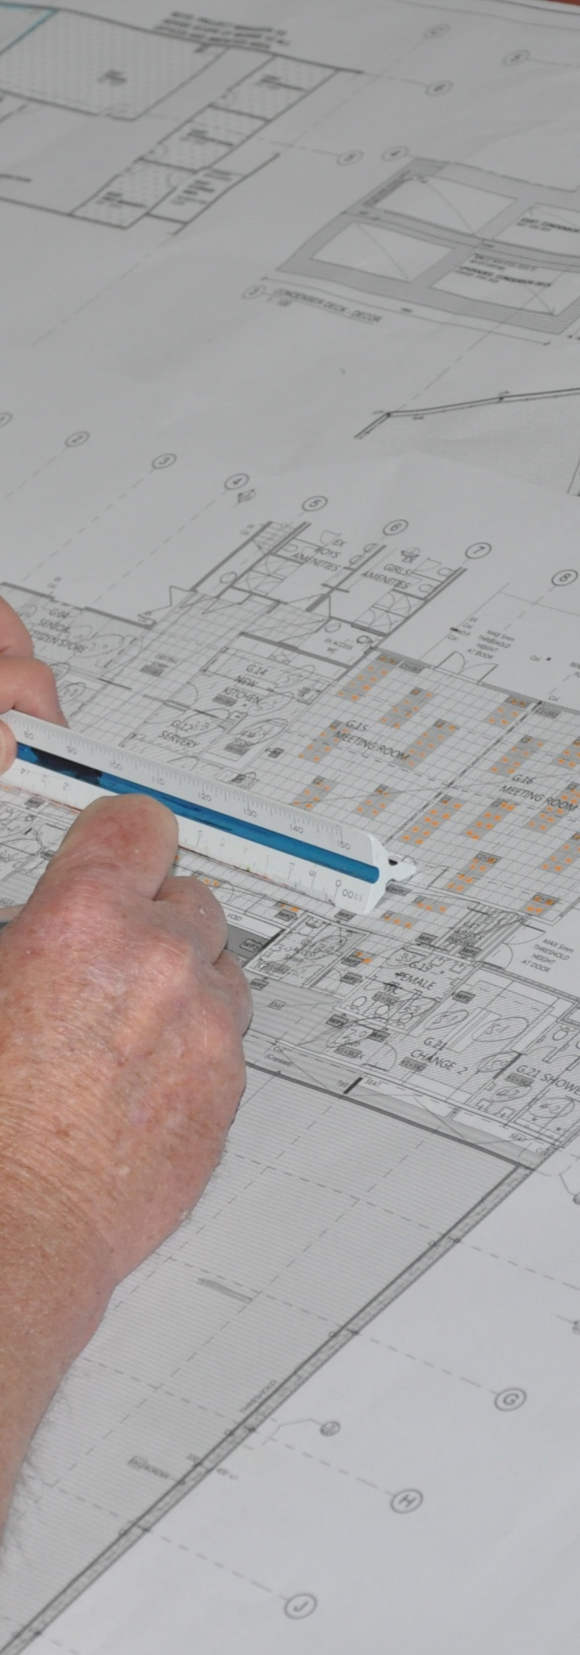
Supporting:
MSFGN3001: Read and interpret work documents
Name:
Workbook

Work documents
Workbook

Containing learning activities and assignments for the unit of competency:
MSFGN3001: Read and interpret work documents

The assignment templates are also available in an electronic ‘Word’ version, downloadable from the INTAR website at:
www.intar.com.au

ISBN: 978-1-925087-50-5
This training resource forms part of the Flooring Technology project, developed and coordinated by INTAR (Industry Network Training and Assessment Resources). To see the on-line versions of the resources available under this project, please go to the INTAR website and follow the links.

Copyright
The original version of this resource was developed by Workspace Training for INTAR members – with the copyright owned by McElvenny Ware Pty Ltd, trading as Workspace Training. Parts of the resource are based on material developed by Workspace Training with funding provided by the Workplace English Language and Literacy (WELL) Program – with copyright owned by the Commonwealth Government under a Creative Commons Attribution-Noncommercial-Share Alike 3.0 Australia Licence. All enquiries regarding copyright should be addressed to:
David McElvenny, Workspace Training, PO Box 1954 Strawberry Hills, NSW, 2012
Email: david@workspacetraining.com.au

Disclaimer
The content of this resource is provided for educational purposes only. No claim is made as to its accuracy or authenticity. The authors, copyright owners and INTAR do not give any warranty nor accept any liability in relation to the information presented in this work.
In all cases, users should consult the original source documents before relying on any information presented in the resource. These source documents include manufacturers’ installation guides, Australian Standards, codes of practice and other materials produced by specialist industry bodies and government agencies.

Acknowledgements
The INTAR project team comprises the following people: David McElvenny (Workspace Training) – lead writer and project manager; Kath Ware (Workspace Training) – instructional designer and graphic artist, Jim Vaughan (VCSS) – technical developer and programmer; Alex Vaughan (VCSS) – assistant programmer and voice-over narrator.
All line drawn graphics were produced by Kath Ware. Many of these graphics are based on line drawings or photographs from installation manuals published by floor covering manufacturers.
Most of the on-site work photos were taken by David McElvenny. Some photos showing product samples were supplied by manufacturers, as acknowledged in the text or photo.
Many TAFE teachers, RTO trainers and industry experts have been involved in the development of this resource. Particular thanks go to the following people for providing learning materials, technical advice and feedback:
Craig Bennett – Hunter Institute of TAFE (NSW)
Steven Dalton – Marleston TAFE
Bruce Ottens – Holmesglen TAFE (Victoria)
Chris Shaw – TasTAFE (Tasmania)
William Tree – ACFIT (NSW)
Mark Willis – Armstrong Flooring

Table of contents
Introduction 1
Part 1 Learning activities 3
Section 1: Working drawings 5
Section 2: Other documents 9
Part 2 Assignments 11
Assignment 1 13
Assignment 2 15
Practical demonstrations 20

Introduction
Work documents is a ‘learning unit’ from the Flooring Technology training resource. It supports the following competency from the Certificate III in Flooring Technology (MSF30813):
- MSFGN3001: Read and interpret work documents
To be assessed as competent, your assessor will use a range of methods to check your understanding of the concepts presented in the Learner guide for this unit and your ability to apply these principles at work.
These may include:
- written assignments
- practical demonstrations
- on-the-job discussions about how you go about particular activities
- learning activities undertaken while you’re progressing through the unit
- log book or work diary.

Literacy, numeracy and computer skills
Literacy is the ability to read and write. To complete this qualification, you will need sufficient literacy skills to produce a range of workplace documents. You will also need the skills to be able to read and understand documents such as order forms, installation instructions, project briefs and safe operating procedures.
Numeracy is the ability to work with numbers. Flooring installers need to do lots of measure-ups and calculations, so there will be many opportunities for you to learn and practise your numeracy skills.
When it comes to completing the written assignments for this qualification, a certain level of literacy ability is required to read the questions and write down your answers. There will also be times when you are asked to generate documents on a computer.
Obviously, it’s important that you clearly understand what the assignment is asking you to do, and that your work is a good reflection of what you really know. So if you’re having trouble reading the questions, writing down your answers, or using certain computer programs, make sure you speak to your trainer before you hand the assignment in.
There are various ways your trainer can help you. For example, they may be able to ask the assignment questions verbally and help you to write down your answers. They may also be able to show you sample answers to similar questions, which will let you look at the way they’re written and give you hints on how to write your own. You may also be allowed to do the assignment with the assistance of another person.

Applying for RPL
RPL stands for Recognition of Prior Learning. It is a form of assessment that acknowledges the skills and knowledge you have gained through:
- on-the-job experience
- formal training in other courses
- life experience, through your hobbies or other outside activities.
If you believe that you are already competent in some or all of the skills covered in this unit, ask your assessor about how to apply for RPL.

Using this workbook
All of the lessons in the Learner guide for this unit have learning activities at the end. Their purpose is to provide discussion points and questions to help reinforce your understanding of the concepts being presented.
There are also a range of assignments, which appear at the end of each section. These are designed to test your knowledge of the subject matter and ability to submit written responses in an acceptable format.
This workbook reproduces all of the learning activities and assignments in a format that lets you handwrite your answers to the questions.
Note that your trainer may ask you to produce a computer-generated document for all of the formal assignments, either printed out in hard copy or submitted electronically. To do this, go to the website version of the unit and look for the Assignment link in each section. This will allow you to type your answers into the ‘Word’ document and then either print it out or email it direct to your trainer as an attachment.
You may also be asked to share your learning activity answers electronically, especially if you are undertaking this unit by distance learning and are linked up with fellow students in other locations. This might be done through group emails or via a social networking site such as Facebook. In these cases, you should use the website resource rather than this workbook.

Part 1

Learning activities

Section 1: Working drawings

Building plans
Below is the South Elevation of the house that we looked at in the plans in the Learner guide. The numbers along the roof indicate the different rooms across the back of the house.
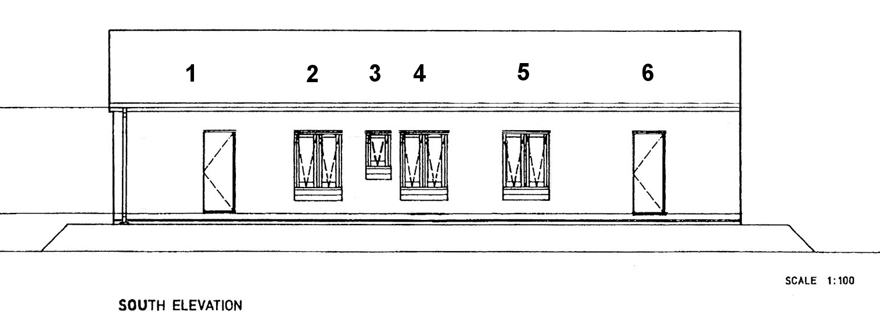
Use the floor plan on page 7 of the Learner guide to identify the rooms that correspond to these numbers. Write your answers in the table below.

Number | Corresponding room
1
2
3
4
5
6

Architectural conventions
The drawings below show a rear elevation and 3D view of a kitchen project. Use a separate sheet of paper to do a simple sketch of the floor plan, using only these two drawings as a guide. There is no need to mark in the dimensions, but try to draw to scale as accurately as possible.
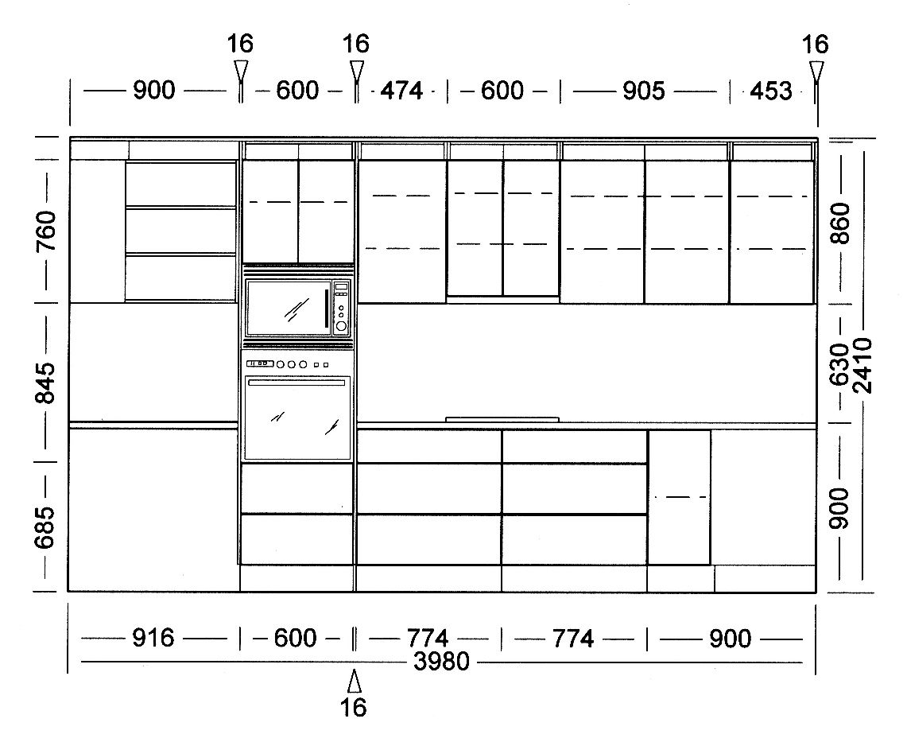
When you have finished, go back to page 7 of the Learner guide to see how your drawing compares with the original floor plan.

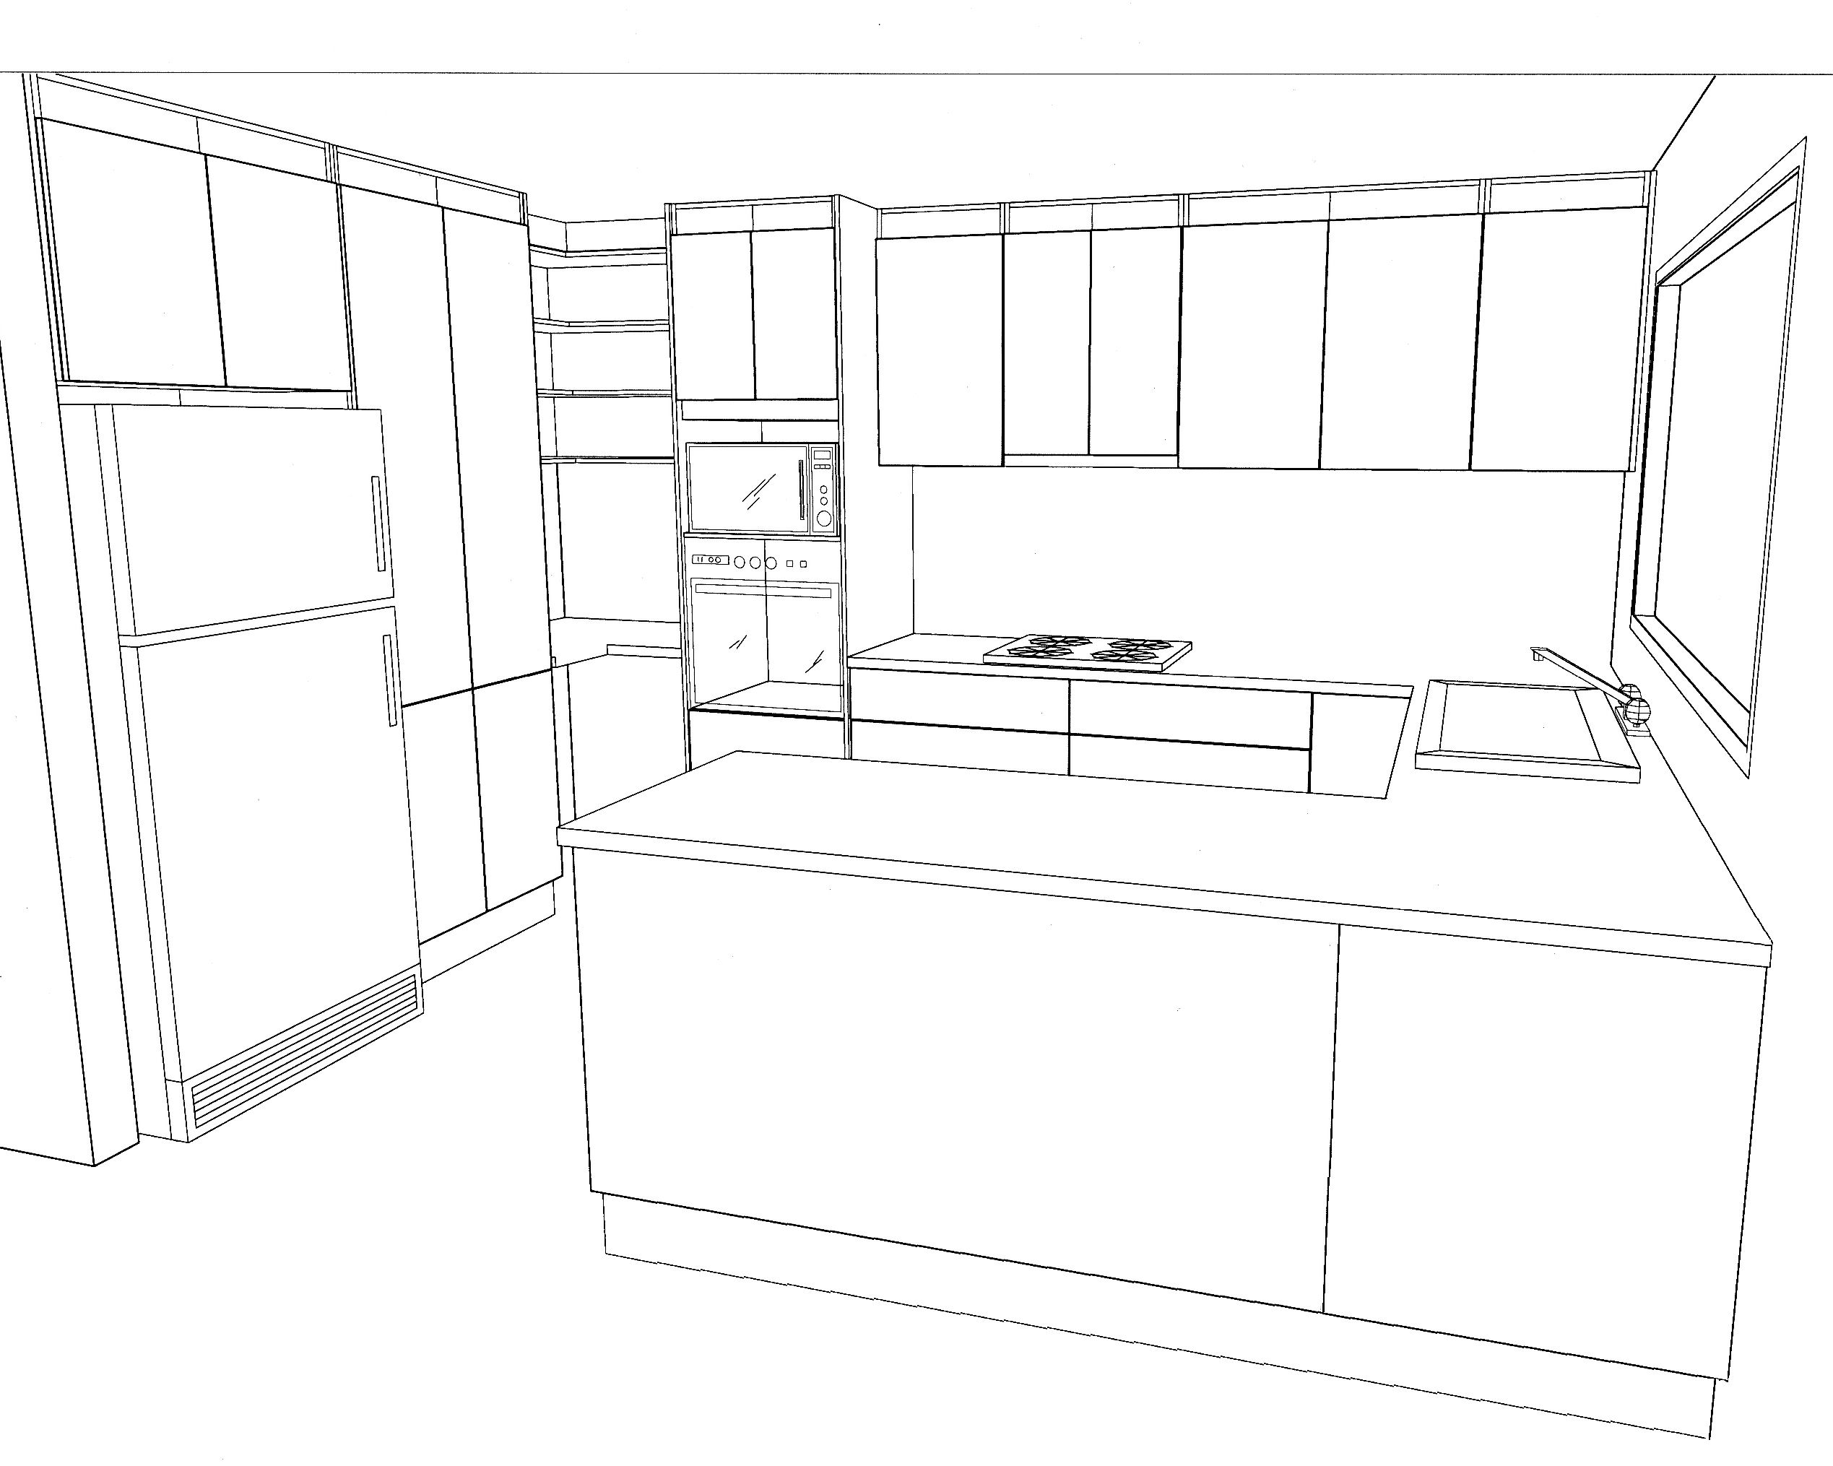

Key information on plans
Below is an excerpt from the floor plan we looked at on page 7 in the Learner guide.
Write out the full name for each of the abbreviations listed in the table underneath the plan. Try to do this task without referring to the abbreviation list in the Learner guide. If you get stuck on any of the abbreviations, you may refer to the list once you’ve finished writing in the answers you know.

Abbreviation | Meaning | Abbreviation | Meaning
FW |  | R
S |  | WC
WM |  | WR
CT |  | CPT

Floor covering plans
Draw a simple floor covering plan below in the form of a proportional sketch.
You may either draw Bedroom 3 in the building plan shown on page 7 of the Learner guide, or choose one or more of the other rooms if you want a more challenging exercise. Alternatively, if you have a tape measure to hand, you may draw up the room you are sitting in right now.
Mark all relevant measurements on the inside of the walls. You may draw the lines freehand or use a ruler if you prefer.

Section 2: Other documents

Standards and specifications
Which Australian Standards do you need to refer to in your day-to-day work?
Are there any other standards you use that aren’t listed on page 27 of the Learner guide? If so, what are they?

Work procedures
Do you use cutting lists for any products? For example, you might use them to pre-cut inlay pieces or pre-formed coving. On larger jobs, you might use them to cut rolls of material to a range of different lengths.
Describe the situations where you have used them and what the cutting list looked like.

Planning and checking
Have you ever found a discrepancy between two documents, or seen something that looked like a mistake in a plan or specification? What were the circumstances? Who did you check with to resolve the problem?
If you haven’t had this experience, describe what you would do if you found a problem in the plans or specifications you were working with.

Maintaining files
Are you responsible for looking after particular documents at work? What are they?
Name each document and briefly describe its purpose and where you store it when it’s not being used.
Document name | Purpose | Where stored

Part 2

Assignments

Assignment 1
Your trainer will give you a set of plans for a floor covering project. You will be asked to find the answers to a range of questions about the project by referring to the plans.
The questions will cover the following details:
- types of floor coverings to be installed
- dimensions of specific rooms
- widths of doorways and other openings
- which way the doors swing (that is, which side the hinges are on)
- structure of the walls and floor
- various details about the floor covering installation.

Assignment 2

Name |  | Date
List 10 different types of documents that you use at work. There must be at least one example of each of the following documents:
- Australian Standard
- manufacturer’s installation guidelines or technical manual
- material safety data sheet
- work plan, project schedule or equivalent
- building code or project specification
- safe operating procedure or equivalent
- safe work method statement, job safety analysis or equivalent
For each of the documents you have chosen, answer the following questions:
- What is the full title of the document?
- What is its purpose?
- Who is responsible for looking after it and making sure the employees are using the latest version? (Give the job title of the person, not their name.)
- What is the version control system – that is, how do you know you’re looking at the latest version?
- Where is it kept at your workplace, and if there are multiple copies, who has copies? (Give the job titles of the people who have their own copies.)
- Who would you consult if you were out on-site and had a query about a detail in the document? (Give the job title or role of the person you would consult.)
Use the tables on the following pages to complete your answers.
Document 1
Title
Purpose
Person responsible
Version control
Where kept / who has copies
Who to consult

Document 2
Title
Purpose
Person responsible
Version control
Where kept / who has copies
Who to consult

Document 3
Title
Purpose
Person responsible
Version control
Where kept / who has copies
Who to consult

Document 4
Title
Purpose
Person responsible
Version control
Where kept / who has copies
Who to consult

Document 5
Title
Purpose
Person responsible
Version control
Where kept / who has copies
Who to consult

Document 6
Title
Purpose
Person responsible
Version control
Where kept / who has copies
Who to consult

Document 7
Title
Purpose
Person responsible
Version control
Where kept / who has copies
Who to consult

Document 8
Title
Purpose
Person responsible
Version control
Where kept / who has copies
Who to consult

Document 9
Title
Purpose
Person responsible
Version control
Where kept / who has copies
Who to consult

Document 10
Title
Purpose
Person responsible
Version control
Where kept / who has copies
Who to consult

Practical demonstrations
The checklist below sets out the sorts of things your trainer will be looking for when you undertake the practical demonstrations for this unit. Make sure you talk to your trainer or supervisor about any of the details that you don’t understand, or aren’t ready to demonstrate, before the assessment event is organised. This will give you time to get the hang of the tasks you will need to perform, so that you’ll feel more confident when the time comes to be assessed.
When you are able to tick all of the YES boxes below you will be ready to carry out the practical demonstration component of this unit.
Specific performance evidence | YES
Explain the meanings of symbols, terms and conventions in specifications and plans
Locate, read and interpret a minimum of 10 different work documents, including:
- Australian Standards relevant to flooring technology
- manufacturer technical instructions and specifications
- real or simulated local work documents, including:
- work plans
- material safety data sheets (MSDS)
- relevant building codes
- job procedures
- safe work instructions or equivalent

General performance evidence | YES
- Identify key information in documents, e.g. title, version, scale, legend and keys
- Locate and evaluate additional information needed to interpret particular documents
- Clarify details to confirm the document’s intention, where necessary
- Correctly interpret symbols, abbreviations, acronyms, technical terms and other information
- Use industry-recognised terms to describe design and style features in drawings
- Consult documents to identify work sequence, tools and equipment, tasks to be performed, and stages where checks must be made against specifications
- Check specifications for accuracy and rectify any errors
- Handle documents and plans carefully and keep them in good condition
- Keep explanatory notes or additional information with the original documentation
- File away documents after use, according to workplace procedures

