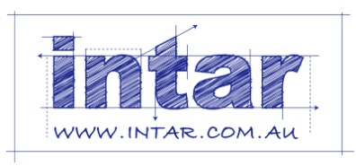
Supporting: MSFFM2001 Use furniture making hand and power tools

Section 1 Assignment: Types of tools
Name |  | Date
Choose three hand tools you use at work that don’t require a power source other than your own muscles.
For each tool answer the questions below using the tables provided on the following pages.
- What type of tool is it?
- Who is the manufacturer and what is the brand name of the tool?
- What is its main purpose?
- What secondary functions does the tool have (if any)? That is, does the tool have any other features, attachments or uses?
- What personal protective equipment should you wear when you are using the tool (if any)? For example, do you need to wear safety glasses, gloves, dust mask, etc. If you only need to wear PPE for certain types of jobs, state the item of PPE and briefly describe when it would be required.
- Does the tool have any fragile or delicate parts that need to be protected? If so, how do you protect them, and how do you carry the tool to the jobsite?
- Does the tool have any parts that are designed to wear out and be replaced on a regular basis? For example, you may need to carry spare blades, cutters, tips, etc. What are these replacement parts, and how do you carry them with you to the jobsite?
- Do you need to carry any other equipment or maintenance item to the site to keep the tool operational? For example, do you need to have a sharpening stone, oil, grease or other item in your toolbox to keep it working properly?
- What checks do you need to carry out before you use the tool? These may include safety checks, adjustments, inspections on the sharpness of blades, tightening of screws, etc.
- What are the main things that can go wrong with the tool? For each problem you state, briefly describe how you would fix it, or whether the problem would mean that the tool must be put in for repair or thrown out.

Tool 1
1. Type of tool
2. Manufacturer
3. Brand name
4. Main purpose
5. Secondary functions
6. PPE required
7. Replacement parts / storage and carrying
8. Support equipment required
9. Pre-operational checks
10. Problems and solutions

Tool 2
1. Type of tool
2. Manufacturer
3. Brand name
4. Main purpose
5. Secondary functions
6. PPE required
7. Replacement parts / storage and carrying
8. Support equipment required
9. Pre-operational checks
10. Problems and solutions

Tool 3
1. Type of tool
2. Manufacturer
3. Brand name
4. Main purpose
5. Secondary functions
6. PPE required
7. Replacement parts / storage and carrying
8. Support equipment required
9. Pre-operational checks
10. Problems and solutions

