Supporting: MSMWHS200 Work safely
MSFFL3002 Establish and maintain a safe flooring technology work environment
TLID2003 Handle dangerous goods/hazardous substances

Section 4 Assignment: Dealing with emergencies
Name |  | Date
Answer the following questions in relation to the emergency evacuation procedure at your own workplace (or alternatively at a building site you have worked at recently).
- Where is the emergency assembly area?
- What is the signal for an emergency evacuation (for example, is it three bursts of the hooter)?
- Briefly describe the procedure that people must follow for an emergency evacuation.
- Complete the table below for each of the fire extinguishers shown.

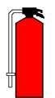 | Contents:
 | Designed for:
 | Not suitable for:

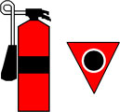 | Contents:
 | Designed for:
 | Not suitable for:

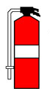 | Contents:
 | Designed for:
 | Not suitable for:

