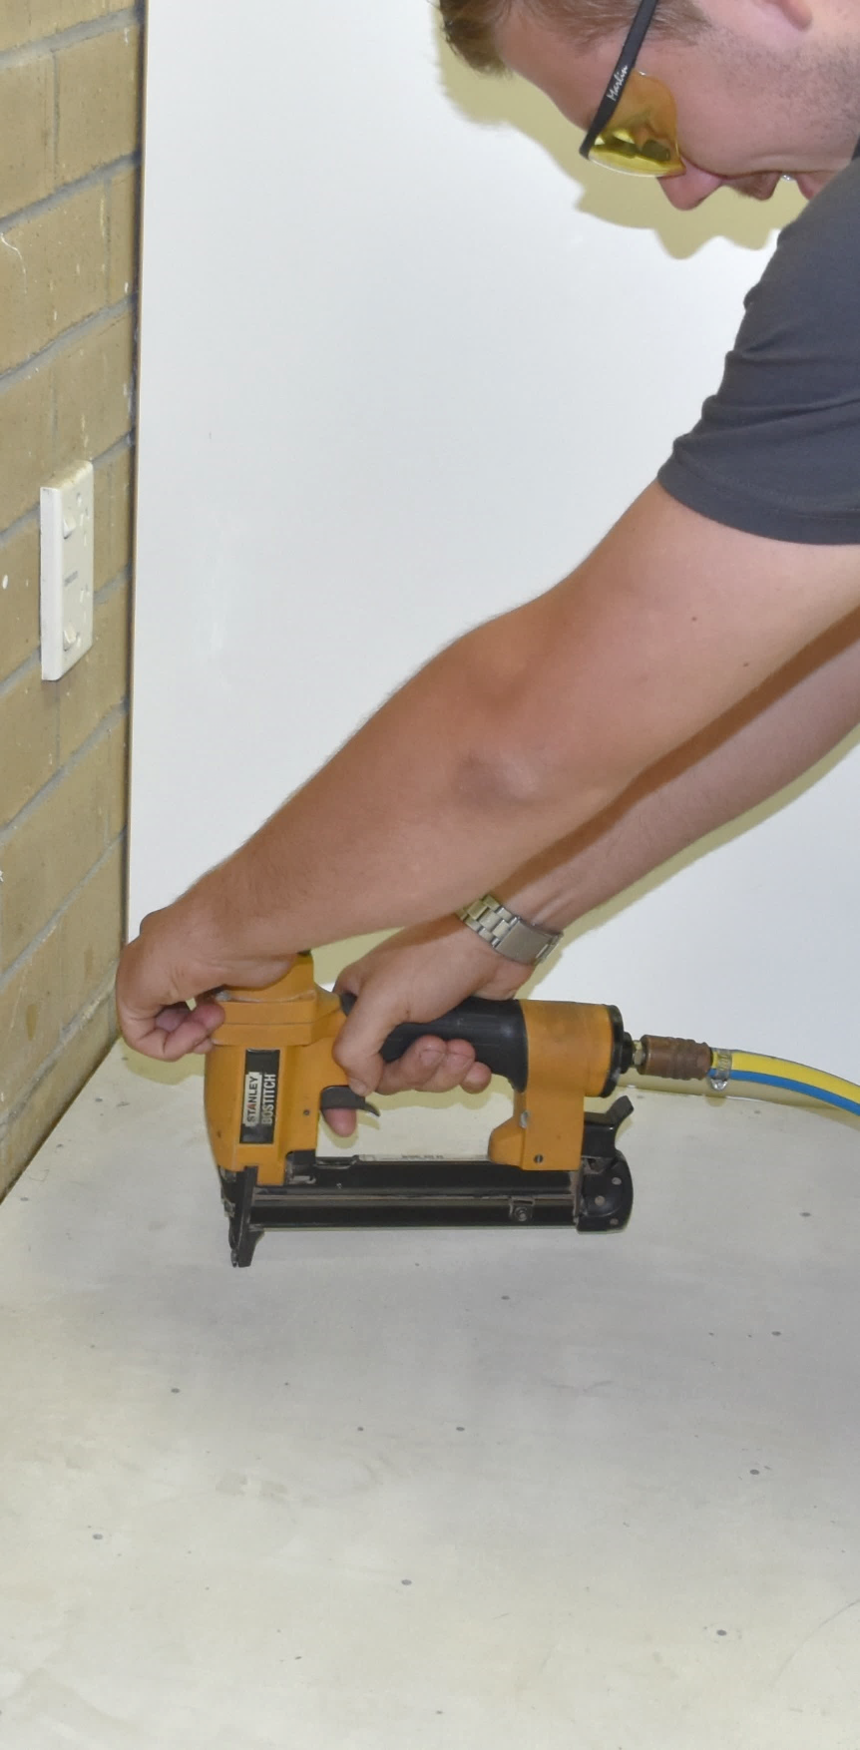

Hard underlays

**Supporting:**

***MSFFL2033***

***Install hard underlays***



**To be used in conjunction with the Learner Guide for this unit**

**Student Workbook**

Name: Date of issue:

**Version: February 2020**

Hard underlays

Student Workbook



This Workbook accompanies the Learner guide for ‘Hard underlays’. It has been developed by Industry Network Training and Assessment Resources (INTAR) for the National Flooring Trainers Network (NFTN).

Its purpose is to help apprentice floor layers, sales staff and other workers to acquire the background knowledge needed to satisfy the theoretical components of the competency: *MSFFL2033 Install hard underlays*.

It is not designed to replace the practical training necessary to develop the hands-on skills required.

© 2020 INTAR, NFTN



**Copyright**

Copyright in this resource is owned jointly by Industry Network Training and Assessment Resources (INTAR) and the National Flooring Trainers Network (NFTN).

All enquiries about the resource should be addressed to the project manager:

David McElvenny   
INTAR   
PO Box 1954 Strawberry Hills, NSW, 2012

Email: [david@intar.com.au](mailto:david@intar.com.au)

**Disclaimer**

The content of this resource is provided for educational purposes only. No claim is made as to its accuracy or authenticity. The authors and copyright owners do not give any warranty nor accept any liability in relation to the information presented in this work.

In all cases, users should consult the original source documents before relying on any information presented in the resource. These source documents include manufacturers’ installation guides, Australian Standards, codes of practice and other materials produced by specialist industry bodies and government agencies.

**Acknowledgements**

All line drawn graphics were produced by Kath Ware (Workspace Training). Many of these graphics are based on drawings from old ABC learner guides, plus the source documents listed at the bottom of this page.

All photographs were taken by David McElvenny (Workspace Training). Some of the photos used in Section 1 come from other Learner guides in the Flooring Technology suite of resources and are acknowledged in those guides. See the ‘Introduction’ chapter for the list of references to these background resources.

Below are the members of the technical advisory team, who contributed the original content material for the text and provided technical advice throughout the development and review process.

Craig Bennett –TAFE NSW

Maugan Courtney – SkillsTech Institute of TAFE (Queensland)

Ben Hallifax – Tonsley TAFE (South Australia)

Chris Belcher – TasTAFE (Tasmania)

Ian Ciesla – WA TAFE (Western Australia)

Colleen Carters – Holmesglen Institute of TAFE (Victoria)

Allan Firth – Carpet Institute of Australia Limited

Geoffrey Robinson – Carpet Institute of Australia Limited

**Source documents**

The following source documents were used for technical information during the development of this resource.

* *Masonite Underlay* (Masonite)
* *Underlay Installation Guide* (James Hardie).

## Table of contents

Introduction 1

Assessment evidence checklists 3

Section 1: Products and fasteners 5

Section 2: Tools and site safety 7

Section 3: Installation procedures 12

## Introduction

*Hard underlays* is a ‘learning unit’ from the Flooring Technology training resource. It supports the following competency from the *Certificate III in Flooring Technology*:

* *MSFFL2033 Install hard underlays*

**Using this workbook**

All of the lessons in the Learner guide for this unit have learning activities at the end. Their purpose is to test your knowledge of the subject matter and reinforce your understanding of the concepts being presented.

This workbook reproduces all of the learning activities in a format that lets you handwrite your answers to the questions. Your assessor will use this workbook as one of the evidence requirements for demonstrating competence in the unit.

**How you will be assessed**

To be assessed as competent in this unit, your assessor will use a range of methods to evaluate your practical skills and understanding of the concepts relating to the installation of hard underlays.

In addition to this workbook, your assessor will also use one or more of the following assessment methods to collect evidence of your competence:

* practical demonstrations of direct stick and dual bond carpet installations
* on-the-job discussions about how you go about particular activities
* log book or work diary
* reports from your workplace supervisor.

See the next chapter – ‘Assessment evidence checklists’ – for a summary of the skills and knowledge you will need to demonstrate in your various assessment activities.

**Literacy, numeracy and computer skills**

Literacy is the ability to read and write. To complete this qualification, you will need sufficient literacy skills to fill in a range of workplace documents and complete the learning activities. You will also need the skills to be able to read and understand documents such as order forms, installation instructions and safe operating procedures.

Numeracy is the ability to work with numbers. Flooring installers need to do lots of measure-ups and calculations, so there will be many opportunities for you to learn and practise your numeracy skills.

When it comes to completing the learning activities for this qualification, a certain level of literacy ability is required to read the questions and write down your answers.

If you have any trouble reading the questions or writing down your answers, make sure you speak to your trainer before you hand the workbook in.

There are various ways your trainer can help you. For example, they may be able to ask the questions verbally and help you to write down your answers. They may also be able to show you sample answers to similar questions, which will let you look at the way they’re written and give you hints on how to write your own.

**Applying for RPL**

RPL stands for **Recognition of Prior Learning.** It is aform of assessment that acknowledges the skills and knowledge you have gained through:

* on-the-job experience
* formal training in other courses
* life experience, through your hobbies or other outside activities.

If you believe that you are already competent in some or all of the skills covered in this unit, ask your assessor about how to apply for RPL.

## Assessment evidence checklists

The checklists below set out the sorts of things your trainer will be looking for when you undertake the practical demonstrations and knowledge tests for this unit.

Make sure you talk to your trainer or supervisor about any of the details that you don’t understand, or aren’t ready to demonstrate, before the assessment events are organised. This will give you time to get the hang of the tasks you will need to perform, so that you’ll feel more confident when the time comes to be assessed.

**Performance evidence**

When you are able to tick all of the YES boxes below you will be ready to carry out the practical demonstration components of this unit.

| **Specific demonstration requirements** (from competency ‘Performance evidence’) | **YES** |
| --- | --- |
| Complete two hard underlay installations using 5.5 mm boards, with:   * one installation requiring adhesive and fasteners fixed to the subfloor * one installation requiring fasteners only fixed to a timber subfloor | ❑  ❑ |

| **General performance criteria** (from competency ‘Elements and performance criteria’) | **YES** |
| --- | --- |
| Follow safe work practices and site procedures | ❑ |
| Assess subfloor condition and suitability for underlay installation | ❑ |
| Select appropriate underlay, adhesive, fixings and tools for the job | ❑ |
| Plan the work to maximise efficiency and minimise waste | ❑ |
| Acclimatise the underlay (where required) | ❑ |
| Cut and install the underlay according to standards and site requirements | ❑ |
| Inspect finished job, clean up site and complete necessary documentation | ❑ |

**Knowledge evidence**

Many of the knowledge evidence requirements will be assessed progressively as you work through the unit. However, you may also be asked to complete a written test as a final assessment of your knowledge and understanding of the concepts.

When you are able to tick all of the YES boxes below you will be ready to undertake the final written test for this unit.

|  |  |
| --- | --- |
| **Background knowledge** (from competency ‘Knowledge evidence’) | **YES** |
| Calculations for estimating material quantities | ❑ |
| Safe work procedures, WHS regulations and site procedures | ❑ |
| Environmental care procedures | ❑ |
| Methods for accessing information, including manufacturer’s guidelines | ❑ |
| Types of underlay products and their characteristics, uses and limitations | ❑ |
| Tools required to carry out underlay installations | ❑ |
| Laying techniques and quality requirements | ❑ |
| Methods for maintaining and recording information | ❑ |

#### Section 1: Products and fasteners

### 1. Medium density fibreboard

Why do you think MDF is not recommended for floors in wet areas? What would happen to the MDF board if it got wet?

|  |
| --- |
|  |

### 2. Plywood

Let’s say the plywood sheets shown in the two images below are 2400 x 1200 in size. You can see that one stack is neat and tidy, and the other is terrible.

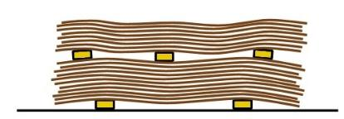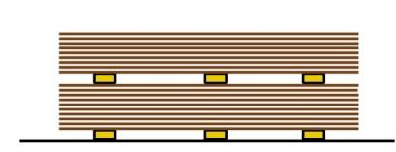

What makes the stack on the left-hand side so much better than the one on the right? In other words – if you were unloading a delivery of large plywood sheets by hand, how would you prepare the stack and ensure that the sheets stayed straight and flat? You may write your answer down in dot points.

|  |
| --- |
|  |

### 3. Hardboard

Borg Manufacturing describes its HPF (high performance fibreboard) hardboard underlay as an ‘environmentally friendly’ product.

Why is hardboard considered to be environmentally friendly?

|  |
| --- |
|  |

### 4. Fibre cement

Fibre cement sheets are so called because they are basically made of sand and cement with a reinforcing fibre to hold the compound together. Traditionally, the reinforcing fibre was asbestos.

What type of fibre is used in modern fibre cement sheets, and where does it come from?

|  |
| --- |
|  |

### 5. Fasteners

Below are some combinations of underlay and subfloor. For each one, indicate which fixings you will use (including adhesive, where required), and specify the actual size and description of the fasteners.

You may use manufacturer’s brand names if you wish. You may also assume that the subfloor is in good condition and ready for the underlay installation.

1. 5.5 mm hardboard underlay fixed to Baltic pine 19 mm thick floor boards

|  |
| --- |
|  |

1. 12 mm plywood underlay fixed to hardwood 19 mm thick floor boards

|  |
| --- |
|  |

1. 5 mm MDF underlay fixed to particleboard flooring (Yellow tongue) 19 mm thick

|  |
| --- |
|  |

1. 5 mm fibre cement underlay fixed to concrete slab subfloor (cured and patched)

|  |
| --- |
|  |

1. 5.5 mm hardboard underlay fixed to concrete slab subfloor (cured and patched)

|  |
| --- |
|  |

#### Section 2: Tools and site safety

### 1. Tools and equipment

The Learner guide shows a range of tools commonly used by floor layers to install hard underlays.

1. Are there any of these tools that you’re not familiar with or haven’t used before? Which ones are they?

|  |
| --- |
|  |

1. Are there any additional tools that you have used on-site for hard underlay installations that aren’t shown in the Learner guide? What are they, and what do you use them for?

|  |
| --- |
|  |

### 2. General health and safety

Do an informal risk assessment right now, either in the room you’re in at the moment or in a nearby room or area. Imagine that you have just arrived at the jobsite and are carrying out a site assessment, in preparation for a hard underlay installation.

Use the following steps:

1. Identify the potential hazards in the area, including accessways and the outside parking area (which you will need for arriving in your vehicle and bringing in the underlay sheets and tools).

2. Assess the risks of these hazards causing an injury or serious problem – you may use a simple scale, such as: H (high risk), M (medium risk) and L (low risk).

3. Decide on suitable control measures to address the risks, making sure that your controls are in keeping with the level of risk associated with each of the hazards you’ve identified.

Write down your findings in the risk assessment table on the next page.

|  |  |  |
| --- | --- | --- |
| **Hazards** | **Risk rating** | **Control measures** |
|  |  |  |
|  |  |  |
|  |  |  |
|  |  |  |
|  |  |  |
|  |  |  |
|  |  |  |

### 3. Using power tools safely

Choose the most hazardous power tool that you regularly use at work, and answer the following questions.

(a) What type of tool is it?

|  |
| --- |
|  |

(b) What is its power source?

|  |
| --- |
|  |

(c) What would you consider to be the top two safety issues that should be kept in mind when using this tool?

|  |
| --- |
| 1. |
| 2. |

### 4. Power sources

Choose a hand-held power tool you’re familiar with that is available in both cordless and main power versions. Answer the following questions.

(a) What type of tool is it?

|  |
| --- |
|  |

(b) What are two advantages of the cordless version (over the 240-volt version) when you’re using the tool on-site?

|  |
| --- |
| 1. |
| 2. |

(c) What are two disadvantages of the cordless version when you’re using it on-site?

|  |
| --- |
| 1. |
| 2. |

### 5. Drill operation

The drawings below show four different types of drill bits – spade bit, twist drill, masonry bit and hole saw.

Write the correct name for each drill bit under its corresponding drawing. Then indicate which types of materials it is suitable for drilling into by ticking the correct box or boxes.

|  |  |  |  |  |
| --- | --- | --- | --- | --- |
|  |  |  |  |  |
| **Name of drill bit:** |  |  |  |  |
| **Suitable for drilling:** | ❑ wood  ❑ metal  ❑ fibre cement  ❑ concrete | ❑ wood  ❑ metal  ❑ fibre cement  ❑ concrete | ❑ wood  ❑ metal  ❑ fibre cement  ❑ concrete | ❑ wood  ❑ metal  ❑ fibre cement  ❑ concrete |

### 6. Jigsaw operation

Do some research on the different blades available for your own jigsaw, or the one you’re using in your training sessions.

Write down the main distinguishing features of the different blades. Also describe which materials each blade is designed to cut.

|  |
| --- |
|  |

### 7. Planer operation

What would you do if you needed to plane 3 mm off the surface of an old cypress pine floor, and the nails were flush with the surface of the boards?

Describe the procedure and hand tool (or tools) you would need to solve this problem.

|  |
| --- |
|  |

### 8. Circular saw operation

The photo in the Learner Guide shows an installer cutting a board product supported on saw stools. Let’s say you didn’t have saw stools at the job site and needed to cut a sheet of 2400 x 1200 plywood, 6 mm thick.

What would you put underneath the sheet to raise it off the floor, and what depth of cut would you set the blade at?

|  |
| --- |
|  |

### 9. Nail and staple gun operation

The basic operating procedure described in the Learner guide refers to a trigger action called ‘single shot mode’. In this action, you need to push the nose into the work to let the safety mechanism depress and then pull the trigger to fire the gun. To fire a second nail, you must go through the whole process again.

Some guns have two operating modes – ‘single shot’ and ‘bump fire’. When the bump fire action is selected, you can keep the trigger depressed and simply bump the nose of the gun onto the work each time you want to fire a nail. Bump fire is handy for jobs where you need to fire many nails in quick succession.

What do you think would be the extra safety problems associated with bump fire mode? How would this affect the way you use the gun, or position yourself before you start firing?

|  |
| --- |
|  |

#### Section 3: Installation procedures

### 1. Plans and specifications

Below is a floor covering plan, showing room sizes measured in millimetres. You have been asked to install 1220 x 915 hardboard underlay in Room 3 only.

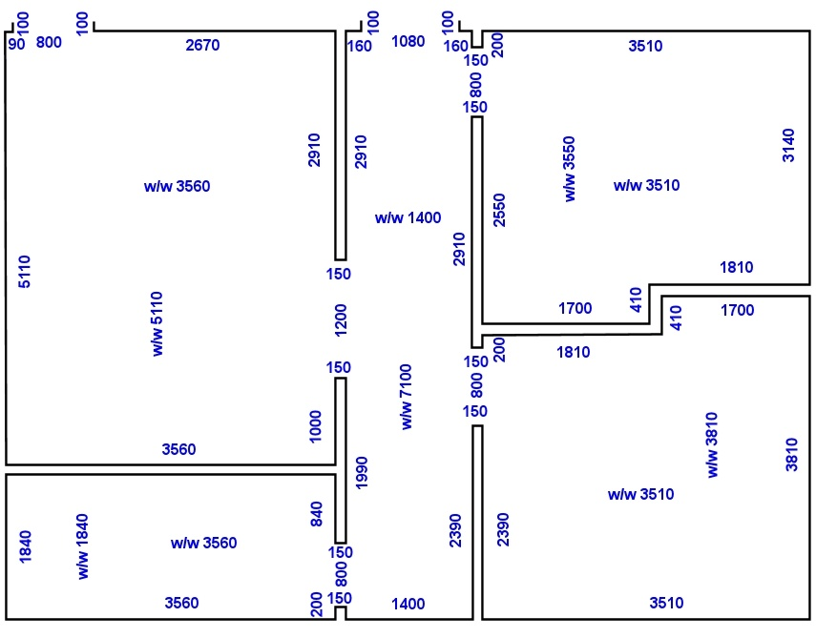How many underlay sheets will you need? Show all your calculations.

**1**

**2**

**3**

**4**

**5**

|  |
| --- |
|  |

### 2. Assessing the subfloor

Choose a particular hard underlay product and get a copy of the manufacturer’s installation guide. Answer the following questions.

1. What is the brand name of the product, and what type of underlay is it?

|  |
| --- |
|  |

1. Are there any types of subfloors that this product is not recommended for? If so, what are they, or what additional preparations would be required?

|  |
| --- |
|  |

1. What is the maximum moisture content allowable in the subfloor?

|  |
| --- |
|  |

1. What would you do it the moisture content in the subfloor exceeded the maximum reading allowable?

|  |
| --- |
|  |

### 3. Preparing the underlay

Have a look at the manufacturer’s installation guide for the same product you chose in the previous lesson.

What are the acclimatisation instructions for this product?

|  |
| --- |
|  |

### 

### 4. Cutting and trimming the underlay

Trace cutting and bar scribing are both commonly used when laying tiles, and the principle is the same when you apply these techniques to underlay sheets.

There is a third method for marking tiles called ‘pattern scribing’ – sometimes referred to as making a template. This is time consuming, but is a very good technique when you need to make accurate cuts around unusual shapes or contours.

Under what circumstances might you decide to make a template for marking out and cutting a hard underlay board? Name one example of a situation where this method could be used.

|  |
| --- |
|  |

### 5. Laying the underlay

The drawings below show the corner of a hardboard panel and a fibre cement panel.

What are the recommended nail or staple spacings for these two products? Write the correct spacings in your workbook.

perimeter spacing between nails

spacing to edge of sheet

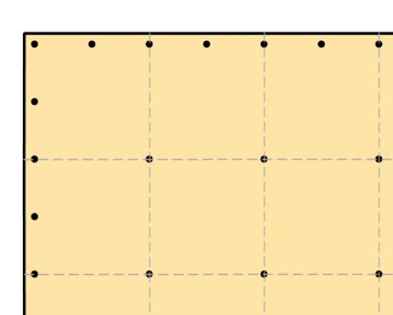

internal spacing between nails

**Hardboard**

spacing at corners

perimeter spacing between nails

spacing to   
edge of sheet

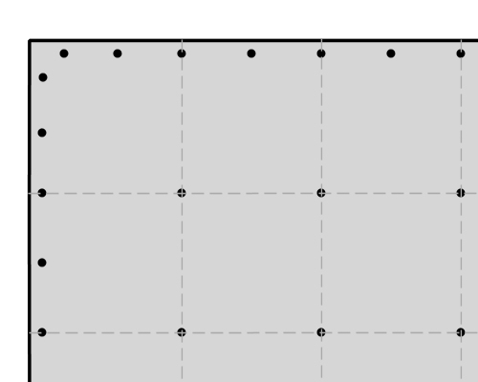

internal spacing between nails

**Fibre cement**

### 6. Finishing the installation

Complete this learning activity after you have finished a hard underlay installation. If you haven’t already done one, you may wait until you have completed a practical demonstration session.

Have a think about the way the installation went and do a self-evaluation of your own performance.

Were there any parts of the preparation and installation process that you had trouble with? Are there any areas that you believe you should practise more to improve your skills? If so, what are they?

|  |
| --- |
|  |