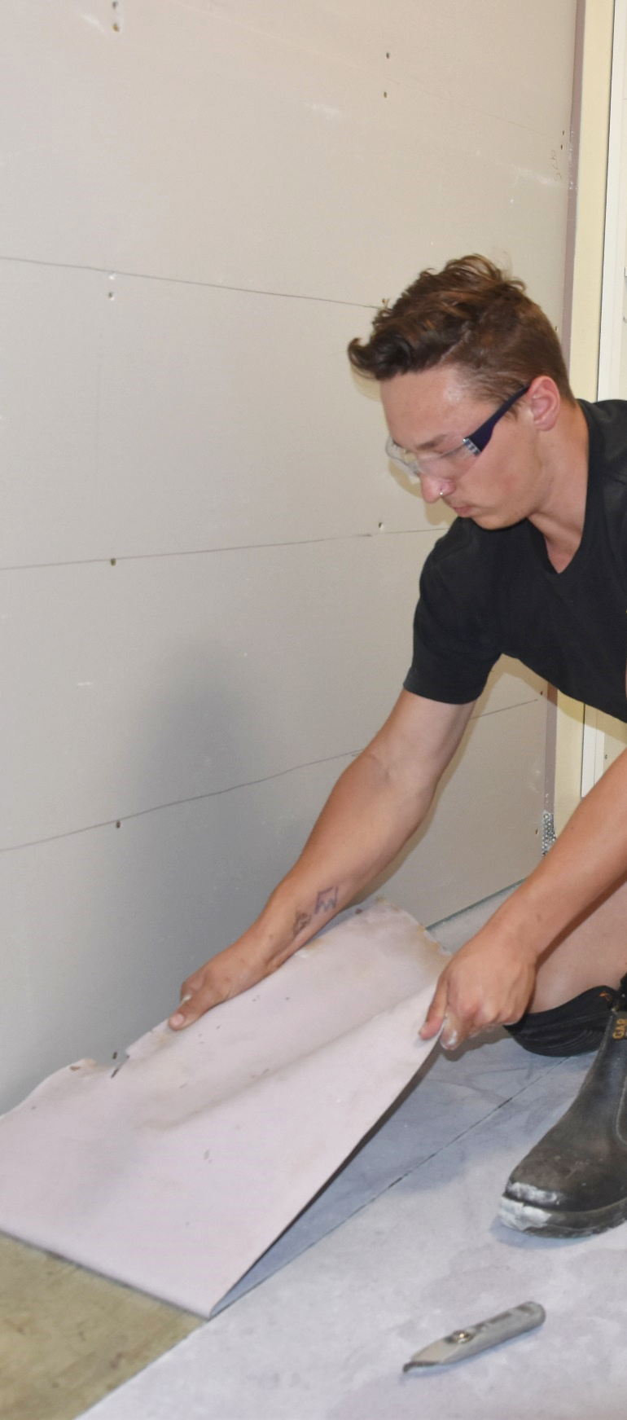

Remove floor coverings

**Supporting:**

***MSFFL2031 Remove existing floor coverings***



**To be used in conjunction with the Learner guide for this unit**

**Student Workbook**

Name: Date of issue:

**Version: February 2020**

Remove floor coverings

Student Workbook



This Workbook accompanies the Learner guide for ‘Remove floor coverings’. It has been developed by Industry Network Training and Assessment Resources (INTAR) for the National Flooring Trainers Network (NFTN), with funding provided by the Carpet Institute of Australia Limited (CIAL).

Its purpose is to help apprentice floor layers, sales staff and other workers to acquire the background knowledge needed to satisfy the theoretical components of the competency: *MSFFL2031 Remove existing floor coverings*.

It is not designed to replace the practical training necessary to develop the hands-on skills required.

****© 2020 INTAR, NFTN, CIAL



### Copyright

Copyright in this resource is owned jointly by Industry Network Training and Assessment Resources (INTAR), National Flooring Trainers Network (NFTN) and Carpet Institute of Australia Limited (CIAL).

All enquiries about the resource should be addressed to the project manager:

David McElvenny   
INTAR   
PO Box 1954 Strawberry Hills, NSW, 2012

Email: [david@intar.com.au](mailto:david@intar.com.au)

### Disclaimer

The content of this resource is provided for educational purposes only. No claim is made as to its accuracy or authenticity. The authors and copyright owners do not give any warranty nor accept any liability in relation to the information presented in this work.

In all cases, users should consult the original source documents before relying on any information presented in the resource. These source documents include manufacturers’ installation guides, Australian Standards, codes of practice and other materials produced by specialist industry bodies and government agencies.

### About the Flooring Technology project

The Flooring Technology project is an ongoing resource development venture coordinated by INTAR to assist apprentice flooring installers undertaking the *Certificate III in Flooring Technology.*

For more information about INTAR, and to see the full range of Flooring Technology units available under this project, go to the following website and follow the links: [www.intar.com.au](http://www.intar.com.au)

## Table of contents

Introduction 1

Assessment evidence checklists 3

Section 1: Preparations and safety 5

Section 2: Removal techniques 9

## Introduction

*Remove floor coverings* is a ‘learning unit’ from the Flooring Technology training resource. It supports the following competency from the *Certificate III in Flooring Technology*:

* *MSFFL2031 Remove existing floor coverings*

**Using this workbook**

All of the lessons in the Learner guide for this unit have learning activities at the end. Their purpose is to test your knowledge of the subject matter and reinforce your understanding of the concepts being presented.

This workbook reproduces all of the learning activities in a format that lets you handwrite your answers to the questions. Your assessor may use this workbook as one of the evidence requirements for demonstrating competence in the unit.

**How you will be assessed**

To be assessed as competent in this unit, your assessor will use a range of methods to evaluate your practical skills and understanding of the concepts relating to the removal of existing floor coverings.

In addition to this workbook, your assessor will also some of the following assessment methods to collect evidence of your competence:

* practical demonstrations of at least two removals of floor coverings
* written test
* on-the-job discussions about how you go about particular activities
* log book or work diary
* reports from your workplace supervisor.

See the next chapter – ‘Assessment evidence checklists’ – for a summary of the skills and knowledge you will need to demonstrate in your various assessment activities.

**Literacy, numeracy and computer skills**

Literacy is the ability to read and write. To complete this unit, you will need sufficient literacy skills to fill in various workplace documents and complete the learning activities. You will also need the skills to be able to read and understand documents such as order forms, instructions and safe operating procedures.

Numeracy is the ability to work with numbers. Flooring installers need to do lots of measure-ups and calculations, so there will be many opportunities for you to learn and practise your numeracy skills.

When it comes to completing the learning activities for this qualification, a certain level of literacy ability is required to read the questions and write down your answers.

If you have any trouble reading the questions or writing down your answers, make sure you speak to your trainer before you hand the workbook in.

There are various ways your trainer can help you. For example, they may be able to ask the questions verbally and help you to write down your answers. They may also be able to show you sample answers to similar questions, which will let you look at the way they’re written and give you hints on how to write your own.

**Applying for RPL**

RPL stands for **Recognition of Prior Learning.** It is aform of assessment that acknowledges the skills and knowledge you have gained through:

* on-the-job experience
* formal training in other courses
* life experience, through your hobbies or other outside activities.

If you believe that you are already competent in some or all of the skills covered in this unit, ask your assessor about how to apply for RPL.

## Assessment evidence checklists

The checklists below set out the sorts of things your trainer will be looking for when you undertake the practical demonstrations and knowledge tests for this unit.

They are divided into ‘Performance evidence’ and ‘Knowledge evidence’ checklists. Performance evidence refers to tasks or activities you will need to perform through practical demonstrations. Knowledge evidence refers to items of information you will need to show an understanding of through the completion of written tests, workbook learning exercises and verbal discussions.

Make sure you talk to your trainer or supervisor about any of the details that you don’t understand, or aren’t ready to demonstrate, before the assessment events are organised. This will give you time to get the hang of the tasks you will need to perform, so that you’ll feel more confident when the time comes to be assessed.

**Performance evidence**

When you are able to tick all of the YES boxes below you will be ready to carry out the practical demonstration components of this unit.

| **Specific demonstration requirements** (from competency ‘Performance evidence’) | **YES** |
| --- | --- |
| Remove a floor covering by hand  Remove a floor covering using mechanical equipment | ❑  ❑ |

| **General performance criteria** (from competency ‘Elements and performance criteria’) | **YES** |
| --- | --- |
| Follow safe work practices and site procedures | ❑ |
| Identify any hazards in the area and take steps to control the risks | ❑ |
| Select the correct tools for the job, and inspect them prior to use | ❑ |
| Plan the sequence of work to maximise efficiency | ❑ |
| Determine the best starting point and prepare the thoroughfares | ❑ |
| Take up the floor covering using suitable techniques and equipment | ❑ |
| Remove any fasteners, adhesive residue and other items from the subfloor | ❑ |
| Take out the waste materials and recycle or dispose of them appropriately | ❑ |
| Clean and inspect the floor substrate and clean up the general work area | ❑ |
| Check tools as they are packed up and stored | ❑ |
| Complete any required workplace documentation | ❑ |

**Knowledge evidence**

Some of the knowledge evidence requirements may be assessed progressively as you work through the unit. However, you will also be asked to complete a written test as a final assessment of your knowledge and understanding of the concepts.

When you are able to tick all of the YES boxes below you will be ready to undertake the final written test for this unit.

|  |  |  |
| --- | --- | --- |
| **Background knowledge** (from competency ‘Knowledge evidence’) | **YES** | |
| Workplace safety and environmental protection requirements | | ❑ |
| Hazardous substances, including asbestos-based products | | ❑ |
| Hand tools and mechanical equipment used to take up floor coverings | | ❑ |
| Procedures for maintaining and recording information | | ❑ |
| Characteristics and removal techniques for the following types of floors:   * carpet with soft underlay and gripper strips * parquetry with hard underlay * resilient floor covering installed on concrete * carpet, resilient and cork tile * tiled floors * strip timber * floating floor | | ❑  ❑  ❑  ❑  ❑  ❑  ❑ |

## Section 1: Preparations and safety

### 1. Tools and equipment

Choose one hand tool (that doesn’t use an external power source) and one powered tool from the examples shown in the Learner guide for this lesson. Answer the following questions for each tool:

* What is the name of the tool (or item of equipment)?
* What types of removal jobs is it best suited for? Include in your answer the types of floor coverings and other materials it is best with, and also the size of the job.
* What are its main disadvantages? Include in your answer issues that might relate to PPE, noise, power requirements, inconvenience to others in the building, etc.

|  |  |
| --- | --- |
| **Hand tool (unpowered)** | |
| Name of tool |  |
| Best suited for |  |
| Disadvantages |  |

|  |  |
| --- | --- |
| **Powered tool** | |
| Name of tool |  |
| Power source |  |
| Best suited for |  |
| Disadvantages |  |

### 2. Planning and documentation

Let’s say that you’ve been asked to take up an old vinyl tiled floor, laid on a concrete subfloor – similar to the job that’s being done in the photo at right.

You drop in at the jobsite on your way home the day before to have a look, so you can plan the job in advance. When you get there, you discover that the room is upstairs in the building shown below.

There is a plumber working downstairs and a tiler laying slate near the front entrance door. An electrician has been working upstairs, and is due to return in the coming days. The roadsign outside says that it will be a clearway each weekday morning from 6-10 am.

What sorts of things will you need to check out and talk to the builder about when you plan this job? Write down the issues you should discuss. You may also include ways you could overcome the main logistical challenges involved in carrying out the job.

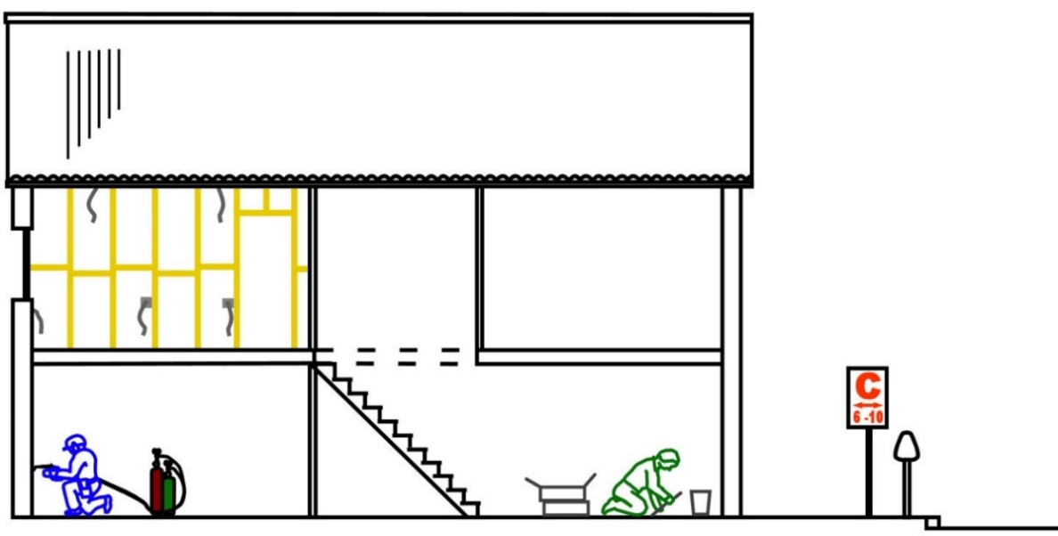

|  |
| --- |
|  |

### 3. Preparing the work area

The worker in the photo at right is replacing the carpet in a set of ground floor apartments in an aged care facility. As he takes up the old carpet, he carries the rolls out to his ute and puts them on the back.

At the end of each day, he takes a load back to the warehouse for disposal – although sometimes he has to leave rolls of old carpet and rubbish on the lawn if they won’t all fit into his ute.

How would you improve the efficiency of this job? Let’s say there were several apartments to take up and none of them are occupied. You can also assume that you have access to other workers, vehicles and equipment. What would be a cost-effective method for taking up the old carpet, and what arrangements would you need to make?

|  |
| --- |
|  |

### 4. Health and safety

On the next page are some photos taken from the Asbestos Awareness website at: <https://asbestosawareness.com.au>. They show examples of various asbestos-based products you may come across from time to time as a flooring installer.

For each product shown, write down what type of product it is (such as vinyl tile, sheet vinyl, cutback adhesive, carpet underlay, etc). Then indicate one or two features about that product (or its surroundings) that would help you in the field to identify that you might be looking at an asbestos-based product.

If you aren’t sure what you’re looking at, you can go to the Asbestos Awareness website, find the original photo and read the descriptive caption. You’ll find these photos, plus many more examples of floor coverings and other asbestos-containing building products under the ‘Asbestos products database’ at: <https://asbestosawareness.com.au/asbestos-products-database/>.

|  |  |
| --- | --- |
| **Flooring product** | **Description** |
|  | Type of product:  Identifying features: |
|  | Type of product:  Identifying features: |
|  | Type of product:  Identifying features: |
|  | Type of product:  Identifying features: |
|  | Type of product:  Identifying features: |

## Section 2: Removal techniques

### 1. Removing stretched-in carpet

Let’s say you have been asked to remove stretched-in tufted carpet from a single room. The carpet is laid over a cushion underlay, which has been secured to the timber subfloor with staples. There was no adhesive used in the original installation.

The subfloor comprises Baltic pine (softwood) T&G boards. It will be sanded back and coated with a clear polyurethane finish.

1. What tools will you use to remove the carpet, cushion underlay, staples and grippers? List all hand tools you would typically expect to use.

|  |
| --- |
|  |

1. 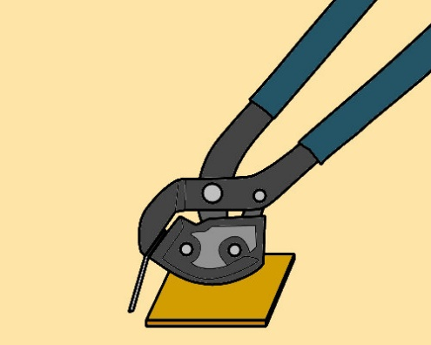How will avoid putting indentations in the timber subfloor with your tools when you pull out the staples?

Describe the technique you should use.   
(The drawing at right will give you a hint).

|  |
| --- |
|  |

### 2. Removing adhesive-fixed carpet

Do some research into powered floor scrapers, either on the web or using product brochures. Choose one walk-behind machine and one ride-on machine that are suitable for removing adhesive fixed carpet. Fill in the tables below with the necessary information.

|  |  |
| --- | --- |
| **Walk-behind machine** | |
| Brand name / model |  |
| Description of machine |  |
| Power source |  |
| Blade width |  |
| Other features |  |

|  |  |
| --- | --- |
| **Ride-on machine** | |
| Brand name / model |  |
| Description of machine |  |
| Power source |  |
| Blade width |  |
| Other features |  |

### 3. Removing resilient flooring

Write up a brief comparison of the advantages and disadvantages of the following methods for taking up vinyl flooring.

* hand scraping plus a heat gun
* hand scraping plus water
* machine scraping with a floor stripper or chisel scraper.

The sorts of issues you should consider in your comparison include: size of the job, speed and efficiency, noise, dust, availability of power, possibility of live wires near water, impact on other people in the building, and any other factors that you think are important.

|  |  |  |
| --- | --- | --- |
| **Vinyl removal** | **Advantages** | **Disadvantages** |
| Hand scraping plus a heat gun |  |  |
| Hand scraping plus water |  |  |
| Machine scraping  with floor stripper / chisel scraper |  |  |

### 4. Removing timber coverings

Let’s say you were pulling up an old timber floor covering and you noticed that there was fungal decay in some of the boards, or that mould was growing underneath the boards.

What alarm bells would that ring for you? In particular, what sorts of checks would you make to try to track down the source of the problem, and what types of questions could you ask the client to get a better understanding of the issues?

|  |
| --- |
|  |

### 5. Removing floor tiles

We’ve indicated in this lesson that hard tiles are made from mineral products, which make them brittle and liable to break with sharp edges when they’re lifted from the floor. They’re also often bedded down on a mortar base, which can be very dusty when it breaks up.

Let’s say you were removing ceramic tiles with a jackhammer or chisel scraper. What personal protective equipment would you need to wear for this task, over and above your normal worksite PPE (such as hi-vis shirt and safety boots)? Include the PPE needed while you’re using the power tools as well as while you’re shoveling up and disposing of the rubble.

|  |
| --- |
|  |

### 6. Removing adhesive residue

For this exercise, we’ll put all the elements together for a removal job that involves taking up the old Axminster carpet from an office reception area.

Your task will be to draw up a plan for the whole process, starting with arriving at the worksite and inspecting the floor, and finishing with the clean-up once you’ve removed the carpet, underlay and adhesive.

Let’s say that the project involves a front reception area measuring 7 metres by 5 metres, and that your supervisor has given you a total of 4 hours to complete the job. We’ll assume that all equipment is already on-site and in good working order.

We’ll also assume that the following details apply to the job:

* the broadloom carpet and underlay have been installed as a full spread dual bond system directly to a concrete subfloor
* there are no asbestos-based products involved in this project
* the adhesive can be lifted through a combination of stripping with a walk-behind machine (powered by mains electricity) and hand scraping
* the room is on the ground floor of the building, and there is a small step-up from the outside car pack
* the front entrance is through a large double-door, with easy access to the carpark, where the skip bin is already in place
* all furniture has been removed, there are no obstacles in the way.

Before you complete this exercise, you may wish to read the following lesson in your learner guide (‘Completing the task’), just to remind yourself of the issues you should consider when cleaning up the work area at the end of a removal job.

Use the blank template on the next page to draw up your job plan.

**Template details:**

Set out below are some hints on the sorts of details you should include in your job plan. Remember that the total time allocated to the job is 4 hours, so you’ll need to divide up that time into segments, according to how long you think each stage will take, and write the duration in the ‘Time’ column.

|  |  |  |  |
| --- | --- | --- | --- |
| **Stage** | **Steps involved** | **Equipment required** | **Time** |
| **Preparation** | Write down the steps involved in preparing for the removal, including: introducing yourself to the client, inspecting the existing floor, looking for hazards, filling in a risk assessment form, assembling all necessary tools, and carrying out any required pre-start checks or maintenance on the tools | List any items of equipment, mobile devices or company documentation required for this stage (not including the removal tools – which you should list in the next stage) |  |
| **Removal** | Write down all steps involved in removing the carpet, underlay and adhesive from the concrete subfloor | List all items of equipment required to do this job with a combination of hand tools and a walk-behind floor stripper |  |
| **Clean-up** | Write down the steps involved in taking the materials outside as they’re removed, disposing of them in the skip bin, vacuuming up the concrete substrate and inspecting the finished job | List all items of equipment required to do this stage of the job |  |
| Total time: | | | 4 hrs |
| **Removal of broadloom dual bond commercial carpet from concrete subfloor** | | | |

|  |  |  |  |
| --- | --- | --- | --- |
| **Stage** | **Steps involved** | **Equipment required** | **Time** |
| **Preparation** |  |  |  |
| **Removal** |  |  |  |
| **Clean-up** |  |  |  |
| Total time: | | | 4 hrs |

### 7. Completing the task

Although there are recycling services available for most types of old floor coverings, their availability varies greatly throughout Australia, and in some regions they are few and far between.

Choose one type of floor covering that your company regularly removes and find out whether there is a recycling facility that will take it in your area. Then answer the following questions:

1. What is the name of the facility, and who runs it (that is, is it operated by a floor covering manufacturer, private company, local council, etc.)?

|  |
| --- |
|  |

1. Does the company you work for already use this facility? If not, why not (is it too far away, too inconvenient, too expensive, etc.)?

|  |
| --- |
|  |