Commercial vinyl
DRAFT VERSION
October 11

Supporting:
LMFFL3302A: Install commercial vinyl floor coverings
LMFFL3303A: Install resilient floor coverings using custom designs and decorative finishes

Developed in 2012-2013 for the WELL Program
Learner guide

Commercial vinyl
Learner guide

This unit is also available in an e-learning format, which contains additional photos, interactive exercises and a voice-over narration of the text. It can be viewed on CD-ROM, or live on the web at:
www.flooringtech.com.au

Developed by Workspace Training for the 2012-2013
Workplace English Language and Literacy (WELL) Program
Flooring Technology resource development project

Copyright and disclaimer
ISBN: 978-1-925087-01-7
Funded under the Workplace English Language and Literacy Program by the Australian Government through the Department of Industry, Innovation, Climate Change, Science, Research and Tertiary Education
© Commonwealth of Australia 2013
CC BY-NC-SA
This work is copyright. Except where otherwise indicated, and save for the Commonwealth Coat of Arms, the Department has applied the Creative Commons Attribution-Noncommercial-Share Alike 3.0 Australia Licence to this work.
The Department of Industry, Innovation, Climate Change, Science, Research and Tertiary Education must be attributed as the author of the Department’s copyright material.
As far as practicable, material for which the copyright is owned by a third party has been clearly labelled. The Department has made all reasonable efforts to ensure that this material has been reproduced in the print-based resources and accompanying website with the full consent of the copyright owners.
Requests and enquiries concerning the Department’s copyright material should be addressed to:
The Legal Branch
Department of Industry, Innovation, Climate Change, Science, Research and Tertiary Education
GPO Box 9839 Canberra ACT 2601
Email: legalservices@innovation.gov.au
Questions about the design and content of the resource itself should be addressed to the project manager:
David McElvenny
Workspace Training
PO Box 1954 Strawberry Hills, NSW, 2012
Email: david@workspacetraining.com.au

Disclaimer
The content of this Learner guide is provided for educational purposes only. No claim is made as to the accuracy or authenticity of the content. The views expressed in this publication do not necessarily represent the view of the Minister for Tertiary Education, Skills, Science and Research or the Australian Government. The Australian Government does not give any warranty nor accept any liability in relation to the contents of this work.

About this resource
This Learner guide is part of a suite of resources developed for the Flooring Technology project, funded by the WELL Program. The resources support 19 competencies from the Certificate III in Flooring Technology (LMF31208). The project comprises a website and an accompanying set of Learner guides and work books.
The individual competencies are grouped into ‘Learning units’ as shown below. Each one is given a title describing the main theme of that set of integrated competencies.

Learning unit title Competencies covered
Safety at work MSAPMOHS200A: Work safely
LMFFL3002A: Establish and maintain a safe flooring technology work environment
Inspecting and testing subfloors LMFFL2004A: Moisture test timber and concrete floors
LMFFL3101A: Inspect sub-floors
Planning and costing LMFFL3001A: Plan and cost flooring technology work
Subfloor coatings and toppings LMFFL2102A: Prepare, select and apply smoothing and patching compounds
LMFFL2103A: Select and apply appropriate compounds and additives
LMFFL2105A: Select, prepare and apply moisture barriers and damp proof membranes to concrete sub-floors
Concrete grinding LMFFL2107A: Select, operate and maintain grinding equipment
Preparing floor coverings LMFFL2002A: Receive and prepare floor covering materials for installation
Lay flat vinyl LMFFL2301A: Install lay flat vinyl floor coverings
Resilient tiles LMFFL2302A: Install resilient tiles using standard installation practices
Commercial vinyl LMFFL3302A: Install commercial vinyl floor coverings
LMFFL3303A: Install resilient floor coverings using custom designs and decorative finishes
Linoleum LMFFL3301A: Install linoleum floor coverings
ESD floors LMFFL3308A: Install anti-static resilient floor coverings
LMFFL3309A: Install conductive resilient floor coverings
Making measurements MSAPMOPS101A: Make measurements
Working sustainably MSAENV272B: Participate in environmentally sustainable work practices
The purpose of these resources is to help trainee floor layers acquire the background knowledge needed to satisfy the theoretical components of the competencies covered in this project. However, the resources are not designed to replace the practical training necessary to develop the hands-on skills required. Learners will still need to receive extensive on-the-job training and supervision before they will be ready to be formally assessed in the relevant competencies.

E-learning version
All of the content material contained in this Learner guide is also available in an e-learning format, which has additional photos, interactive exercises and a voice-over narration of the text. The e-learning version can be viewed on the web at: www.flooringtech.com.au
The web version can also be purchased on a CD at a cost-recovery price from the project developer:
Workspace Training
PO Box 1954 Strawberry Hills, NSW, 2012
Email: david@workspacetraining.com.au

Acknowledgements

Project team
Project manager: David McElvenny
Instructional designer: Kath Ware
Technical developer (website): Jim Vaughan
Assistant technical developer (and voice-over artist): Alex Vaughan
Quality assurance consultant: Giselle Mawer
Industry coordinator: Gary Dunshea (MSA Industry Skills Council)

Technical Advisory Group

Lead advisors
William Tree – South West Sydney Institute of TAFE
Mark Willis – Council of Textile and Fashion Industries of Australia
Craig Bennett – Hunter Institute of TAFE

Reviewers
Ian Ciesla – Polytechnic West
Robert Cole – Furnishing Industry Association of Australia
Steven Dalton – Marleston TAFE
Shane Eales – SkillsTech Australia
David Hayward – Australian Timber Flooring Association
Bruce Ottens – Holmesglen TAFE
Chris Shaw – Skills Institute Tasmania
Warren West – Australian Resilient Floor Covering Association

Industry advisors
Peter Brack – Forbo Flooring Systems
Don Considine – IKW Consulting Group
Gary Eggers – Tarkett Flooring
Jim Hilston – Hilston Floors
Lionel Jacobs – Epoxy Solutions
Owen Jordian – Choices Flooring
Steven King – Armstrong Floors
Jarka Kluth – Pro Grind Australia
Haydn Reynolds – Floorex Products
Naomi Archer – All Preparation Equipment

Photographs
Most of the photos in this suite of resource were taken by David McElvenny. Additional photos were provided by:
David Beeforth (ParexDavco)
Don Considine (IKW Consulting Group)
Craig Bennett (Hunter TAFE)
David Hayward (Australian Timber Flooring Association)
Gary Eggers (Tarkett)
Lionel Jacobs (Epoxy Solutions)
Jarka Kluth (Pro Grind Australia)
Haydn Reynolds (Floorex Products)
Naomi Archer (All Preparation Equipment)
We would like to thank the following organisations for allowing us to take on-site photos of their employees at work or students in class.
Choices Flooring – Sandgate, Bulleen, Thomastown and Mornington
Lidcombe College of TAFE
Lomac Commercial Flooring
Tarkett
Epoxy Solutions

Graphics
Graphics were drawn by Kath Ware. Many of these graphics are based on line drawings or photographs from installation manuals published by the following flooring manufacturers:
Armstrong: http://www.armstrong.com/flooring/guaranteed-installation-systems.html
Forbo: http://www.forbo-flooring.com.au/Commercial-flooring/Support-installation-and-maintenance/Installation/Installation-technique/
Tarkett: http://professionals.tarkett.com.au/commdocu?field_docu_type_value=
Installation+guide

Financial contributions
This resource was funded by the Workplace English Language and Literacy Program by the Australian Government through the Department of Industry, Innovation, Climate Change, Science, Research and Tertiary Education. Additional financial assistance was provided by Manufacturing Skills Australia (Industry Skills Council).

Table of contents
Introduction 1
Section 1 Commercial vinyl basics 3
Overview 5
Structure of commercial vinyl 6
Types of adhesives 7
Planning and preparation 10
Handling and conditioning 13
Basic cutting and fitting 15
Assignment 1 17
Section 2 General laying techniques 19
Overview 21
Applying an adhesive 22
Problems with adhesives 24
Heat welding equipment 28
The welding process 31
Heat welding problems 34
Finishing the job 36
Assignment 2 38
Section 3 Borders, features and coving 39
Overview 41
Borders and feature strips 42
Types of coving 44
Fitting cove formers 46
Coving field material 48
Fitting cove skirting 51
Motifs and patterns 54
Assignment 3 57
Practical demonstrations 58

Introduction
Resilient floor coverings include all the products that have the characteristic of resilience, or ‘bounce back’. This distinguishes them from ‘non-resilient’ flooring products like timber, stone, slate and ceramic tile.
The Australian Standard that covers the installation of resilient products –
AS 1884-2012 – defines ‘resilience’ as the ability of a floor covering to return to its original shape and thickness after being subjected to heavy foot traffic, dropped objects or static loads.
In this unit, we’ll discuss the installation techniques that apply to commercial vinyl flooring, which is the most common resilient sheet material used in industrial and commercial applications.
We won’t cover lay flat vinyl in this unit, or the general preparations you should make before undertaking an installation. These topics are covered in detail in the unit: Lay flat vinyl, along with the basic principles of cutting sheet products. If you haven’t already completed the Lay flat vinyl unit, you should read through it first before tackling the more advanced techniques covered in this unit.
We’ll also leave two other types of resilient sheet products to other learning units: ESD floors and Linoleum. These specialist units follow on from the installation techniques described in this unit and provide details on the differences that apply to the way they are laid.

References
The methods described in this unit are based primarily on the information provided by Armstrong and Forbo in their installation guides. You can download the original PDF documents from their websites via the following links:
Armstrong: http://www.armstrong.com/flooring/guaranteed-installation-systems.html
Forbo: http://www.forbo-flooring.com.au/Commercial-flooring/Support-installation-and-maintenance/Installation/Installation-technique/
We have also used a variety of photos provided by Tarkett Australia. You can see these photos in the original document at: http://viewer.zmags.com/publication/6612b1a9#/6612b1a9/22.

Working through this unit
There are three sections in this unit:
- Commercial vinyl basics
- General laying techniques
- Borders, features and coving.
Each section contains an Overview, an Assignment and Lessons which cover the content material.

Assignments
Your trainer may ask you to submit the assignments as part of your assessment evidence for the unit. You will find hard-copy templates for these assignments in the separate workbook.
Electronic ‘Word’ templates of the assignments are available on the website for this resource, at: www.flooringtech.com.au

Learning activities
Each of the lessons has a learning activity at the end. The Workbook for this unit contains all of the learning activities together with spaces for written answers.
Again, you will find the learning activities on the website version, together with some interactive ‘Just for fun’ exercises.

Practical demonstrations
Your final assessment of competency in this unit will include various practical demonstrations. Their purpose is to assess your ability to install a range of commercial vinyl floor coverings. To help you get ready for these hands-on assessment activities, see the sample checklist shown in the Practical demonstrations section at the back of this Learner guide.

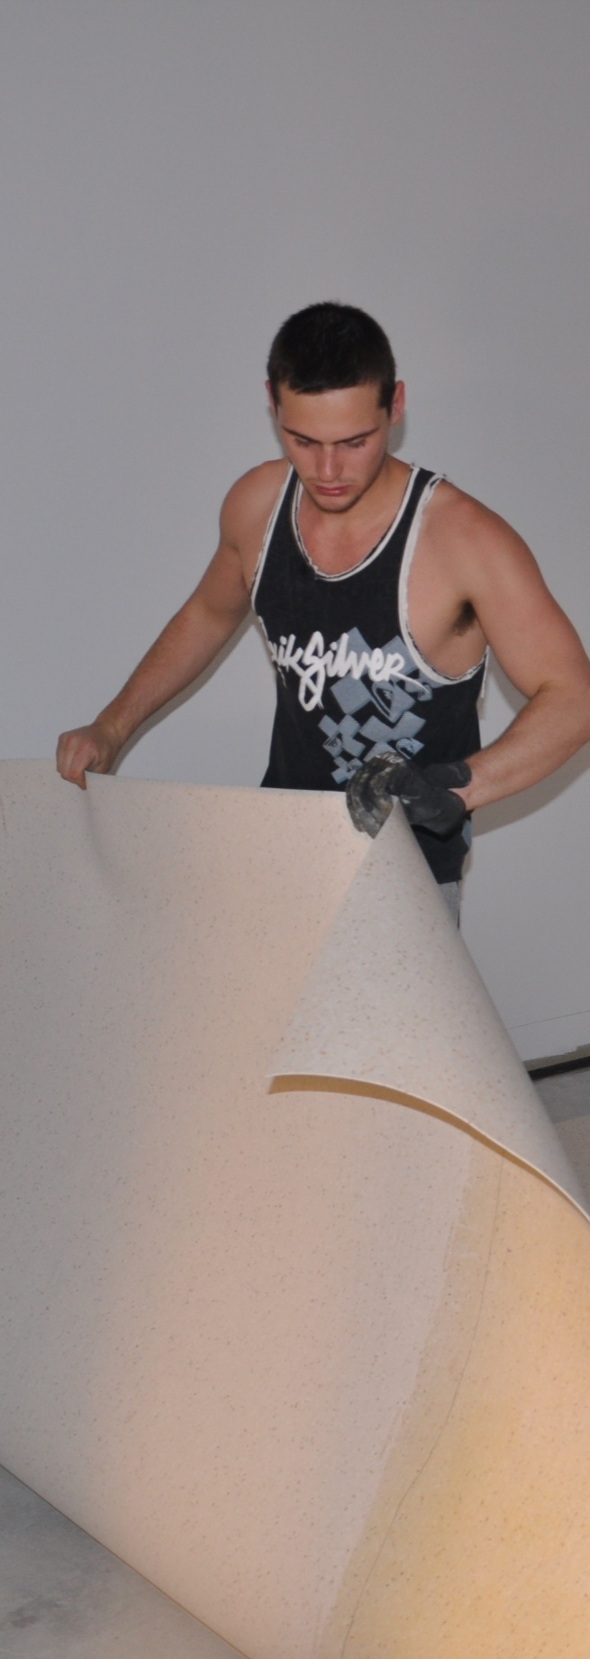

Section 1

Commercial vinyl basics

Overview
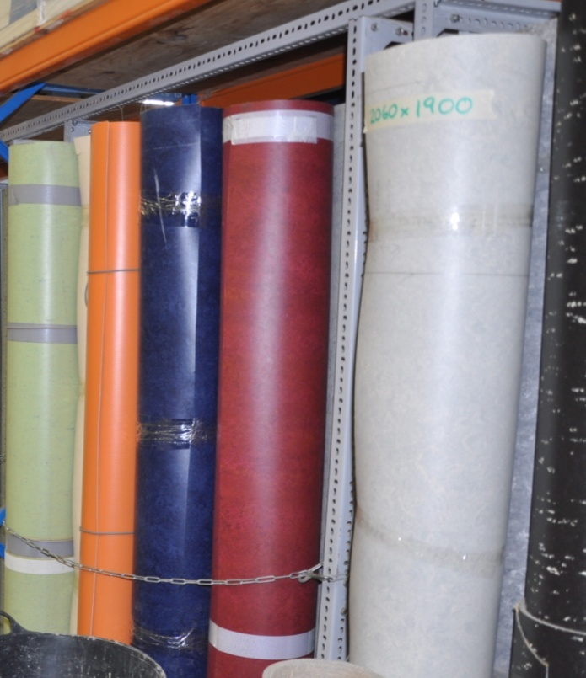
In this section, we’ll cover some basic principles relating to commercial vinyl.
We’ll look at the structure of the product, the range of adhesives used, and basic cutting and fitting techniques.
We’ll also talk briefly about the planning that goes into getting ready for an installation, and the preparations you should make before you show up to the jobsite.
Some of these topics are covered in more detail in other units from this resource. In these cases there are references to the relevant lessons from those units.

Completing this section
The assignment for this section is designed to test your knowledge of the commercial vinyl products available and the different types of adhesives used to install them.
Have a look at the Assignment on page 17 to see what you'll need to do to complete it.
There are five lessons in this section:
- Structure of commercial vinyl
- Types of adhesives
- Planning and preparation
- Handling and conditioning
- Basic cutting and fitting.
These lessons will provide you with background information relevant to the assignment and the practical demonstration requirements.

Structure of commercial vinyl
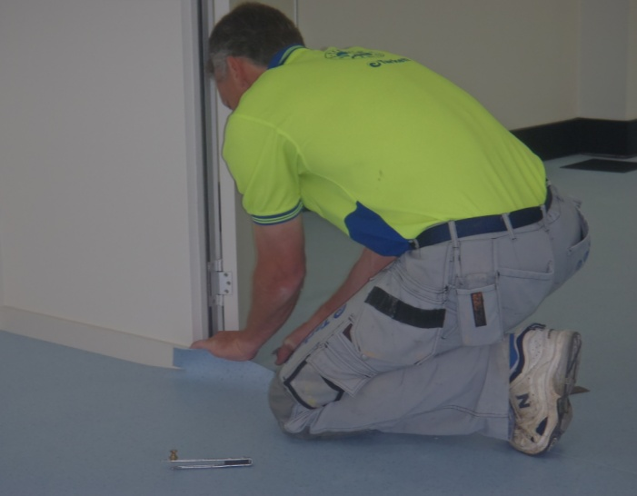
You’ll recall that in the unit Lay flat vinyl, we talked about the two main structures used in the manufacture of vinyl flooring:
- heterogeneous (or layered) vinyl
- homogeneous (or solid) vinyl.
The term ‘commercial vinyl’ is generally used to refer to homogeneous products that are laid in industrial or commercial applications, such as schools, hospitals, offices and factories.
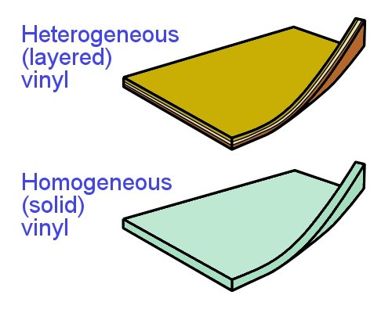
The easiest way to tell whether you’ve got a solid or layered sheet is to look at the back. Solid sheets are the same colour on both sides, whereas layered sheets have a different colour on the back because it’s a different layer.
Another common difference between lay flat and commercial vinyl sheets is the make-up of the wear layer on top. Lay flat vinyl generally has a PVC (polyvinyl chloride) wear layer.
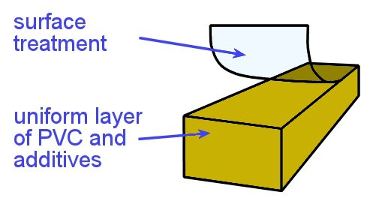
However, most commercial vinyl products have a PUR (polyurethane) surface treatment, which is tougher and more scuff resistant.
The composition of commercial vinyl is a uniform layer of PVC and various additives, such as binders, plasticisers, stabilisers, fillers and pigments.

Learning activity
Identify two brand name commercial vinyl products and their manufacturers.
Which of these products have you installed? What type of projects were they used in?

Types of adhesives
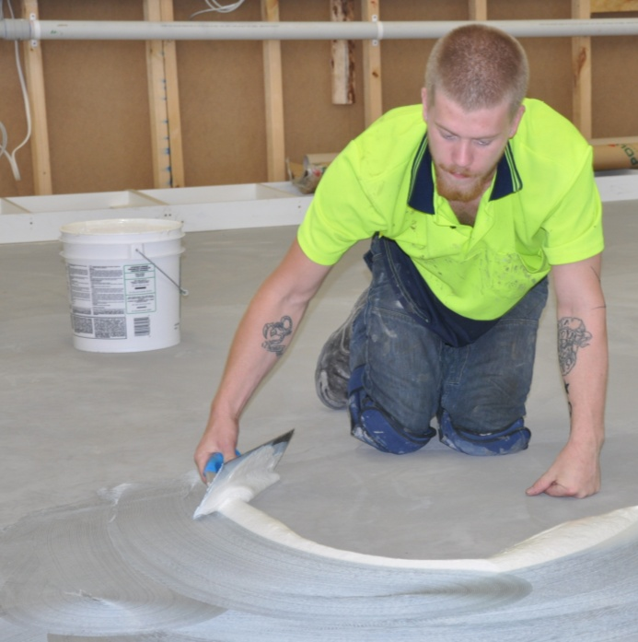
There is no single adhesive that’s suitable for all types of resilient floor coverings.
The best adhesive for any particular job will depend on a range of factors, including what type of material is being laid, what the substrate is made from and how much wear and tear the floor will be subjected to.
The selection of the most appropriate adhesive is generally made by the floor covering manufacturer and specified in the installation instructions.
However, there are times when the client may have unusual site conditions or requirements, and an alternative adhesive needs to be used. In these cases, you should always check with the flooring manufacturer before going ahead – otherwise you may find that you’ve voided the warranty conditions.
Below are the main categories of adhesives used with sheet vinyl installations. Note that with the continuing development of new chemical compounds and combinations of compounds, some products may fall into more than one category.

Epoxy
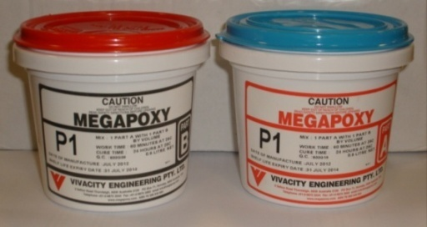
Epoxy resins are two-part reactive adhesives. That is, when the separate components are mixed together they set off a chemical reaction.
They are classified as hard set adhesives because they crystallise to form a non-flexible bond.
This gives them a high peel strength, meaning that the floor covering does not peel away easily from the substrate.
But their shear strength is not as good, which means that they are less resistant to forces that tend to slide one layer against another. This can be a problem in areas where there might be movement in the subfloor, such as on steel floors around gantry cranes.
However, they have excellent water and chemical resistance, and can withstand high temperatures. These adhesives are used in wet areas, commercial kitchens, bars and areas subject to high levels of traffic.

Polyurethane
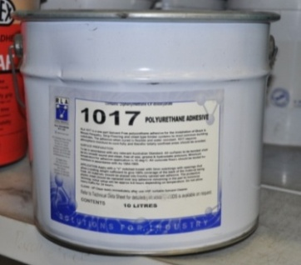
Most polyurethanes are also two-part adhesives that cure due to a chemical reaction between the components, although there are some one-part polyurethane products.
They are classified as semi-soft set, because they remain reasonably flexible and are able to withstand subfloor movements.
Polyurethanes have excellent sheer and peel strength. They come in a wide range of brand names and are a popular choice for most resilient floor installations. Like the epoxy resins, they are widely used in wet areas and commercial applications.

Acrylic
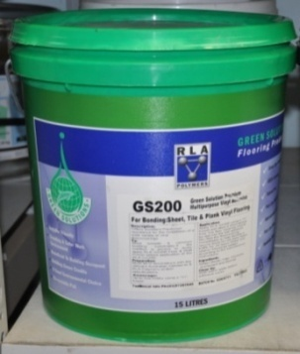
There are many acrylic adhesives on the market. Most are solvent based or water based, which means that the curing action occurs when the solvent or water evaporates after the adhesive is applied. They can be one or two part adhesives and are classified as soft set and semi-soft set.
Although their bond strength is excellent, they are generally water soluble, which makes them unsuitable for use in wet areas.
Acrylics generally have a longer open time than other adhesives and are non-toxic and non-flammable. They are also highly resistant to plasticiser migration (see the next lesson for details on this problem).

Contact
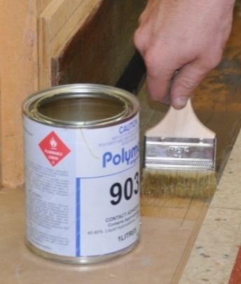
Contact adhesives have a solvent, neoprene or water base and are classed as soft set. The adhesive is applied to both surfaces and allowed to dry before the two surfaces are brought together.
When the surfaces contact each other the bond is instant. This makes them suitable for use on vertical surfaces, such as vinyl skirtings and covings. Note that the adhesive is not waterproof, so the exposed edges must be sealed to stop water penetration.

Looking to the future
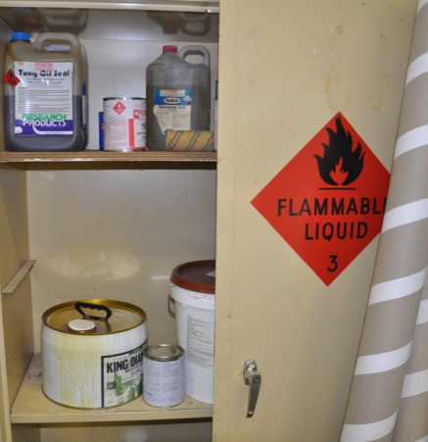
In recent years there has been an enormous amount of research into new formulations for adhesives. The challenge has been to find products that are less damaging to the environment and the health of installers who use them.
The main problem for scientists has been that many of these more ‘environmentally friendly’ water based products are less effective than the adhesives they are designed to replace.
However, new products are being developed, trialled and brought onto the market all the time. One example is ‘Envirostix’, a poly-acrylic adhesive system manufactured by Base King. Follow the link below for more information about this product and the issues that they are aiming to overcome:
http://www.baseking.com/.

Learning activity
Choose two sheet vinyl products that are designed for different purposes and get a copy of the manufacturer’s installation instructions.
Check that the two products specify different types of adhesive.
For each product, answer the following questions:
- What is the brand name and who is the manufacturer of the flooring?
- What adhesive brand name is recommended for laying the flooring?
- What type of adhesive is it – that is, what category does it fall into?

Planning and preparation
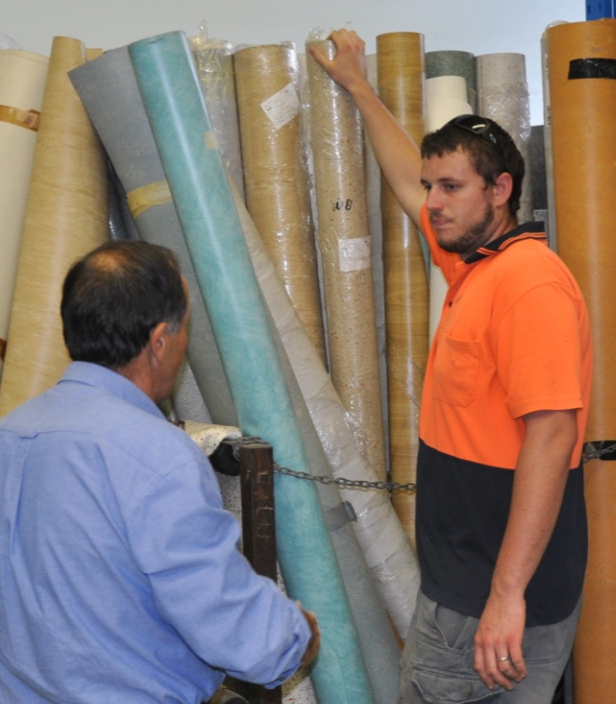
A smooth and efficient installation doesn’t happen by chance. It’s always the product of careful planning and preparation.
For many floor layers, a lot of the arrangements are made in advance by the company that’s supplying the flooring products and handling the installation contract.
But even when you’re working as a subcontractor, you still need to know what the arrangements are and confirm whether everything will be ready for you when you show up on-site to start the installation.
Set out below is a summary of the main factors that need to be considered before you physically begin the installation. Also shown are references to the other Learner guides that have more information about these topics.

Site access and working conditions
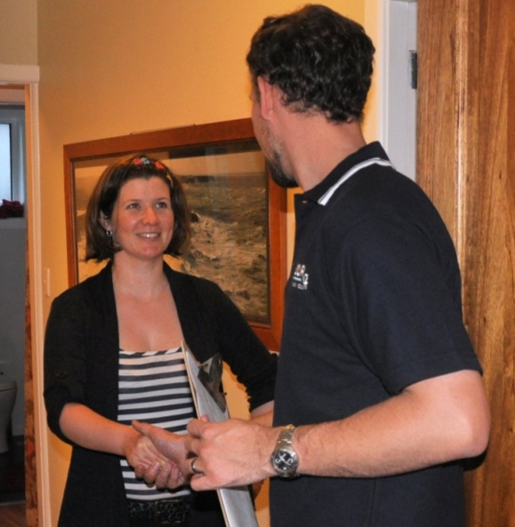
One of the most important issues that need to be dealt with is access to the worksite and the condition it should be in when you arrive.
This includes organising a day that suits everyone, as well as making sure that no other trade work will be going on that could hold up your progress.
It also includes making arrangements in advance about who is responsible for moving existing furniture, appliances and old floor coverings.
For more details on these issues, see:
- ‘Dealing with the client’ in Lay flat vinyl
- ‘Issues to consider’ in Planning and costing.

Health and safety
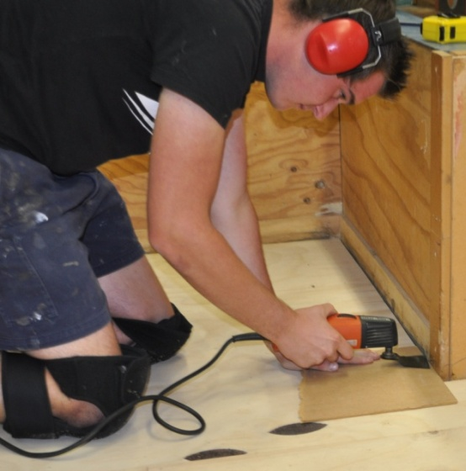
Professional floor layers take safety very seriously – because they know that a happy, healthy life is far more valuable than a bit of time saved by taking shortcuts or not following safe procedures.
We’ve dealt with various aspects of health and safety throughout this series of Learner guides. Below is a summary of the main topics relevant to resilient floor laying that are covered in other guides. You should go back to these lessons if you need to refresh your memory on the details.

Summary of topics
- Manual handling – see: ‘Manual handling’ in Safety at work
- Knee problems – see: ‘Looking after your knees’ in Safety at work
- Dust and fumes – see: ‘Health and safety’ in Subfloor coatings and toppings
- Skin contact with hazardous substances – see: ‘Health and safety’ in Subfloor coatings and toppings
- PPE – see: ‘Personal protective equipment’ in Safety at work
- Knife safety – see: ‘Health and safety’ in Lay flat vinyl.

Documentation
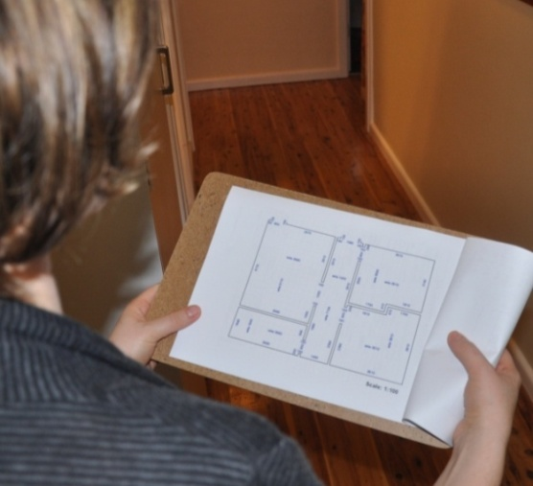
The main document that sets out the specifications of a flooring project is the floor covering plan.
Some contracting companies give their installers a job sheet, which contains most of the information contained in the floor covering plan, but also provides details relating to specific products used and arrangements that have been made with the client.
For more information about these documents see:
- ‘Floor covering plans’ in Planning and costing
- ‘Documentation’ in Lay flat vinyl.

Subfloor assessment
When something goes wrong with a finished floor, more often than not the problem can be traced back to the condition of the subfloor. Sometimes a problem only becomes obvious months or even years after the installation was completed.
But as a professional installer, you’ll still be liable for the cost of repairs if it can be proved that you didn’t properly assess the subfloor and deal with any issues that you were responsible for at the time.
Because this is such a crucial topic, we’ve revisited it in several Learner guides. However, the most comprehensive coverage is in Inspecting and testing subfloors. You’ll also find a useful summary of the main points in Lay flat vinyl.

Tools and equipment
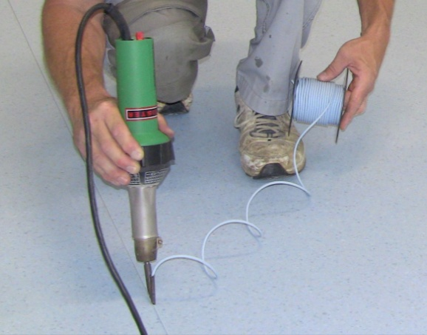
The tools you’ll need for any particular project will depend on the specifications of the job and the site conditions you’re faced with. We talked about the basic range of hand tools required in the ‘Tools and equipment’ lesson in Lay flat vinyl.
We’ll talk more about the specific tools needed for heat welding and other specialised tasks in later sections of this unit.

Learning activity
Can you remember what the Australian Standard says about the maximum relative humidity (RH) allowed in a concrete subfloor?
If you’re not sure of the answers, look back in Inspecting and testing subfloors, or go straight to AS 1884.
- What is the maximum RH allowed in a slab when measured with a surface mounted hood?
- What is the maximum RH allowed when measured with an in-situ probe?
- What installation procedure can you follow if the RH is above these levels?

Handling and conditioning
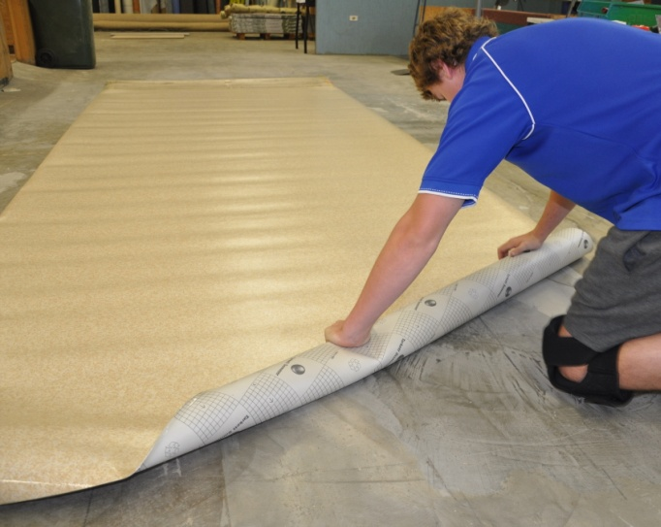
Sheet products are tightly rolled in the factory where they’re made. This puts the material under tension, which is only released when the material is unrolled again. As the material returns to normal, it will shrink slightly in length.
The best way to avoid problems with shrinkage is to re-roll a cut length back on itself and wait for about 15 minutes. Then you can unroll it again and start fitting it in position.
If you’re fitting a long length, such as in a corridor, you should take the extra precaution of only scribing and sticking down the sheet up to about the last 2 metres. Then scribe the second end, spread the remaining adhesive and stick that end down.
Note that the whole sheet must be stuck down before the adhesive sets. If the first part starts to set before you lay down the last section, any overspread in adhesive might result in bubbles where the two parts meet.

Conditioning
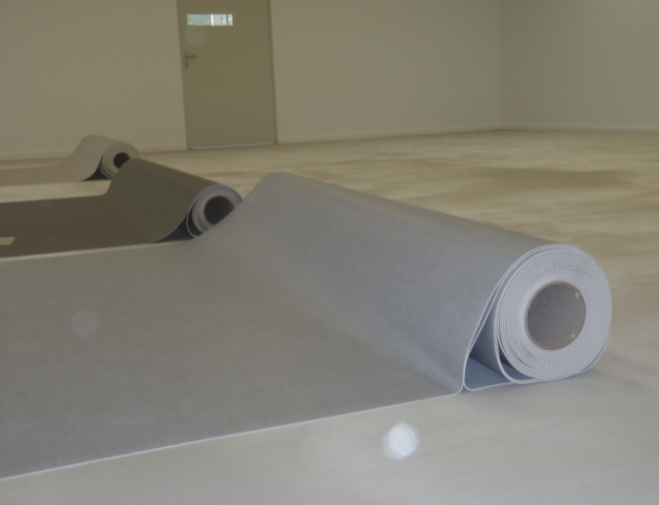
Before you begin an installation, you need to let the floor covering condition to the surrounding temperature and humidity in the room. This process is also called acclimatisation.
AS 1884-2012 says that floor coverings should be conditioned for at least 24 hours, or until the product has achieved an ‘ambient room temperature’ range of between 15° and 28° C.
For more information on the conditioning process, including the procedures you should follow in buildings with air conditioners or heated floors, go to the lesson ‘Conditioning’ in the unit: Preparing floor coverings.

Batch lots
Floor coverings are manufactured in batch lots, also called dye lots. Each roll of material has a batch number on the packaging to indicate which batch of colour dyes was used in that particular manufacturing run. It will also have a roll number.
Where possible, you should try to use flooring with the same batch number and sequential roll numbers when they are being placed side by side. This will help to provide the best match of colours and avoid any inconsistency in shade or intensity.

Handling long lengths
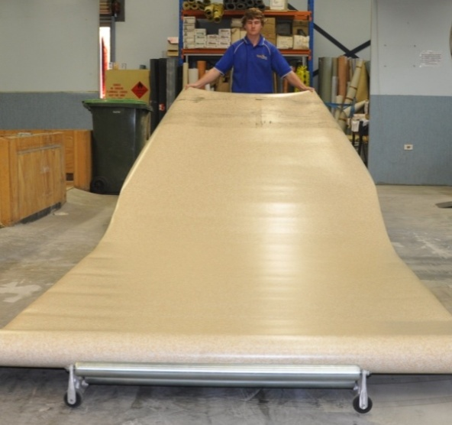
An easy way to lay out long lengths of sheet material on the floor is to use a linoleum dolly.
The dolly not only allows you to roll out the material with the face side up, it also reduces the risk of injury.
There will be times, however, when you won’t have access to a dolly on-site and you’ll have to make do with your own manual handling skills.
In these cases, you should roll out the material on the floor with the face side down, and then turn it over. The learning activity below will give you some hints on how to turn over a long sheet without damaging the material or straining yourself.

Learning activity
Go to the web link below to see a video clip produced by Altro Flooring called: ‘Altro handy hint – turning over a length of Safety Flooring without any lifting’.
http://www.youtube.com/watch?v=c8t0vSqr0W8
Watch the clip and answer the following questions:
- When the demonstrator doubles the flooring over, he rolls the top layer several times before lifting the bottom layer up over the top. How many times does he suggest you should roll the top layer before you lift the bottom layer up?
- Underneath the video clip there are some viewers’ comments. One entry asks: ‘Does it work for linoleum?’. What advice does Altro Flooring give, and why is it necessary to use a slightly different technique for linoleum?

Basic cutting and fitting
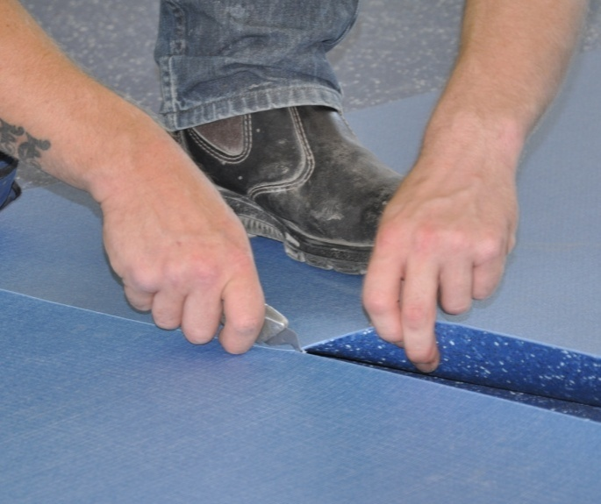
The basic techniques used to cut and scribe resilient sheets are similar for all sheet products, including lay flat vinyl, commercial vinyl and linoleum.
We covered these principles in Lay flat vinyl, under the following lessons:
- ‘Seams and joins’
- ‘Freehand cutting’
- ‘Direct scribing’
- ‘Pattern scribing’.
Let’s now look at the main differences that apply to commercial vinyl.

Seams and joins in commercial vinyl
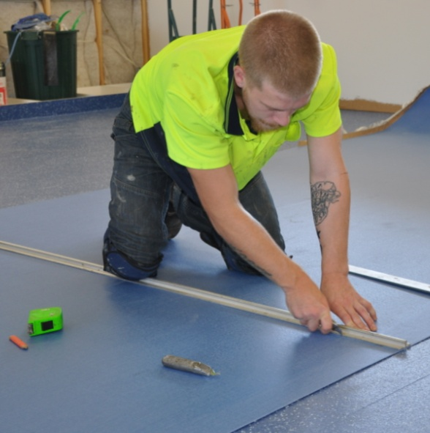
Commercial vinyl is thicker and tougher than lay flat vinyl, so you need to cut it in two passes of your knife – first with a straight or concave blade and then with a hook blade.
With the first cut, keep the blade vertical so that it runs cleanly and safely along the straightedge.
Maintain an even pressure and cut to a depth of about halfway to two thirds. With some materials you may need more than one pass to achieve this depth.
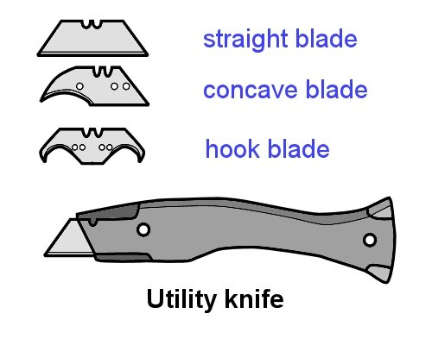
Complete the cut with a hook knife. If you want to make a bevel cut, such as when you’re fitting to a wall, you can tilt the blade slightly.

Using a recess scriber
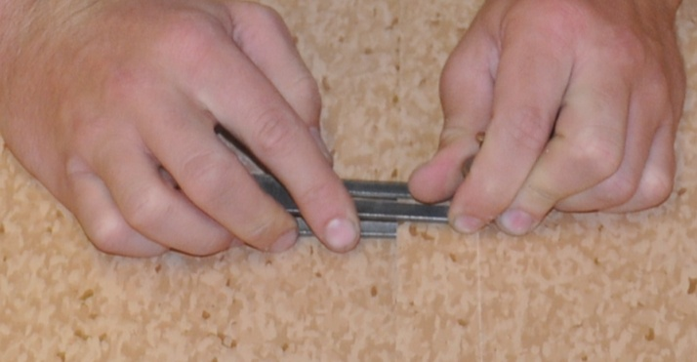
When you get to the second sheet, you can mark it with a recess scriber instead of using the straightedge, if you prefer.
A recess scriber is also called an under and over scriber, or simply ‘unders and overs’
The scribing procedure is as follows:
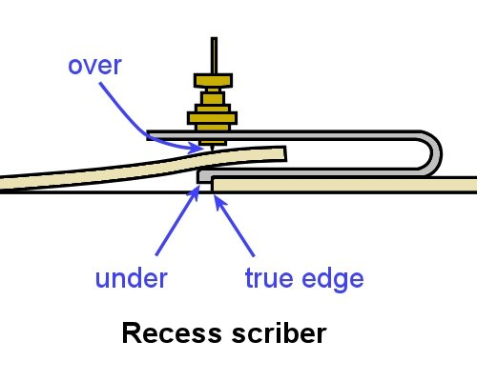
- Set the ‘over’ scribe pin to the point where the ‘under’ guide will run along the true edge. You can test the setting at one end of the sheet nearest the wall and make adjustments if required.
- Place the second sheet over the first sheet.
- Scribe the top of the second sheet, keeping the ‘under’ firmly against the true edge of the first sheet.
- Cut the scribed sheet using a straight blade and then a hook blade.
If the scribe mark is hard to see in the vinyl surface, you can rub it with chalk to highlight the line.

Learning activity
You’ll remember from the Lay flat vinyl unit that we watched the Armstrong Floors ‘Vinyl sheet installation video – Part 2’ at:
http://www.armstrong-aust.com.au/commflrpac/aus/ep/au/vinyl_video_library.html
The installer demonstrates how to use a recess scriber at
7 mins 35 seconds into this video.
Have a look at this little excerpt and then answer the following question:
- What setting does the narrator recommend that you use between the over pin and the under guide?

Assignment 1
Go to the Workbook for this unit to write your answers to the questions shown below. If you prefer to answer the questions electronically, go to the website version and download the Word document template for this assignment.
___________________________________________________________________________
- What does ‘resilience’ mean, according to Australian Standard 1884-2012?
- Choose two commercial vinyl products with different properties and end uses. For each one, answer the following questions:
- What is the product name and who is the manufacturer?
- What types of end uses is it most suitable for?
- What are its main features – that is, what characteristics would clients be looking for when they choose this product?
- What general maintenance advice is provided by the manufacturer?
- For each of the adhesive types listed below, answer the following questions:
- What is the product name and who is the manufacturer?
- Which resilient sheet products is it most appropriate for?
- What type of installation is it designed for (concrete subfloors, cove skirtings, wet areas, etc.)?
- How is it applied? If it requires a notched trowel, state the trowel notching size.
Adhesive types:
- Epoxy
- Polyurethane
- Acrylic
- Contact.

Section 2

General
laying techniques

Overview
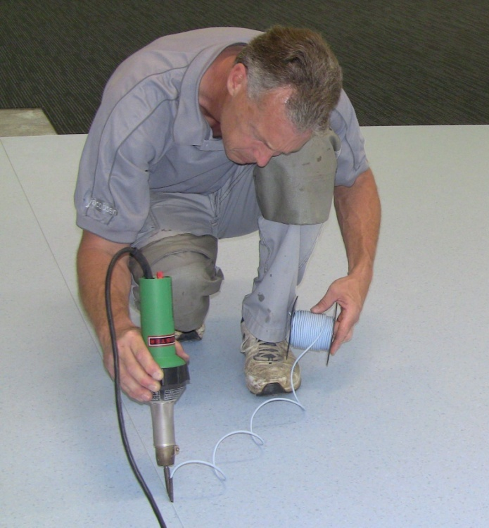
In this section, we’ll talk about the techniques used to stick down commercial vinyl and finish the job with heat welded seams.
When these tasks are done properly, the resilient floor becomes a very durable surface that will last for many years.
But there are some potential issues you need to look out for, because they can mean the difference between a high quality job and a call-back to rectify a problem. We’ll talk about these issues, and discuss ways of avoiding them.

Completing this section
The assignment for this section will test your knowledge of methods used to apply adhesives and heat weld commercial vinyl.
Have a look at the Assignment on page 38 to see what you'll need to do to complete it.
There are six lessons in this section:
- Applying an adhesive
- Problems with adhesives
- Heat welding equipment
- The welding process
- Heat welding problems
- Finishing the job.
These lessons will provide you with background information relevant to the assignment and the practical demonstration requirements.

Applying an adhesive
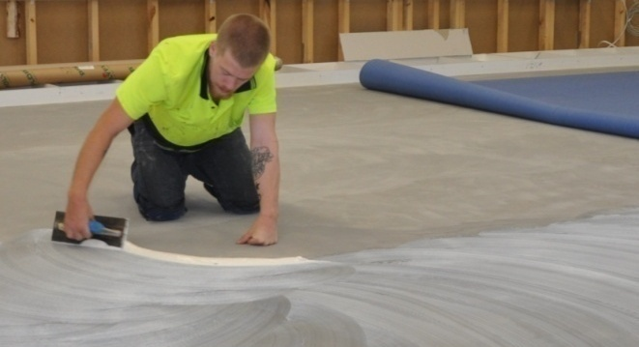
We covered the process of applying an adhesive in Lay flat vinyl, under the lesson ‘Full spread installation’.
Below is a summary of the procedure. If you need to revise any of the details, you should go back to that lesson and read the material again.

Notched trowels
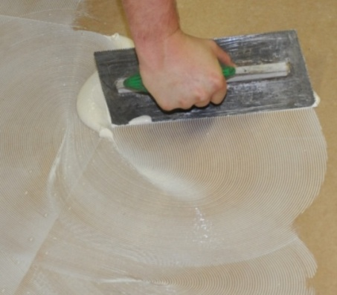
Most adhesives are designed to be spread with a notched trowel. The purpose of the notches is to control the amount of adhesive that’s spread on the substrate.
Manufacturers sometimes specify different trowel notchings for particular flooring and adhesive products. It’s important to follow these specifications, because if you don’t, you’ll end up applying either too much or too little adhesive.

Open time
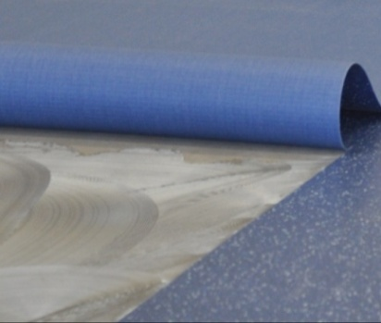
Once an adhesive has been spread, you need to wait until the open time has elapsed before placing the floor covering in position. This is also called the tack up time, because the ridges in the adhesive start to ‘skin over’.
If you place flooring onto the adhesive too soon, it traps the gasses being given off and can cause bubbles under the surface.

Working time
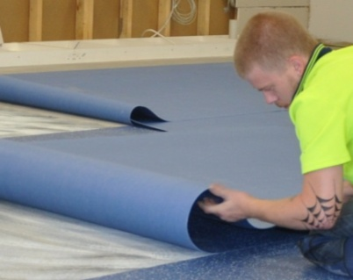
When the adhesive is ready for the flooring to be placed on top, the working time begins. This is the time you have available to lay the material and complete all cutting and fitting.
If you place flooring onto the adhesive after the working time has passed, the flooring won’t bond properly.

Variations in open and working time
The open time and working time of an adhesive will vary depending on the temperature, humidity and porosity of the surface. High temperatures, low humidity and porous surfaces will all reduce the times.
For very porous surfaces, such as wood-based underlays, manufacturers generally specify that a primer be applied first with a brush. This helps to avoid the problem of late placement, where the adhesive has already set and will no longer bond to the flooring covering.

Rollers
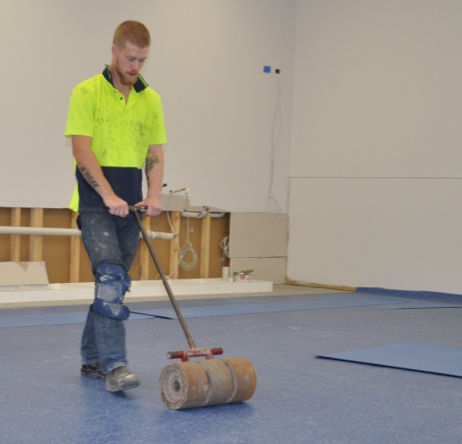
Once the floor covering has been placed in position and fitted, it needs to be pushed firmly into the adhesive. You should do this with a heavy floor roller, running lengthwise and then across the floor.
In areas that can’t be reached with a floor roller, use a hand roller.
Be sure to roll the edges and seams properly, because these are the areas where adhesive failures tend to start.

Learning activity
Go back to the Armstrong Floors ‘Vinyl sheet installation video – Part 2’ at:
http://www.armstrong-aust.com.au/commflrpac/aus/ep/au/vinyl_video_library.html
This time, go to the section called ‘Adhesive’, which starts at
5 min 10 seconds into the clip.
Watch this section and then answer the following questions.
Acrylic sheet vinyl adhesives contain two types of resin in the compound – a ‘tackifier resin’ and a ‘primary resin’.
- What is the purpose of the tackifier resin?
- What is the purpose of the primary resin?

Problems with adhesives
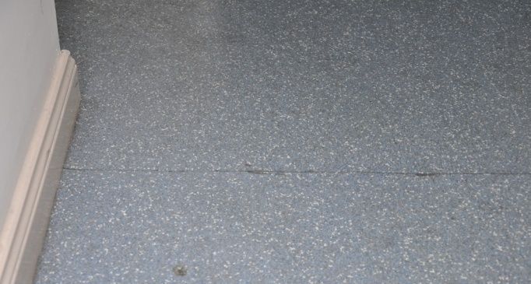
It’s worth remembering that most resilient floors never get a chance to actually wear out.
In practice, they often need replacement before they reach that stage because the adhesive has either failed or caused discolouration in the floor surface.
Below are some of the problems relating to adhesives and the technical terms used to describe the issues.

Plasticiser migration
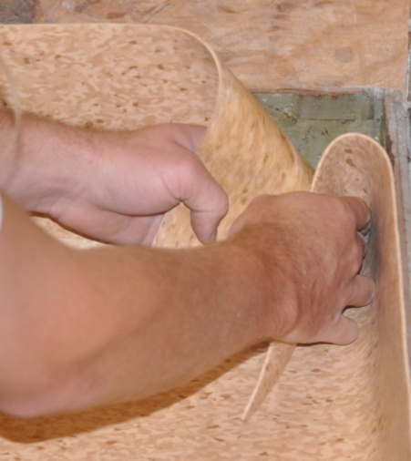
Plasticisers are used in vinyl flooring products to soften the material and improve its flexibility. They’re also used in adhesives to improve tack, or stickiness. Two common plasticisers are mineral oil and hydrocarbon oil.
When plasticisers leech out – or ‘migrate’ – from the flooring into the adhesive, they can send the adhesive soft and break down its holding power. This tends to happen when multi-purpose adhesives are used with vinyl-backed sheet floors.
The best way to avoid plasticiser migration is to only use adhesives that have been specifically recommended by the flooring manufacturer. This ensures that the two products are compatible with each other.

Adhesive failure
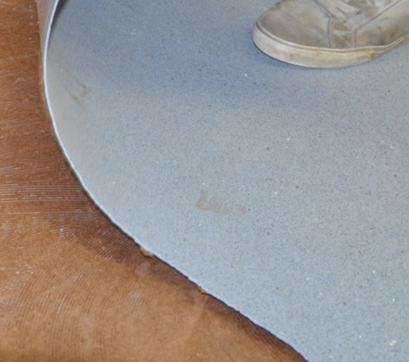
When an adhesive doesn’t bond properly to the substrate, the problem is often due to dampness in the subfloor, a curing compound on the surface, or weak material or dust on the surface.
If the adhesive doesn’t bond properly to the underside of the floor covering, the failure is more likely to be caused by late placement. That is, the floor covering has been placed on top of the adhesive after it has set.
The problem can also be due to using a worn or incorrectly-sized notched trowel, resulting in poor transfer of adhesive to the floor covering. In other cases, it could simply be because the wrong adhesive has been used.

Temperature extremes
Adhesives should only be used when the room and subfloor temperatures are within the range specified by the manufacturer. High temperatures can cause the solvent to evaporate too quickly in solvent-based adhesives, resulting in thickening and early setting.
Low temperatures can result in poor workability and heavy spread. In the case of emulsion-type adhesives, low temperatures can cause the components to break down and separate.

Shelf life and pot life
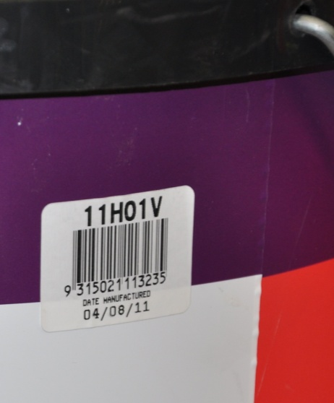
Some adhesives have a ‘use-by’ date stamped on the container or drum, indicating how long the product can be kept on the shelf. Once this shelf life has expired, you can no longer guarantee that the product will work exactly as you expect it to, because the components might start to deteriorate.
The photo at left shows a sticker with the date of manufacture printed on it. Although this isn’t a use-by date, it still lets you see how old the product is. You should always try to rotate the stock on the shelf, using the older stock first.
Pot life refers to the length of time you have available to use a two-part adhesive once you’ve mixed the components together, before it becomes thick and unworkable. It’s similar to ‘working open time’, which we discussed earlier in this section.
Don’t forget that the pot life shown on the container will refer to a particular temperature range, such as 20-23° C. If the temperature is hotter, the pot life will be reduced. If it’s colder, the pot life will be increased.

Diagnosing faults
Set out below is a table showing some of typical problems you’re likely to see in a floor when the adhesive fails. It is adapted from the ‘Adhesives fault diagnosis’ table produced by Forbo Flooring Systems in their publication: Forbo Floorcoverings Installation Guide.
You can download a copy of this guide from their website at:
http://www.forbo-flooring.com.au/
Note that the descriptions of problems and their causes are only generalisations. In practice, there might be other reasons why a particular floor has failed.

Adhesive problems and causes
Appearance on subfloor | Appearance on flooring | Cause
Clearly defined ridges | No transfer, or only slight transfer | Lack of rolling
Clearly defined ridges | Shadowing on surface with no or slight transfer | Late placing
'Pooling', smeared and crinkled, or 'cratered' | Smeared and crinkled, especially at seams and edges | Uneven subfloor
Flat ridges | No transfer | Wrong adhesive
Wet, sludgy, smelly | Staining badly | Wet or damp screed
Adhesive soaked in | Granules of screed adhering | Dusty, weak screed
Powdering of adhesive and wet patches, possibly smelly | Pale coloured, powder on tile edges and back | Alkali attack
Asphalt subfloor softened | Vinyl tile stained dark brown or black | Wrong adhesive, e.g. petroleum base
No key to subfloor | Good key | Contaminated subfloor
Sparse and low ridges | Not sticking, little transfer | Wrong trowel used
Heavy application, 'skinned' | Indentation, little transfer | Over application of adhesive, late placing of flooring
Soft, wet, thick adhesive film | Adhesive squeezing through joints | Over application of adhesive, early placing of flooring
No adhesive | Curling at perimeter, no transfer | Adhesive stops short of wall
Clearly defined adhesive ridges (when present) | Perimeter tiles only – loose, curling and hollow sounding | Late placement

Learning activity
Have another look at the ‘Adhesive problems and causes’ table on the previous page. Have you seen any examples of these problems, either in your own work or in another floor you’ve inspected?

Describe one or two of the examples you’ve seen, including the type of flooring involved and other aspects of the job that were relevant to the problem.

Heat welding equipment
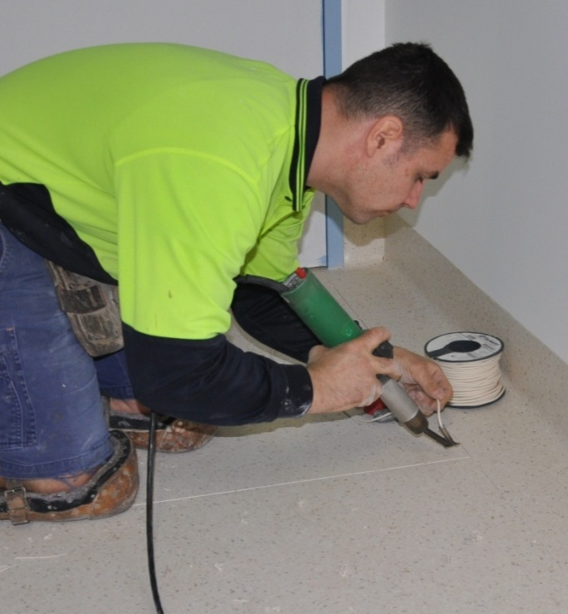
Commercial vinyl seams are always heat welded. This stops dirt, moisture and other substances from getting into the joins.
The job specifications will generally set out the specific requirements for the welds, particularly in projects where hygiene is important, such as in hospitals and aged care facilities.
Although the welding cable and flooring material melt and fuse together, the seams still need to be well cut and fitted properly, otherwise the welded join will be very noticeable.
Note that some people say ‘welding rod’ instead of ‘welding cable’. Both of these terms mean the same thing.

Welding equipment
Most installers use hand-held tools to heat weld a seam. However, on large projects installers sometimes use powered machines. Below are the typical tools used in heat welding.
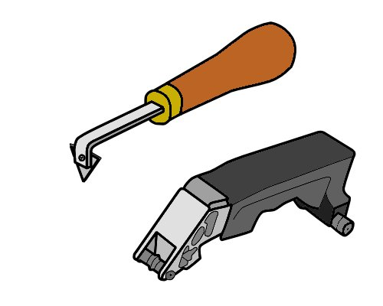
Hand groover or turbo groover – used to groove out the seam in preparation for heat welding with a welding cable.
The depth and width of the groove may vary, depending on the type of flooring product being welded.
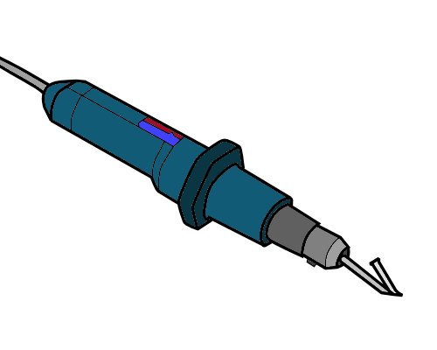
Welding gun – used to heat the flooring material and welding cable so that they melt and fuse together.
The gun is fitted with the correct tip to match the welding cable diameter and type of flooring being welded.
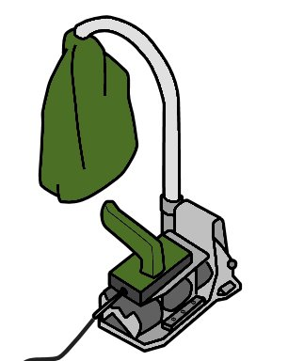
Spatula and slider – used to trim the welded material in the first pass.
Once the welded material cools it is trimmed
a second time, flush with the floor surface, using the spatula only.

Grooving machine – an alternative to a hand groover.
There are various types of electric-powered machines available.
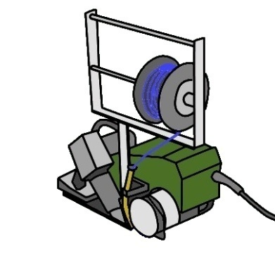
Welding machine – an alternative to a
hand-held welding gun.
Again, there are various types and sizes
available to suit different applications and
job sizes.

Welding gun maintenance
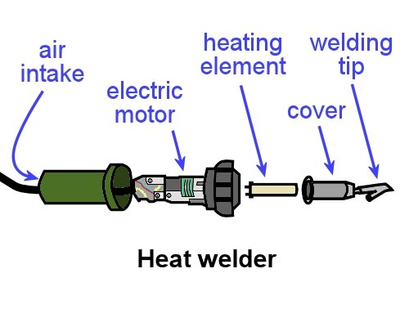
When it’s looked after properly, a welding gun should last for many years. The way it works is quite simple – air is sucked in at the back, heated by a heating element, and blown out through the tip.
However, if dust is allowed to build up in the air intake gauze, it can be drawn into the electric motor and cause it to overheat. Always keep the intake gauze clean, and check that there is no build-up of lint or dust before you turn it on.
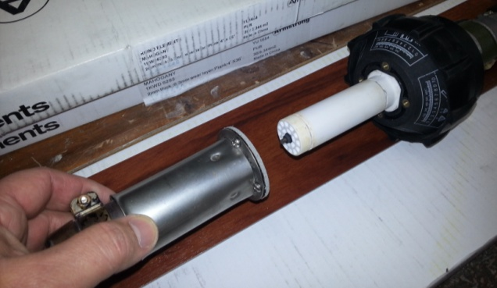
The heating element is also very sensitive. You need to let it cool down before you switch off the internal fan so it doesn’t burn out.
Installers often carry a spare heating element with them just in case they need to replace it while they’re on the job.
Note that you should never pull apart the electrical side of a welder or tamper with the wiring. Always leave those sorts of repairs to an electrician.

Learning activity
We’ll look in detail at the process of manually grooving and heat welding a seam in the next lesson. But for now, let’s have a look at some of the power tools on the market designed to do these tasks.
Follow the links below to see the video clips produced by two manufacturers. Watch the videos and then answer the questions.

1. ‘Master Turbo groover’
http://www.youtube.com/watch?v=qbg2WH3tS9c
- What blade sizes are available for the Turbo groover?
- Which blade size is factory fitted?

2. ‘Welding floor with Leister Unifloor’
http://www.youtube.com/watch?v=vSe94CQzRS4
There is a range of nozzles available for different types of floors. What types of floors are the following three nozzles used for?
- Standard
- Pressed
- Air knife.

The welding process
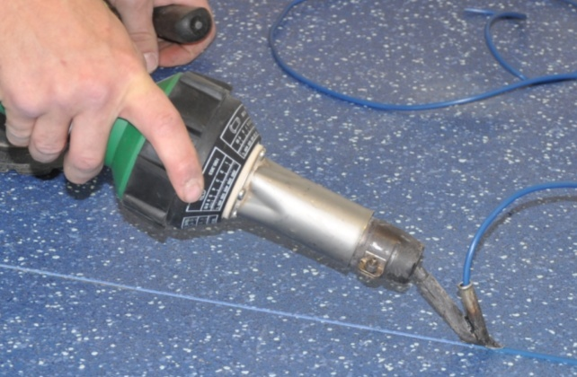
The first step in achieving a good weld is to wait until the adhesive has properly dried. For most types of adhesive, the minimum waiting time is overnight.
If you start to weld before the adhesive has dried, the heat from the gun will turn the moisture into water vapour, which will affect the quality of the thermo-fusion (or ‘heat’-fusion) that takes place.
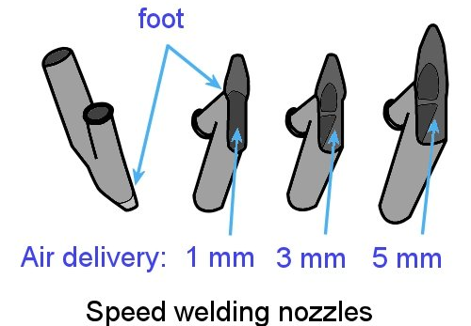
Secondly, you must select the correct tip – or ‘nozzle’ – for the type of material being welded. The size of the foot at the base of the tip controls the amount of air being blown through.
Most solid (homogeneous) sheets require a 5 mm speed tip. Layered (heterogeneous) sheets, on the other hand, generally need a 3 mm tip to reduce ‘glossing’ on either side of the seam.
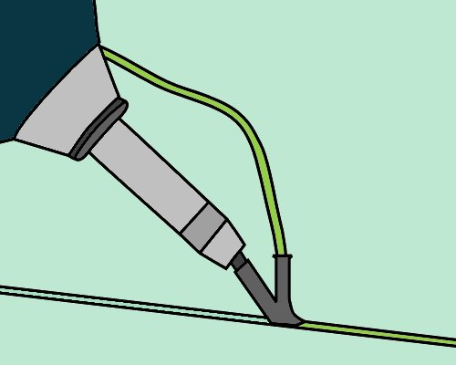
Thirdly, you need the right combination of temperature, speed and pressure. The correct temperature will be specified in the flooring manufacturer’s guidelines.
The speed and downward pressure will depend on the materials you’re welding and the model and temperature of the welding gun. Vinyl seams are generally welded at about 2 metres per minute.

Manual welding procedure
The general procedure used to manually groove and heat weld a seam in commercial vinyl is as follows:
- Groove out the seam to two-thirds of the depth of the material with a hand groover or turbo groover. Make sure that the width of the ribbon that’s cut from the edge of each sheet is the same.
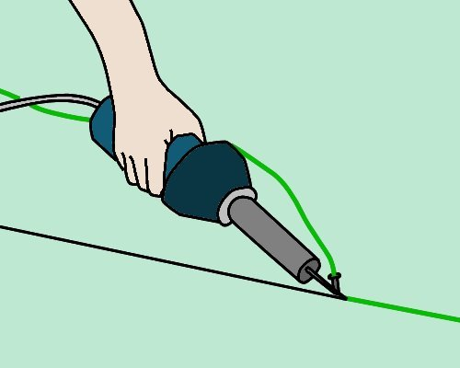
- Fit the correct nozzle to the welding gun. Make sure the nozzle is facing away from the floor and other objects, and turn the gun on and allow it to reach the set operating temperature.
Cut the welding cable to length, or unwind a certain amount from the reel. Thread the cable through the nozzle.
- Weld the material, starting at the wall and moving away at a steady speed.
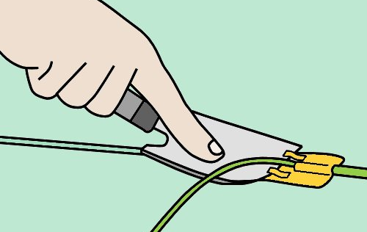
- When you’ve completed that section, trim off the excess material down to about half a millimetre using a sharp spatula and slider.
Do this while the cable is still warm so that it cuts smoothly without gouging. This first cut will also help the cable to cool more quickly.
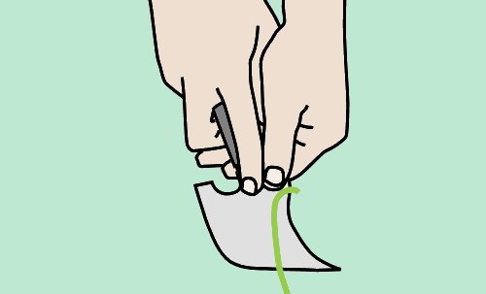
- Wait until the material cools, and then trim the cable flush with the floor surface using a spatula angled slightly across the line of the cut.
If the trimming action pulls out the weld, you’ll need to remove it and do that part again with fresh welding cable.

Joining a weld
To join a weld where you’ve left off in the middle of a seam:
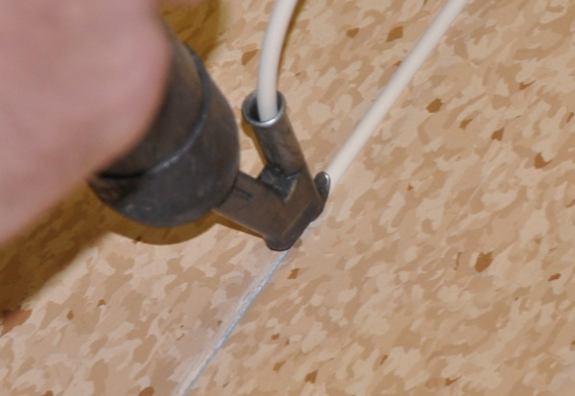
- Trim the loose end with a knife and chamfer down the end of the existing weld with a hand groover where it is to be overlapped.
- Start the gun at the end of the existing weld and apply pressure as it travels over the un-welded section. Complete the weld and trim as normal.

Welding PUR coated floors
Most resilient sheet products have a PVC (polyvinyl chloride) coating on top. However, there is an increasing range of PUR (polyurethane) coated products coming onto the market. These provide the benefit of a harder wearing surface for the client, but present a new headache for the installer who has to weld them.
PUR surfaces tend to plasticise and decompose at lower temperatures than PVC. If they’re welded in the same way as for PVC, the surface can be discoloured or destroyed.
There are special welding tips used for PUR floors, designed to heat the inner areas of the groove to the required temperature without destroying the surface. One example is the ‘air knife’ nozzle developed by Leister (see the second video clip from the last lesson – ‘Welding floor with the Leister Unifloor’).

Learning activity
Go to the Armstrong Flooring instructional videos at:
http://www.armstrong-aust.com.au/commflrpac/aus/ep/au/vinyl_video_library.html
Select ‘Vinyl sheet installation video – Part 3’.
Watch the first 2 minutes of the video and then answer the following questions:
- How long should you wait after sticking down the sheets before you start the welding process?
- How deep and how wide should you groove out the seam with a grooving tool?
- Why do the seams need to be well cut with a gap of no more than 0.5 to 1 mm? That is, why can’t you simply fill up a wide gap with welding cable?

Heat welding problems
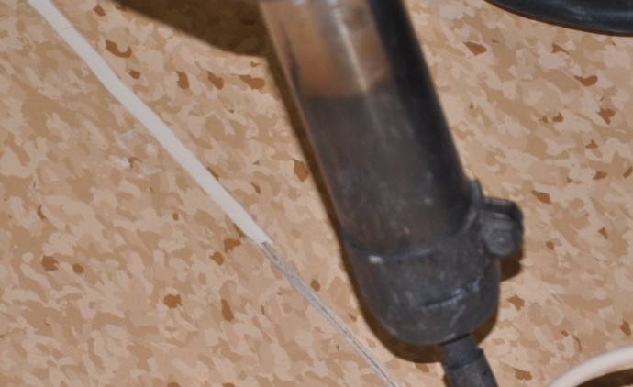
There are lots of reasons why welds fail. Sometimes it is due to problems in the materials or subfloor. Other times it’s simply due to a lack of skill or knowledge in the process.
However, heat welding is like most other skills, in that the more you practise the better you’ll get.
Below are some of the common problems that can occur with welds. They are summarised from an article written by Ray Thompson called ‘Why did the heat melt fail?’ You can read the original article on the Floor Trends website at:
http://www.floortrendsmag.com/articles/94158-why-did-the-heat-melt-fail?v=preview
Note that to access the full article you’ll need to register first. However, registration is free.

Common problems

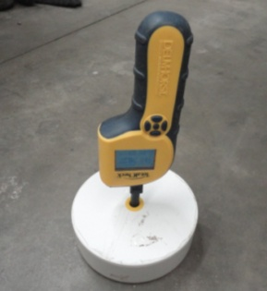
Substrate and adhesive
Excessive moisture in the slab – water vapour in the seam can affect the heat fusion process and reduce its bonding strength
Wet adhesive – for most adhesives, you need to wait until the following day before you start to weld the seams.

Groove
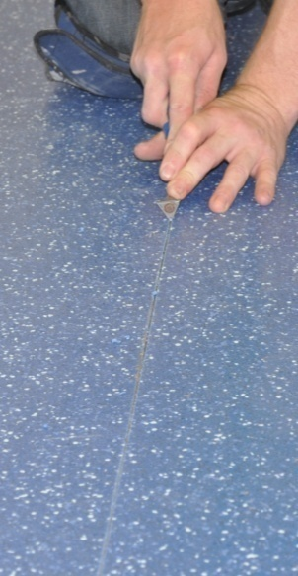
Uneven groove – if the edges of a seam aren’t even, or the groove isn’t centred properly, there won’t be a consistent V-shaped depth to the groove. This will affect the strength of the weld.
Groove too wide – the width of the groove needs to be correct for the diameter of welding cable being used, otherwise the quantity of cable won’t match the gap being filled.
Contaminated groove – if you allow dust or other contaminants to fall into the groove, the weld won’t bond properly. Don’t groove the whole area before you start welding – only groove the seam you are about to weld.

Welding gun
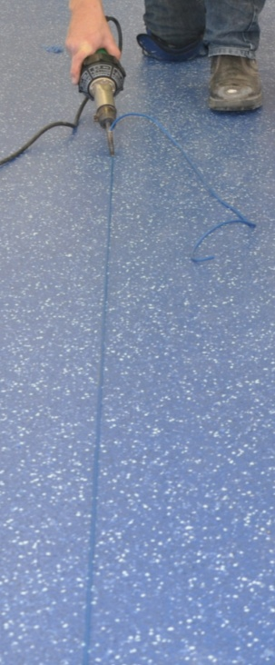
Sudden movements – if you reposition your body and make the weld tip jump while you’re welding, it can result in a loose section of welded material.
Moving too fast – the gun needs to be pulled along the groove at just the right speed for the temperature setting and material being welded. If it’s too fast there won’t be enough time for the fusion to take place.
Gun not hot enough – it takes time for the gun to warm up, so you must wait until it reaches its operating temperature. Low heat will result in poor fusion.
Gun not held over the groove – if you hold the gun at an angle you’ll ‘crowd’ one side of the seam. Make sure you keep the gun upright with an even pressure on the tip.
Wrong tip – the tip must be the correct type and size for the cable and product being welded. If there is too much ‘hot air wash’ because the wrong tip is being used, you might scorch or distort the coating on the wear surface.
Dirty tip – the tip must be cleaned after every weld, as some residue can burn inside it and become embedded as black specks in the next weld..
Trimming
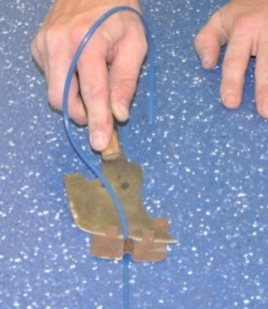
Trimming too early or too late – the timing of the first trimming pass is determined by the material you’re welding. With commercial vinyl you should do the first pass while the weld is still warm, and then let it cool completely before doing the second pass.
If you’re too quick with the second pass, you might end up with a severely concaved weld.

Learning activity
Have you experienced any of these problems in your own welds or seen them in other people’s work?
Describe the appearance of the weld and state what you think might have caused the problem.

Finishing the job
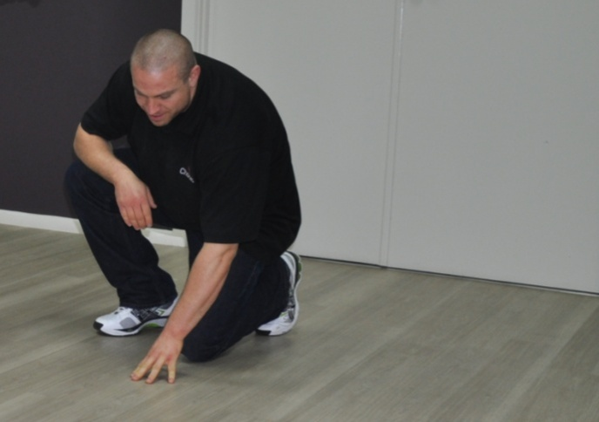
Once you’ve completed the installation you should carefully check the finished floor to make sure everything looks right.
In particular, look for:
- loose edges or seams
- trapped air bubbles or buckles in the flooring
- adhesive on the surface.

Protecting the new floor
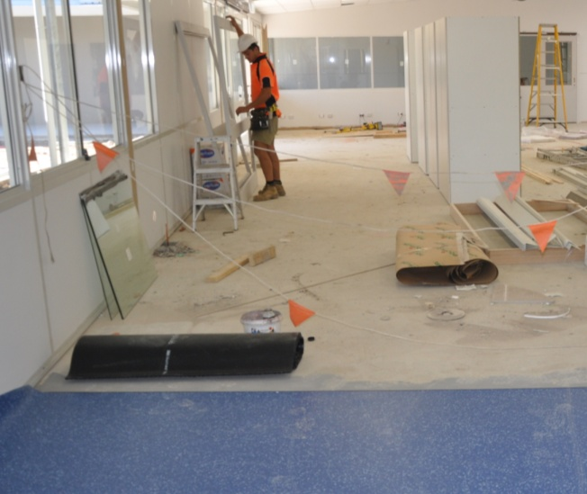
Depending on the type of worksite you’re at, you might need to put up signs or barriers to stop people from entering the area until the adhesive has fully cured.
In high traffic areas you can also put a protective covering over the floor to minimise the chance of damage.
If you do, make sure the covering doesn’t have a rubber or latex backing that might discolour the floor surface.
On projects where it’s your job to move heavy appliances back into position, use plywood panels or other board products as protection underneath the appliance.
Slide the first board under the object as you lift it off the floor one side at a time. Then put another board beside the first one and push the object over the boards. Don’t roll or drag the object directly across the new flooring material.
Commercial floors should be protected from rolling loads for at least 72 hours after the installation is finished.

Housekeeping
Take all your rubbish and materials with you, except for left-over pieces of floor covering that might be useful to the client for future repairs. Be particularly careful with hazardous products that need to be disposed of in an approved way.
Don’t put materials or rubbish in doorways or other access ways, because they’ll probably get knocked over and end up being a trip hazard. Keep everything well stacked and out of everyone’s way.

Maintenance
It’s important to give the floor a good clean once the job is completed. You need to make sure that there is no grit left behind that could scratch the floor and no marks or dirt that might look unsightly.
Be careful not to over-wet the floor in its initial clean. Although most flooring adhesives have a good resistance to moisture once the adhesive has cured, it often takes a few days for that level of resistance to be achieved.
This is especially the case when alkaline cleaning liquids are used.
On small jobs you should mop up the dust and then use a low speed rotary machine to mechanically clean the floor. On large jobs it is often more cost effective to get a professional cleaner in to do the task with specialised equipment.

Learning activity
Go to the Armstrong Flooring videos page at:
http://www.armstrong-aust.com.au/commflrpac/aus/ep/au/vinyl_video_library.html
Select ‘Vinyl sheet installation video – Part 6’.
Watch the video and then answer the following questions:
- What are the recommended methods for carrying out the ‘initial maintenance’?
- What coloured pad should you fit to the floor polisher?

Assignment 2
Go to the Workbook for this unit to write your answers to the questions shown below. If you prefer to answer the questions electronically, go to the website version and download the Word document template for this assignment.
___________________________________________________________________________
- What on-site conditions can affect the duration of an adhesive’s open time and working time? Name three factors.
- List three things that can go wrong with an installation due to an adhesive problem. For each one, answer the following questions:
- How has the problem affected the finished floor (that is, what has it done to the floor, or what does it look like)?
- What is the cause of the problem?
- How would you avoid this problem (what extra precautions could you take, or how would you vary the installation process)?
- List three things that can go wrong with a heat weld. For each problem, answer the following questions:
- What effect does the problem have on the finished weld?
- What is the cause of the problem?
- How would you avoid this problem?
- What advice would you give to the client about protecting their new floor immediately after installation?

Section 3

Borders, features
and coving

Overview
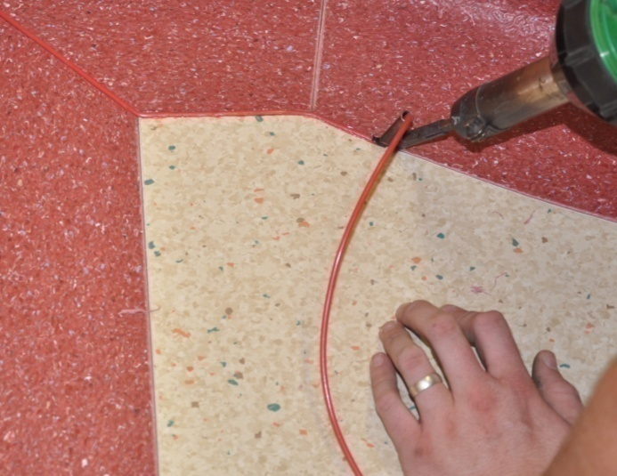
The way you finish a floor covering at the borders will depend on the purpose of the floor and the design that the client has asked for.
In this section, we’ll examine the main types of coving used in commercial floors and methods used to install them.
We’ll also look at some basic techniques for incorporating motifs and features into a flooring project.
These sorts of decorative designs can be as complex as the client’s imagination and budget allow. However, the principles of cutting and fitting them remain much the same, even though in practice there may be a huge variation in the work involved in setting out and installing them.

Completing this section
The assignment for this section will test your understanding of the different types of coving used in commercial flooring and the basic methods used to install coving, borders and features.
Have a look at the Assignment on page 57 to see what you'll need to do to complete it.
There are six lessons in this section:
- Borders and feature strips
- Types of coving
- Fitting cove formers
- Coving field material
- Fitting cove skirting
- Motifs and patterns.
These lessons will provide you with background information relevant to the assignment and the practical demonstration requirements.

Borders and feature strips
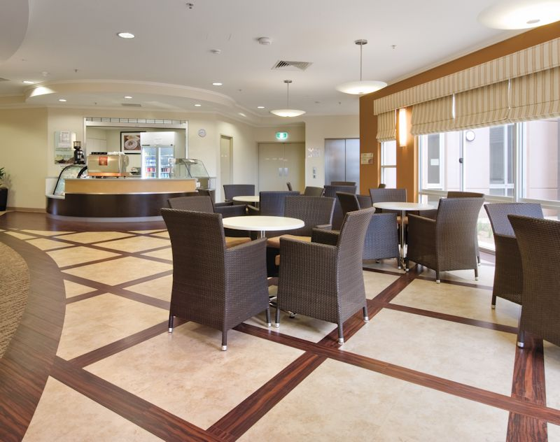
Borders and feature strips are designed to make a floor look more attractive.
Borders go around the field area of a floor and can vary in size and style. Feature strips are generally narrower, and often form part of the overall floor design.
Apart from these differences, they are much the same in terms of installation techniques.

Installing a simple border
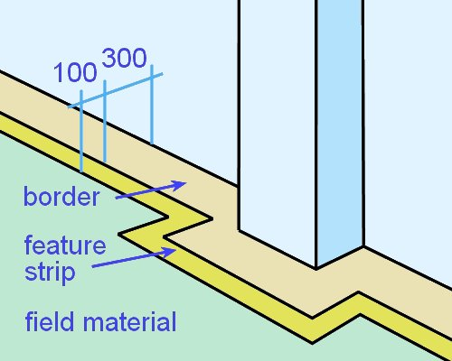
The drawing at right shows a yellow feature strip set in 300 mm from the wall, and a beige coloured border against the wall.
To install this border:
- Strike a chalk line to mark out the inside edge of the border pieces (the edge furthest away from the wall). Note that ‘striking’ a chalk line means snapping it against the surface to leave a chalk mark.
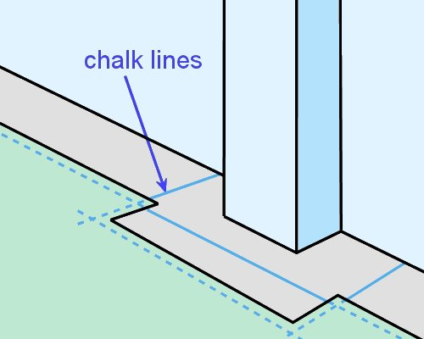
- Cut the field material so it overlaps the chalk line by about 50 mm.
- Spread the adhesive to the chalk line only and press in the field material, leaving the last 50 mm unstuck. Roll out the field material with a roller.
- Transfer the chalk line to the top of the field material, using the line on the floor either side of the material as reference marks.

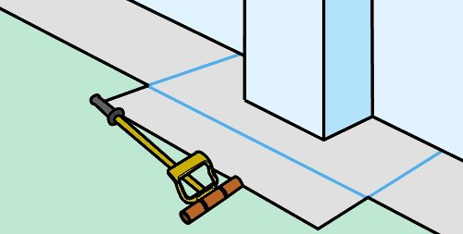
- Cut along the line with a straight edge and upright knife and then roll the
edges again.
- Cut the border strip 50 mm wider than its finished size will be (that is, cut it to 350 mm) to allow for scribing and trimming.
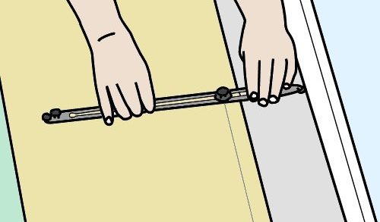
- Butt the border piece against the field material, set the bar scriber to make allowance for the 100 mm distance from the wall, and scribe the wall line onto the piece. Then cut the piece to size.
- Cut the feature strip to the exact width (100 mm).
- Check the fit of the feature strips and border pieces by putting them into position, starting at the inside and working towards the wall.
- Remove the pieces and spread adhesive between the wall and field. Press the pieces into position and roll thoroughly with a hand roller.
Some installers like to weld the seams using a contrasting colour of welding cable. A seam weld can even be used as a feature strip in its own right, set into the floor in a contrasting colour. It’s also possible to install the border first, before you lay the field. This helps with the overlapping of the two colours in the weld.

Learning activity
Have you worked on any installations that involved borders or feature strips?
What type of project was it? What was the design?
If you haven’t done these sorts of installations before, have a look around in your travels at some examples of borders and feature strips. You’re likely to find them in shopping centres, foyers in large offices, hospitals, and so on.
Also ask your supervisor or another experienced installer about the types of jobs they have worked on. What were the designs and patterns? How did they set them out on the floor?

Types of coving
Coving is the process of turning up a sheet at the perimeter to provide a continuous surface between the floor and wall, or floor and other vertical surfaces.
It’s often used in commercial buildings, hospitals and schools, especially in areas where hygiene is important or a watertight seal is necessary.
When the field material is used as the cove, the process is often called:
- flash coving, because the coving is ‘flashed’ up the wall, or
- integral coving, because the cove is an ‘integral’ part of the sheet.

Types of coving
Australian Standard 1884 describes three types of cove: preformed, border and pencil cove.

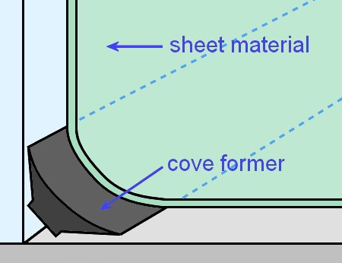
Preformed cove
When a cove former or fillet is used to support the sheet at the floor/wall junction, the cove is called preformed, since the radius of the curve is set by the fillet piece.
We’ll look in detail at the process used to install preformed coving in the next lesson.

Border cove
A border cove uses a separate piece of sheet material which is joined at the floor to the field material. The border piece can be the same colour as the field material or a contrasting feature colour.
Linoleum coving is generally installed in this way. We’ll cover the installation process for border coving in the unit: Linoleum.

Pencil cove
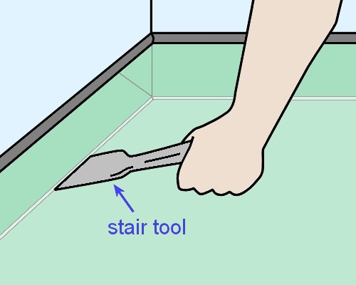
Vinyl sheets with good flexibility can be installed with a pencil cove.
The field material is flashed up the wall, in the same way as with preformed coving, but there is no cove fillet involved.
Instead, the material is simply pushed into the junction between the wall and floor with a stair tool.
AS 1884 specifies that the radius of the curve for a pencil cove must be a maximum of 5 mm. To help achieve this tight radius, the material is warmed with a heat gun to make it more flexible.

Learning activity
The curve at the bottom of a cove is sometimes described in terms of its size and other times in terms of the radius of the curve. For example, a common size for a cove former is 25 x 25 mm, which refers to the height and width of the piece when it’s in position.
But a pencil cove is required to have a curve of no more than 5 mm radius. Can you explain what this means?
If you have trouble remembering what a radius is, go to the lesson ‘Area’ in the unit: Making measurements.

Fitting cove formers
PVC cove former, or cove fillet, comes in a range of sizes – typically 20 mm, 32 mm and 38 mm. It is stuck in place with contact adhesive.
Traditionally, a solvent-based adhesive was always used, but these days manufacturers often recommend two-part acrylic contact adhesives.
To fit a cove former into place:
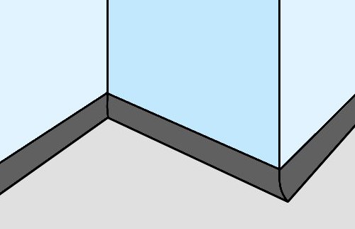
- Apply contact adhesive to the back of the cove former and the substrate with a brush or roller and allow it to ‘tack up’.
- Carefully put the cove former in place and push it into the adhesive.
- Mitre the joints at corners with a utility knife.
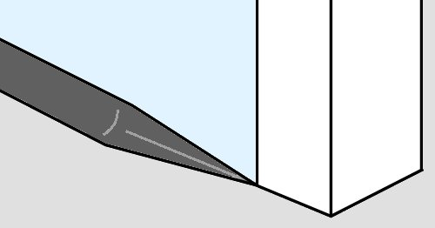
If the room has doorways without architraves (or has very thin architraves), you should taper the last 200 mm of cove former so that there is no gap at the end of the sheet.
This is called fitting a ‘reduced cove’.

Learning activity
The links shown below will take you to two video clips produced by Altro Flooring on the methods used to fit cove formers.
Although these techniques apply to cove formers in general, the products used in the videos are manufactured by Altro.
This is why the narrator refers to the floor covering as ‘ASF’ – which stands for Altro Safety Flooring.
Installing and laying safety flooring on a reduced cove:
http://www.youtube.com/watch?v=aOESvsQWl7U

Fitting cove former:
http://www.youtube.com/watch?v=KMWRstRqoCY
Watch the video clips and answer the following questions:
- How does the installer take the tension out of the reduced cove former (first video) after he has cut a V shape in the end?
- What type of adhesive does he apply to the back of the cove former and to the wall and floor (second video)?

Coving field material
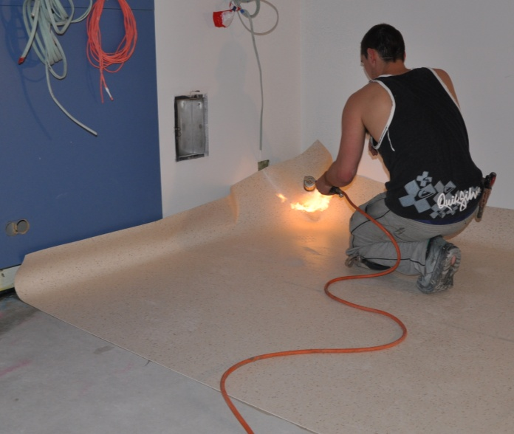
In many installations, the field material is flashed directly up the wall as a cove.
When it’s installed in a wet area, such as a shower, bathroom or other area subjected to running water, the coving height must be at least 150 mm at the wall or vertical fixture.
Depending on the radius of the curve at base of the coving, a heat gun may be used to make the floor covering more flexible, particularly at corners.
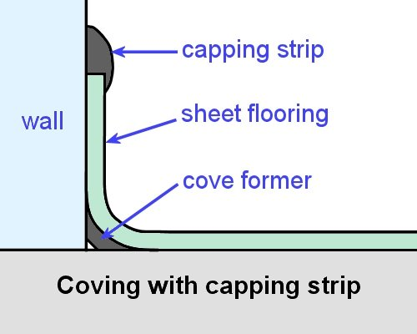
There’s a variety of techniques used to flash the field material up a wall and cut internal and external mitres at corners. The method you choose will depend on the products you’re using and the specifications for the project.
Some installations specify a cove former and capping strip. Others require a cove former only, with no capping.
In wet areas, AS 1884 says that the overlap method or welded method may be used to finish the coved sheet to a resilient wall.
The overlap method is preferred in shower cubicles because it provides more protection to the join. You’ll see in the diagram below that a diminishing strip is used to fill the space under the wall sheet where it overlaps the coved floor sheet.
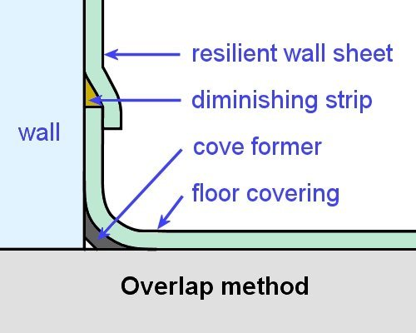
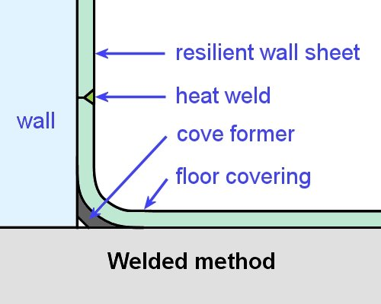

Internal and external ‘butterfly’ corners
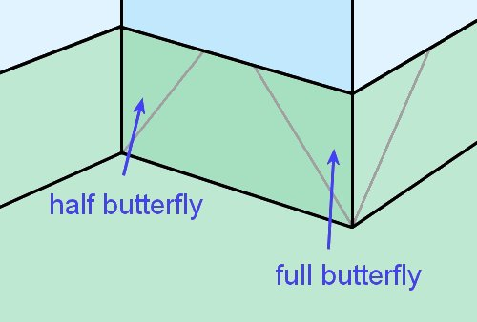
AS 1884 does not permit vertical welds in the corners of coved sheets in wet areas. This is because the weld could become a weak point if there is any movement in the substrate, which would reduce the corner’s water resistance.
Instead, the joints must be cut at 45 degrees to the corner.
An easy way to do this with an external corner is to insert a V-shaped piece of material that wraps around the corner.
This is called a full butterfly. The back of the butterfly piece is grooved to make it fold around the corner more easily.
Internal corners are also finished at 45 degrees. In this case, the triangular shape of the piece that wraps around the corner is called a half butterfly.
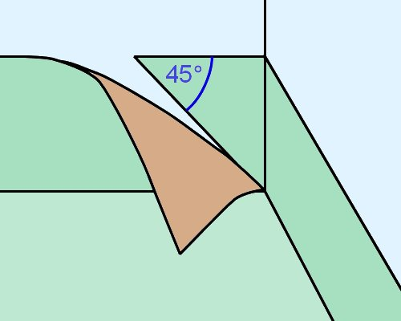
The link below goes to a video clip produced by Altro Flooring that demonstrates how to form butterfly corners.
Note that it is called ‘Alternative methods’, because there are other clips in the Altro series that show how to cut and weld mitred corners with vertical joins.
However, these techniques are not approved in AS 1884 for wet areas.
Altro Flooring – ‘Alternative methods’:
http://www.youtube.com/watch?v=ni57m2zVYxo

Mitred corners using a ‘make-out’ piece
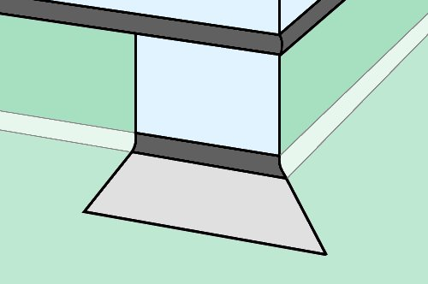
In areas where water resistance is not a priority, it is possible to mitre the corners with the aid of a separate make-out piece.
However, the end result is a corner with a vertical join, so you must make sure that it will be acceptable in the project you’re working on before you decide to finish the corner in this way.
The video clip linked below shows the process for fitting internal and external mitres with a make-out piece.
‘Altro handy hint – fitting to an internal and external mitre’:
http://www.youtube.com/watch?v=71Cy4cuiHBM

Learning activity
Here are the individual video links again, together with questions relating to the techniques being demonstrated.
Watch the videos and then answer the questions.
1. Butterfly corners:
http://www.youtube.com/watch?v=ni57m2zVYxo
- How does the installer make the flooring material more flexible so it can be pushed tightly into the corner?
- How does he enable the butterfly piece to bend easily around the external corner?
- What technique does he use to avoid scorching the capping seal while he is welding the joint?
- How does he ‘blend in’ the ends of the welds after they have been trimmed?
2. Make-out piece:
http://www.youtube.com/watch?v=71Cy4cuiHBM
- How does the installer mark a line in the coved material in the internal corner before he cuts it?
- Which part of the make-out piece does he cut first?
- Which part of the make-out piece does he cut last?

Fitting cove skirting
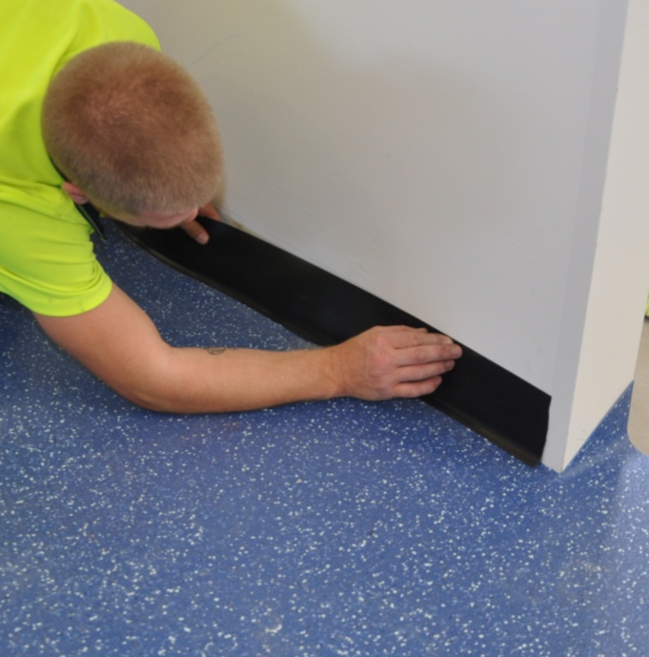
Cove skirting is an extruded vinyl product that’s stuck to the wall around the floor perimeter.
It is sometimes called:
- feather edge skirting, because it’s tapered at the top and toe
- sit-on cove skirting, because it sits on top of the floor covering.
The product is very flexible, so it can either be mitred at the corners, or simply wrapped around with the aid of relief cuts. It is often supplied in 15 metre coils.

Straight lengths
To fit straight lengths of cove skirting:
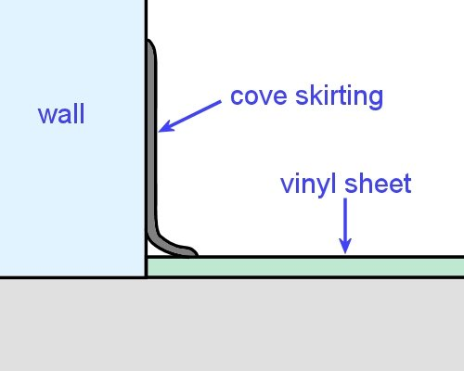
- Draw a pencil line on the wall to mark the height of the coving.
- Spread contact adhesive on the wall to the pencil line and wait for it to tack up. Use an offcut as a drop sheet to protect the flooring.
- Press the skirting into the adhesive, keeping the toe at an even distance from the wall.

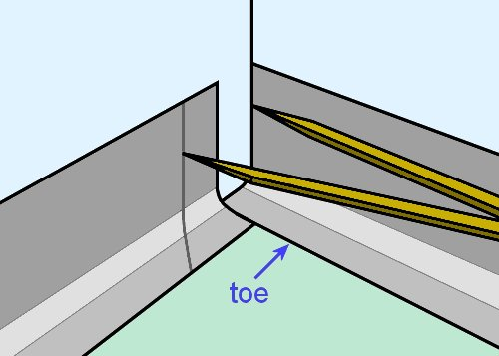
Internal corners
To fit an internal mitred corner:
- Stick the first piece of skirting to one wall, leaving the toe un-mitred.
- Scribe the vertical part of the second piece with dividers and then mark the toe with a 45° internal mitre.
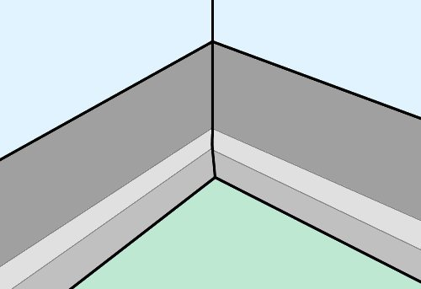
- Cut the coving and chamfer the underside of the cut to ensure a tight fit.
- Stick the second piece to the toe of the first piece.
To fit a wrap-around internal corner:
- Roll the skirting around the corner and put a cut in the toe.
- Push the skirting tightly into position, and then double cut a 45 degree mitre into the toe.

External corners
To fit an external mitred corner:
- Place a piece of skirting along one wall, extending past the corner, and draw a pencil line on the floor against the toe. Do the same on the other wall and draw a second line so that both lines intersect.
- Draw a line from the corner to the intersection of the two lines to mark the angle of the mitre.
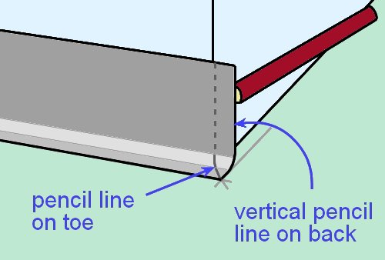
- Place the first piece of coving in position and draw the mitre cut on top of the toe
with a pencil.
Keep the coving in position and draw a vertical line down the back of the coving at the wall corner – using a small scrap as a spacer to ensure that the thickness of the second piece is allowed for.
Push a knife into the back of the coving at two points on the line – this will show as two white marks on the front of the coving, which can be used as guide marks – and then draw a corresponding line on the front.

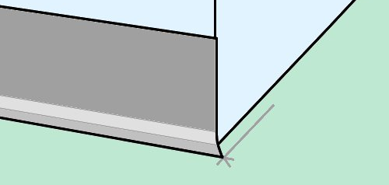
- Cut the coving along the pencil line on the front, including the mitre at the toe.
Pare away the face of the cut at a 45° angle on the vertical and curved sections, so that when the two pieces of coving are pushed together they will form a tight fit.
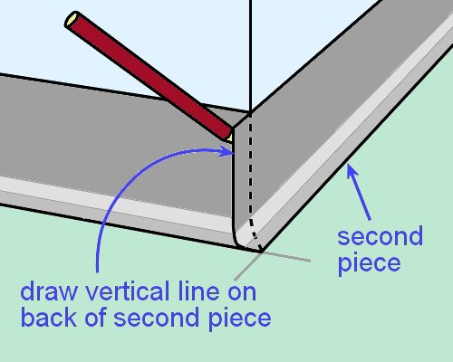
- Prepare the other end of the piece, as required, and then stick the piece into position with contact adhesive.
- Put the second piece in position, overlapping the outside point of the mitre on the first piece. Mark that point on the toe of the second piece.
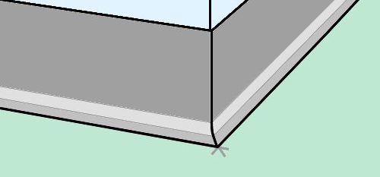
Mark the vertical line on the back of the second piece by tracing along the line of the first piece.
- Cut and fit the second piece.

To fit a wrap-around external corner:
- Gently heat the skirting to improve its flexibility.
- Wrap the skirting around the corner using a hand roller.
If the external corner is tight, you may need to cut a groove in the back of the skirting to about ¼ of the depth, so it bends around the corner more easily.

Learning activity
The link below will take you to a PDF document issued by Armstrong called ‘Feather edge skirting’:
http://www.armstrong-aust.com.au/pdbupimages/191341.pdf
Read through the document and answer the following questions:
- What two sizes are available in feather edge skirting?
- What adhesives are recommended? State the brand name and type of adhesive for each one.
- How is the adhesive applied?

Motifs and patterns
The processes used to insert motifs and make custom-designs patterns are much the same as for borders and feature strips.
Some clients like to put their company logo or a distinctive motif into the floor in the entrance foyer.
If the motif is to be inserted some distance from the end of a sheet, you should scribe and stick down that end of the sheet first, before marking and cutting out the insert.
This will help to ensure that the sheet won’t pull back slightly due to tension being released when you fold back the other end.
Motifs are generally delivered to the site preassembled. They may already be inset into a surround that can be re-trimmed to size. Alternatively, they could be pre-cut to the precise finished shape.

Installing pre-assembled motifs
If the motif is inset in a surround that can be re-trimmed:
- Put the motif on the floor in position and mark the outline with a pencil. Then cut a hole in the sheet material, following the pencil line.
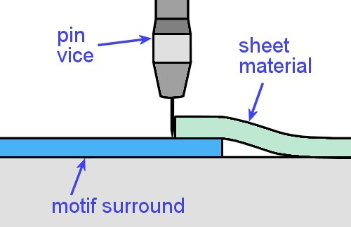
- Slide the motif surround under the sheet material into its final position, under the hole, and trace the edge of the hole onto the surround using a pin vice.
- Remove the surround and cut it to its finished shape, holding the knife vertically.
- Check the fit, then spread adhesive over the area.
- Lay down the sheet material and motif and roll the area thoroughly.
If the motif is already cut to its finished size, you should put it in position on the sheet material and hold it down firmly while tracing the outline with a pin vice. Then cut the sheet material to the exact shape.
Alternatively, you can stick the finished motif directly to the subfloor first. Then place the sheet material over the top and rough cut a hole over the motif.
Scribe the exact shape of the motif onto the sheet material with over and under scribers, and then cut the exact shape required.
If the pre-cut designs have been held in place with tape, make sure you remove the tape as soon as the motif has been stuck down. This will let you make any final adjustments needed before the adhesive starts to cure.

Site-cut patterns
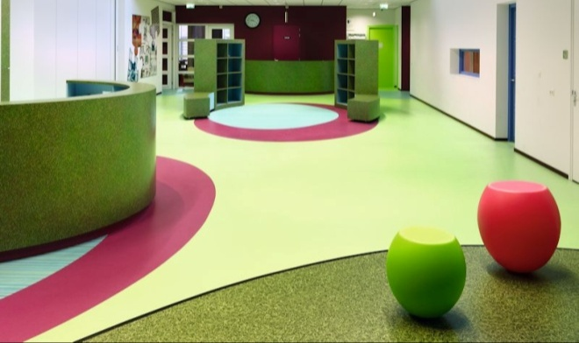
Large scale designs are generally assembled piece by piece on-site.
In most cases this also means that a lot of the pieces need to be cut on-site, to make sure they’ll fit tightly together.
Here are some hints on installing site-cut patterned floors:
- Before you start, work out where any seams will go and make sure the client agrees with their positioning.
- Note that this may affect the material wastage, so it’s best done at the quotation stage of the job.
- Agree with the client on the orientation of patterns and the direction of individual features.
- Mark out the design on the floor, including the centre points of circles or curves, to ensure that the assembly goes exactly to plan.
- Use a recess scriber (or ‘unders and overs’) to scribe adjoining pieces.
- Run the ‘under’ guide of the scriber along the true edge of the first piece after it has been stuck to the floor.

Learning activity
Have a look at the promotional video produced by Polyflor called ‘Education flooring from Polyflor’ at:
http://tv.polyflor.com/video/education-flooring-from-polyflor?current-channel=all-channels
As you watch the different designs, think about the steps that would have been involved in setting them out and fitting the individual pieces.
We’ll talk more about geometry and set-outs in the unit: Resilient tiles.
You should also speak to your supervisor or another experienced installer about the motifs or customised patterns they have installed. What were the designs? How did they go about setting out and installing them?

Assignment 3
Go to the Workbook for this unit to write your answers to the questions shown below. If you prefer to answer the questions electronically, go to the website version and download the Word document template for this assignment.
___________________________________________________________________________
- What are the three types of coving described in AS 1884? For each type, name a typical application where it would be most suitable.
- Why does AS 1884 say that butterfly corners must be used in wet areas?
- What are the two techniques for fitting feather edge skirting to internal and external corners?
___________________________________________________________________________

Practical demonstrations
In this unit we have provided background material to cover the following competencies:
LMFFL3302A: Install commercial vinyl floor coverings
LMFFL3303A: Install resilient floor coverings using custom designs and decorative finishes
Your trainer may ask you to keep a log book or diary of the work you do on-the-job that relates to either or both of these competencies. This will help them to determine when you will have had sufficient hands-on practice in the tasks to undertake the assessment events.
When you’re ready to be assessed, your assessor will watch you carrying out a range of practical demonstrations. The checklists below set out the sorts of things the assessor will be looking for when you undertake these practical tasks.
For LMFFL3302A Install commercial vinyl floor coverings, you will be asked to install:
- commercial vinyl using internal and external mitres and heat welded seams in:
- one piece with pre-formed coving
- custom designs with pattern scribed coving
- commercial vinyl with chemically welded seams.
If you are also undertaking LMFFL3303A Install resilient floor coverings using custom designs and decorative finishes, you will be asked to install:
- resilient flooring using a custom design containing a logo or motif that includes decorative welding, inlays and borders.
For both competencies, you will need to:
- follow all work, health and safety requirements and environmental care procedures
- correctly interpret company documents and work instructions
- communicate and work effectively with other workers in the area
- prevent damage to goods, equipment and products
- work productively and produce a high quality job
- modify activities and techniques used to suit different sites and working conditions.
As part of the practical demonstrations, you will be asked to use of the following tools:
- utility knife with hook, straight and concave blades, spatula knife, wall trimmer, seam and edge trimmer
- straight edge square, roofing square, chalk and chalk-line, tape measure
- hacksaw, hammer, rubber mallet
- recess scriber, pre-formed linoleum recess scribers, scribing bar, dividers
- grooving tool, welding gun and accessories,
- pencil cover roller, hand roller, cove gauging tool, roller
- gas bottle and gun, hot air gun
- notched trowel, paint brush and bucket, contact bucket,
- liquid seam sealer, seam sealer applicator
- linoleum trolley.
Make sure you talk to your trainer or supervisor about any of the details you don’t understand, or aren’t ready to demonstrate, before the assessment events are organised. This will give you time to get the hang of the tasks you’ll need to perform, so that you’ll feel more confident when the time comes to be assessed.

